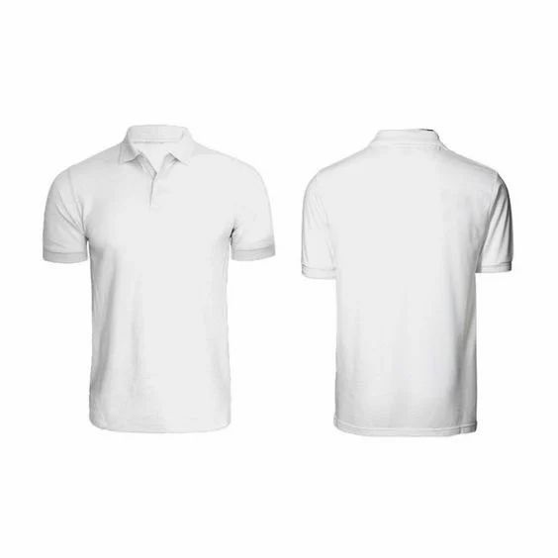**FRONT VIEW MHPSS SCHOOL- BASED PROGRAMMING.**

**Details:**

**Color:**

|  |  |  |  |  |
| --- | --- | --- | --- | --- |
| s/n | **JUBA** | **YEI** | Grey | 200 |
| 01 | **200** | **600** | Blue | 266 |
| 02 | Red | 266 |
|  | White | 68 |
| Total | | | | **800** |



**Sizes**

Small=300,

Medium=300,

Large=120

Extra-large=80



**BACK VIEW**

**“Invest in Your Mental Health for a Brighter Future"**