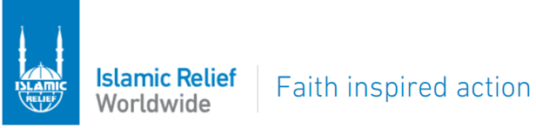

REQUEST FOR QUOTATION (RFQ) – (SUPPLY OF GBV FRIENDLY SPACE MATERIALS).
9th April 2026
Location: WAU AND WARRAP
Background

Islamic Relief is an independent humanitarian and development UK based organization, with an active presence in over 40 countries across the globe, we strive to make the world a better and fairer place for people still living in poverty. Islamic Relief South Sudan began its humanitarian operation in South Sudan in 2004 focusing on providing life-saving aid and implementing developmental programmes to support people affected by drought and conflict by establishing three sub-offices in Narus (Kapoeta East), Wau, Warrap, a satellite office in Yei and its main offices in Juba.
In this regard IRSS is looking for a competent bidder quote for assorted items.

No | Items description | Sample photos | Unit | Quantity | Unit cost (USD) | Total (USD)
1 | Durable Plastic Mukwano Chair (Blue colour) | 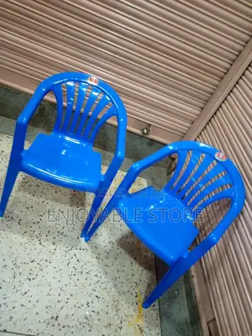 | Piece | 200
2 | Round plastic table (Blue colour) | 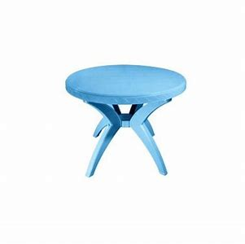 | Piece | 40
3 | Plastic mats  Measurement: (Sleeping mat Synthetic, Tear proof, Plastic, Water impervious; finished size: 120cm X 280cm minimum). | 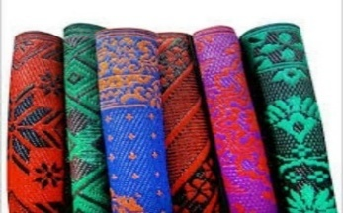 | Roll | 50
4 | Metallic boxes  Specification measurement:  Length: 1.2m  Width: 0.5m  Height: 0.4m | 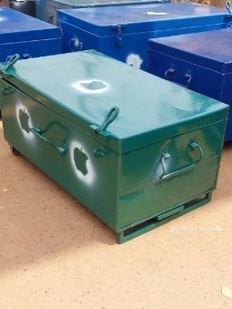 | Piece | 15
Total Cost (USD)
Inclusive delivery cost to Wau & Warrap (to be delivered 50/50 of items to Wau & Warrap)

REQUIRMENTS
SCORE CRITERIA SUPPLY AND DELIVERY OF MATERIAL TO SUPPORT WGFS.
 | Total | 100
A | Mandatory Criteria (Fail will not be considered for next stage) | Pass/Fail
 | Certification of Incorporation | Pass/ Fail
 | Tax Clearance Certificate. Must be valid and updated. | Pass/ Fail
 | Operation License - Must be valid and updated. | Pass/ Fail
 | ID/Passport copy of the director (s). | Pass/ Fail
 | Memorandum of Understanding (MOU) Must be valid and updated/ stamped page | Pass/ Fail
 | South Sudan membership certificate (Chamber of Commerce) Must be valid and updated. | Pass/ Fail
Pass Mark
NOTE: | Bids lacking any of the documents listed as Mandatory will lead to automatic disqualification and shall Not be considered for technical evaluation
B | TECHNICAL ANALYSIS | 100
1 | Value of Similar Work Experience in last 3 years (Contract/Completion Certificates)
 | No similar past work experience (Contract/Completion Certificates) | 0
 | One (1) similar past work experience (Contract/Completion Certificates) | 10
 | Two (2) similar past work experience (Contract/Completion Certificates) | 10
 | Three (3) similar past work experience (Contract/Completion Certificates) | 10
 | Four (4) similar past work experience (Contract/Completion Certificates) | 10
2 | Brief Company Profile with verifiable physical location/address, Areas of expertise, Organograms maximun 4 pages. | 20
3 | Number of Years in Operation at least 5 years. (1yr -2, 2yrs-4, 3yrs-6, 4yrs-8, 5yrs&above-10}. | 20
6 | List of Referees with their contact details (Name, telephone number, official email, location, and Organization) | 20
 | Pass mark -70%N/B: Bids who will not score 70% and above in the technical analysis will automatically be disqualified and shall not be considered for financial evaluation
C | c). FINANCIAL ANALYSIS | 100
1 | No Certified Bank statement. | 0
 | Certified Bank statement of last three months (1st Jan 2026 to 31st Mar 2026 ) | 50
 | with closing balance to sufficiently cover for the value of the RFQ. | 50
2 | Within Budget | 30
 | Not within Budget | 0
3 | Evidence of Certified letter of credit facilities from the reputable bank, indicating maximum credit allowed. | 20
 | Pass mark 70%.
 | N/B: Bids who will not score 70% and above in the financial analysis will automatically be disqualified and shall not be considered for further evaluation

Supplier Code of Conduct
- Islamic Relief’s Supplier Code of Conduct
- Islamic Relief Worldwide requires all suppliers to adhere to:
The Modern Slavery Act 2015
The International Labour Standards as defined by the ILO (International Labour Organisation).
The United Nations Global Compact’s 10 principles as stated below:
Human Rights
Principle 1: Businesses should support and respect the protection of internationally proclaimed human rights;
and
Principle 2: Make sure that they are not complicit in human rights abuses.
Labour
Principle 3: Businesses should uphold the freedom of association and the effective recognition of the right to collective bargaining;
Principle 4: The elimination of all forms of forced and compulsory labour;
Principle 5: The effective abolition of child labour;
and
Principle 6: The elimination of discrimination in respect of employment and occupation.
Environment
Principle 7: Businesses should support a precautionary approach to environmental challenges;
Principle 8: Undertake initiatives to promote greater environmental responsibility;
and
Principle 9: Encourage the development and diffusion of environmentally friendly technologies.
Anti-Corruption
Principle 10: Businesses should work against corruption in all its forms, including extortion and bribery.
All RFQs must be submitted before Wednesday,15th April 2026 at 10:00 AM (local time).
Interested bidders are required to strictly follow the specified criteria and submit all documents online to the following email address: Tendering.IRSS@islamic-relief.com.ss with the subject of the email as REQUEST FOR QUOTATION (RFQ) – (SUPPLY OF WOMEN AND GIRLS FRIENDLY SPACE MATERIALS).

Late submissions or failure to adhere to the submission requirements will result in disqualification.
For any issues relating to the tender or its contents please email directly to; Procurement.IRSS@islamic-relief.com.ss

Instructions to Interested Bidders
- No hardcopy submissions will be accepted.
- All tenders should be submitted via email to the above-mentioned email & subject of email.
- The size of the email should not exceed 25MB
- Interested suppliers should send the documents in PDF format that is not password protected.
- Any links sent or password protected documents will not be considered.
- Suppliers are encouraged to send documents as one batch in one email.

