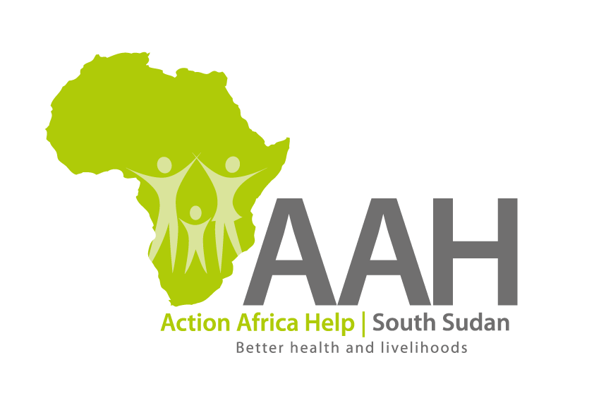
AAHI-South Sudan
Juba Office: Hai Gabat – Opp JIT Supermarket
Behind South Sudan Customs, Tel: +211 925 478 457
Email: ssudan@actionafricahelp.org
Website: www.actionafricahelp.org

INVITATION TO TENDER

Background
Action Africa Help International (AAH-I) is a nongovernmental and nonprofit making Organization operating in South Sudan with a mission to support disadvantaged Communities to sustainably improve their standard of living through a Community empowerment approach in partnership with stakeholders. AAH-I implements Primary Health Care, Agriculture, Humanitarian aid projects, and Capacity Building.

The organization is inviting bids from reputable companies for the provision of the following construction services in Juba.

 | DETAILS | LOCATION OF THE TENDER
1 | Provision of labor and materials for repairing and tiling of the drug store floor at AAHI Logistics Store in Juba. | AAHI/UNHCR Juba Logistic base

The deadline for submission will be on 9th September, 2022 at 4:00 pm.

More details on the bids to be picked at AAHI/UNHCR Juba Logistic base

