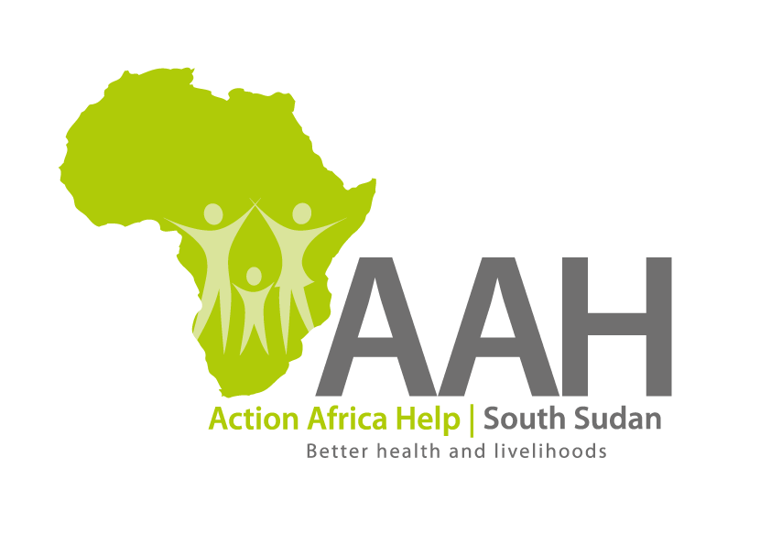
AAH-I South Sudan
Juba Office, off Munuki Road,
Next to South Sudan Civil Service Commission

CALL FOR PROPOSAL

Background
Action Africa Help International (AAH-I) is a nongovernmental and nonprofit making Organization operating in South Sudan with a mission to support disadvantaged Communities to sustainably improve their standard of living through Community empowerment approach in partnership with stakeholders. AAH-I implements Primary Health Care, Agriculture, Humanitarian aid projects and Capacity Building.

The organization is calling for quotations from reputable companies for provision of money transfer services to the following areas:

Geographical coverage:
SN | REGION
1. | Jamjang Office
2. | Maban Office
3. | Yambio
4. | Yei
5. | Malakal
6. | Mundri East
7 | Mundri West
8 | Maridi
9 | Wau
10 | Juba

Terms of Service
- At the receipt of notification from AAH, arrange to transfer/deliver the advised and approved amount(s) to the named location(s); and claim for reimbursement from AAHI thereafter.
- Arrange to deliver the amount of money advised to the named destination within 48 hours from the date of notification;
- Be able to deliver cash to all the geographic locations of AAHI operation mentioned in the list above.
- Ensure that money delivered and received at the named location is acknowledged by senior staff member, in writing (signed cash delivery note);
- Submit proof and acknowledgement of delivery and receipt of the monies.
- AAH shall thereafter arrange to reimburse the service provider the confirmed transferred and received amount, plus the agreed service fee in respect to the transaction as per agreed contract terms.
- Payment in respect to this service shall be through either Bankers Cheque or Direct Transfer within 7 days from the date of receipt of invoice from the service provider. Payment shall only be made to the service provider’s account named in the contract.

2. Eligibility and requirements:
2.1 Administrative requirements:
2.1.1 Valid certificate of incorporation as a business in South Sudan
2.1.2 Valid and certified certificate of registration as a Cash Transfer Service Provider in South Sudan, issued by the relevant authority
2.1.3 Valid and certified registration with the Tax Regulatory Authority of South Sudan
2.1.4 Copy of Articles and Memorandum of Association

2.2 Technical Requirements
2.2.1 Proof that the Service Provider has provided similar service to other Non-Governmental Organizations (NGOs).
2.2.2 Recommendations from reputable organizations operating in the Republic of South Sudan (RSS) for the similar services provided.
2.2.3 Proof of having insurance cover for the said services
2.2.4 Bank recommendation letter stating the financial capacity of the Service Provider during the last 18 months.

2.3 Financial Proposal (in US Dollars)
The financial proposal should be detailed, clear and must indicate any variables and unit rates. The proposal should be valid for 60 days from the date of opening of proposal.

3.0 Submission of quotes:
The quotations shall be submitted in Hard copies in sealed envelopes, and there shall be no submission of quotes in soft copies.
Submission Address

bids shall be submitted to:
AAH-I/UNHCR Logistic Base Juba South Sudan
Near JIT Supermarket, the envelope should be labeled
Read: PROVISION OF MONEY TRANSFER SERVICES
AAH-I South Sudan.

Registration for submission:
Please ensure that, you register your hand delivered quotation/bid with the Procurement department and drop it in the bid box yourself, before you leave the Procurement department.

Each hand delivered quotation/bid must be registered individually on the bids submission forms which will be available at Procurement department. Unregistered quotation/bid will not be considered even if it is dropped in the tender box.

Request for clarifications
Any request for clarification must be made in writing through the email: procurement.southsudan@actionafricahelp.org strictly and must be received not later than Saturday the 5th December, 2020 at 12:00 pm Local Time.

Deadline for the submission of the quotation
The deadline for the submission of the quotes will be strictly on Wednesday the
9th December, 2020, at 4:00 pm Local Time.

4.0 Notification of the results
Only the successful and competitive bidder will be notified, and if you do not receive email communication within two weeks after the expiry of the deadline, consider your bid not successful.

5.0 Language for the bids

The language for the bids shall be English only.

6.0 Evaluation of proposals:
A comprehensive criteria will be followed in evaluating the proposals submitted in accordance with the guidelines prescribed above. The criteria will follow a weighting system advised below:

- Administrative compliance 10 points
- Technical compliance 70 points
- Financial proposal 20 points

Importance Notes:
The bidder’s proposal MUST obtain all the 10 points under the Administrative Compliance Stage and a minimum of 42 points from the Technical Compliance Stage to qualify for the Financial Evaluation Stage. Accordingly, any bidder whose proposal fails to obtain all the 10 points under the Administrative Compliance Stage, will not be considered for Technical Evaluation.

Award of contract:
The contract will be awarded to the Bidder who scores the highest total marks from the evaluation process detailed above.

Disclaimer
This is only a Call for quotations and AAH-I South Sudan reserves the right to either amend or cancel it at any time with or without notice. In such cases, AAH-I South Sudan shall accept no liability whatsoever. The prospective bidder is wholly responsible for any and all costs related to the preparation and submission of their quotations.

The decision of the AAH-I South Sudan Procurement Review Committee shall be final.

