INVITATION TO TENDER
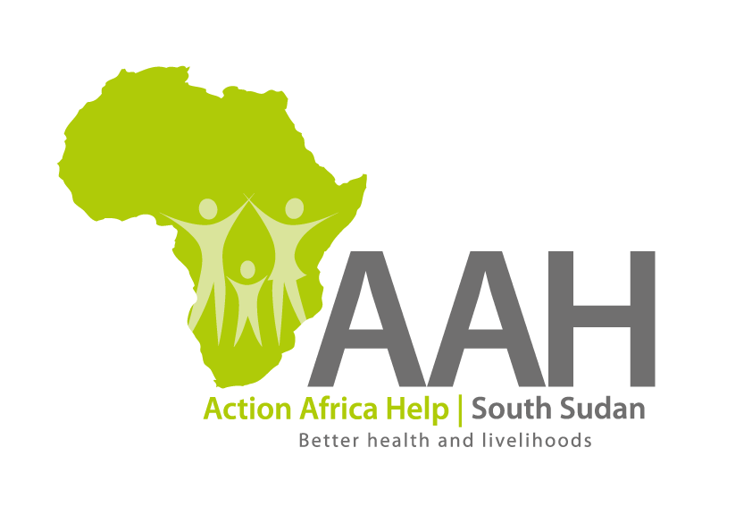
Background
Action Africa Help International (AAH-I) is a nongovernmental and nonprofit making Organization operating in South Sudan with a mission to support disadvantaged Communities to sustainably improve their standard of living through Community empowerment approach in partnership with stakeholders. AAH-I implements Primary Health Care, Agriculture, Humanitarian aid projects and Capacity Building.

The organization is calling for quotations from reputable companies for provision of the following Food and Nonfood items for Maridi Nursing School in Western Equatoria.

S/No: | Description: | specifications: | Unit: | Qty.
01 | Sugar (produced in Pakistan) | Brown | Kgs | 410
02 | Tea bags (Unit of 50 tea bags), Lipton | Unit of 100 tea bags | Pkts | 348
03 | Beans (Yellow), New stock (New produce) | Yellow | Kgs | 1,231
04 | lentils (cleaned)-Red (bags of 20 Kgs) | Cleaned | Kgs | 1,206
05 | Rice (Pakistan rice) | White Pakistan Rice | Kgs | 1,665
06 | Maize flour (First class) | Grade 1 (First class) | Kgs | 1,665
07 | Cooking oil (Vegetable cooking oil) | Hayat | Litres | 114
08 | Onion (Red) | (Red) | Kgs | 184
09 | Table salt (Iodized salt) | Unit of 500 grams | Pkts | 150
10 | OMO/Nomi powder (Unit of I kg)(1000g) | Unit of I kg | Tins | 38

- REQUIREMENTS

Administrative Requirement:
Transporter must provide the following documents;
- Valid registration Certificate
- Valid Tax compliance certificate
- Operation License
Only registered company will be evaluated.
Technical Requirement
- Truck should be of sound Mechanical condition and should be a box body truck.
- Any other cost on the road during the transport of the items will be the responsibility of the supplier.
- The supplier should ensure that, all the prices quoted must be for good quality items and the specifications must be followed.
- All the Expiry dates of the food and other nonfood items should be indicated against each item on a separate column. The expiry dates should be above one year the minimum is two years.
- The price should be quoted based on the unit of the items E.g. Kgs, Pkts, Litres, and tins as indicated in the above table.
- Late quotation will not be accepted.
- Items of poor quality will not be accepted by AAH-I
- The successful bidder should give AAH-I at least one (1) to two (2) days for the verification for the food and nonfood items before they are loaded into to the truck.
- The supplier is responsible to ensure that, there is Insurance cover for items in transit and the truck.

- Price and Currency: The prices shall be in United States Dollars (USD).
- The price should include transport cost, from Juba to AAH-I Maridi in Western Equatoria including loading and handling from Juba to Maridi

- Quotation should be on Company’s letter head

Delivery Point:
The food and nonfood items will be delivered to AAH-I Maridi in Western Equatoria.

Submission of Quotes
The quotations shall be submitted in Hard copies in sealed envelopes, only and there shall be no submission of quotes in soft copies. AAH-I will not accept any quotation sent through the email.

Submission Address:
bids shall be submitted to:
AAH-I/UNHCR Logistic Base Juba South Sudan
Near JIT Supermarket, the envelope should be labeled/ marked:
Supply of Food & nonfood items to AAH-I Maridi Western
Equatoria AAH-I South Sudan.
(Reference RFQ No:AAH-I SS/10606/MNTS/2022)

Registration for submission:
Please ensure that, you register your hand delivered quotation/bid with the Procurement department and drop it in the tender/bid box yourself, before you leave the Procurement department.

Each hand delivered quotation/tender must be registered individually on the bids submission forms which will be available at Procurement department. Unregistered quotation/bid will not be considered even if it is dropped in the tender box.

Request for clarifications:
Any request for clarification must be made in writing through the email: procurement.southsudan@actionafricahelp.org strictly and must be received not later than Thursday the 14th April, 2022 at 12: 30 pm Local Time.

Deadline for the submission of the quotation
The deadline for the submission of the quotes will be strictly on Monday the 25th of April 2022 at 12:00 pm Local Time.

Notification of the results
Only the successful and competitive bidder will be notified, and if you do not receive email communication within two weeks after the expiry of the deadline, consider your bid not successful.

Language for the bids
The language for the bids shall be English only.

Disclaimer
This is only a Call for quotations and AAH-I South Sudan reserves the right to either amend or cancel it at any time with or without notice. In such cases, AAH-I South Sudan shall accept no liability whatsoever. The prospective bidder is wholly responsible for any and all costs related to the preparation and submission of their quotations. The decision of the AAH-I South Sudan Procurement Review Committee shall be final.

