Malteser International
Country Coordination Office
Plot No. 246, Block 3k 2nd Class Residential
Tongping (behind Indian Embassy)
Central Equatoria State, Juba, South Sudan.

SOB_YEI_2022_0049

Specification of Bidding (SOB) SOB_YEI_2022_0049 for supply and delivery of PPEs and shelter items for Ebola response in Yei County to Yei County Hospital.

- Annex 1: Specification of Tendering
- Annex 2: Bill of Quantity
We look forward to receiving your tenders before the submission deadline on 28 November 2022 at or before 4:00 pm via E-mail to: mb.procurement-juba@malteser-international.org.
Please write in the Subject line of your email with tender: SOB_YEI_2022_0049 for purchase of PPEs and shelter items.

Sincerely Yours,

Nermin Silajdzic
Country Logistics and Security Coordinator
Plot No. 246 Block 3k South 2nd Class
Behind Indian Embassy, Tong Ping
Central Equatorial State, Juba, South Sudan
M: +211 (0) 911 746 963 · M: +211 (0) 924 767 949
nermin.silajdzic@malteser-international.org · Skype: nsilajdzic
www.malteser-international.org
Malteser International Europe/Malteser Hilfsdienst e. V., County Court Cologne, VR 4726
Executive Board: Karl Prinz zu Löwenstein, Dr. Elmar Pankau,
Douglas Graf Saurma-Jeltsch, Verena Hölken
Legal advice: This communication is for use by the intended recipient and contains information that may be privileged, confidential or copyrighted under applicable law. If you are not the intended recipient, you are hereby formally notified that any use, copying or distribution of this e-mail, in whole or in part, is strictly prohibited. Please notify the sender by return e-mail and delete this e-mail from your systems.
Please consider the environment before printing this email

SPECIFICATION OF BIIDING
Related to our advertised SOB_YEI_2022_0049 for supply and delivery of PPEs and shelter items for Ebola response in Yei County to Yei County Hospital under the following reference number:
- Donor project numbers: 1357-WAU
- MI project number: 1357

Description of the organization and its activities
Malteser International is the international humanitarian relief agency of the Sovereign Order of Malta. For over 60 years we provide relief and recovery for people during and following conflicts and disasters around the world. Christian values and humanitarian principles form the foundations of our work. In over 30 countries in Africa, the Americas, Asia and the Middle East, we support people in need – regardless of their religion, origin or political convictions.
Malteser International has been working in the geographic area of today’s South Sudan since 1996. MI implements a multi-sectoral program including Food & Nutrition Security, Livelihoods, WASH, health and peaceful conflict resolution. This includes activities such as agricultural trainings, cash distributions, food for education and access to water, sanitation and hygiene. The program is aiming to increase its work with local partner organisations in order to optimise its sustainability. Furthermore, MI applies a participatory, gender sensitive and inclusive approach in its programming. As of today, MI maintains its country office in Juba while operating a program office in Wau and project offices in Uyujuku and Yei.
Objective of SOB: In accordance with the overall targets of above-mentioned operations, MI plans to purchase PPEs and shelter items for Ebola response in Yei County to Yei County Hospital.
The technical specifications and conditions of the tendering process are described below in the Specification of Tendering and in the Annex 2: Bill of Quantity which are part of this SOB.
Suppliers are invited to present tenders complying with the requirements here below specified.

Tenders Presentation
- The tender shall be sent via E-mail to: mb.procurement-juba@malteser-international.org.
The deadline for the submission of tenders is: 28 November 2022 at or before 4:00pm
- The tender shall be written in English
- The tender should be valid for 30 days after the deadline
- The format BoQ can be used or a separate one depending on supplier’s choice.

General conditions
- The tender shall be typed or written and signed on each page by the legal representative of the supplier,
- The winning supplier might be requested to provide catalogues, pictures, technical descriptions and/or samples of items at the order stage when required,
- The prices of the tender will be expressed in United States Dollars. The prices must be on unit price basis as well as by totals,
- The prices will be considered fixed. No additional change of whatsoever nature and type will be accepted by Malteser International,
- Malteser International reserves the right to accept or reject all tenders depending on prevailing condition at the time.

Validity of tenders
Each company is bound to the tender submitted for a period of 30 days from the deadline for submission of tenders.

Language of tender
All tenders, official correspondence between companies and MI, as well as all documents associated with the tender request will be in English.

Submission of tender

Each tender shall be submitted via E-mail to: mb.procurement-juba@malteser-international.org on 28 November 2022, at or before 04:00 pm (local Juba time).

Content of tender
All submitted tenders must conform to the requirements mentioned in the SOB. Furthermore, they must include the following documents:
Part 1 - Tender: A tender for purchase of PPEs and shelter items for Ebola response in Yei County to Yei County Hospital.
The format BoQ can be used or a separate one depending on supplier’s choice. Additional sheets may be attached for further details.
Part 2 - Legal documents
- Copy of the company’s certificate of incorporation,
- Copy of Chamber of Commerce registration,
- Copy Tax Identification Certificate,
- Copy of Certificate of Operation,
- Copy of License to operate Pharmaceutical Business,
- Company’s Bank Statement of last three months,
- Questionnaire for tender,
- Company’s official address,
- Bank account details (where money would be paid),

Ownership of tenders
MI reserves/funds ownership of all tenders received. As a consequence, bidders will not be able to stipulate requirements that their tenders are to be returned.
- Opening of submitted tenders
The tenders will be opened on 29 November 2022 in MI Country Coordination Office in Juba, South Sudan, by the Evaluation committee. The selection process will be recorded in writing by the committee.

Tender evaluation
The criteria applied for the evaluation of suppliers will be
- the legal conformity,
- the price,
- working capital from the last 3-month bank statement,
- average turnover in the last two years,
- the technical experiences,
- submitted questionnaire for tender,
- the compliance with technical specifications and quality standards,
- the capacity to deliver and
- delivery time and meet timeframes as specified.
The work will be awarded to the winning tenderer according to the timetable mentioned above.
12) Exclusion criteria
The following are exclusion criteria:
- Not submitted the following company registration documents in South Sudan:
    - Copy of the company’s certificate of incorporation,
    - Copy of Chamber of Commerce registration,
    - Copy Tax Identification Certificate,
    - Copy of Certificate of Operation,
- Not bided according to the specification,
- Not provided questionnaire for tender and
- Mathematical error of total bided price >±2 %

- Specific Technical and Financial Evaluation Criteria to standards:
- Evaluation report and justification basing on responsiveness of the selected supplier by evaluation committee
- Contract agreement will directly be issued to the selected supplier upon approval.

Technical specification of tender
For supply and delivery of PPEs and shelter items for Ebola response in Yei County to Yei County Hospital.
1 | PPE-Overalls for Ebola Response in Yei County-Coverallm yellow, size medium, level3/4/5/6b protection(Honeywell special 3000) | 20.00 | Pc |  | 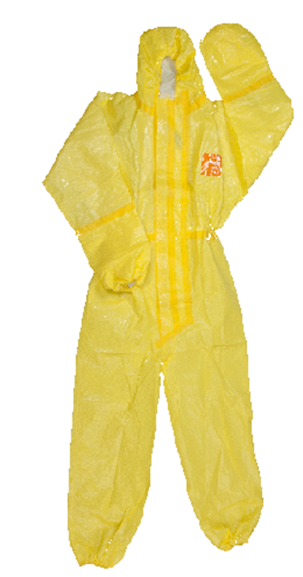
2 | PPE-Gumboot for Ebola Response in Yei County-(Boots, PVC, white, height 38,5 cm, size 44) | 20.00 | Pair |  | 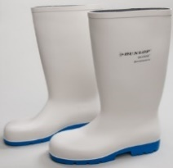
3 | PPE- Examination gloves for Ebola Response in Yei county-Gloves examination, nitrile, size medium, length 284 mm(11,18), powder free, non -stérile, disposable(medline-sensicare extended cuff MOSEXTM) | 9.00 | Pkt |  | 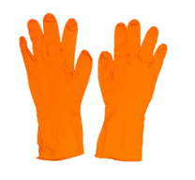

4 | PPE- Utility gloves for Ebola Response in Yei county-Gloves Utility, nitrte, size 11 thickness 0,4mm, lengh 390-410 m, green catgory III, EN 388-3001(Honeyxell spacial) | 18 | Pair |  | 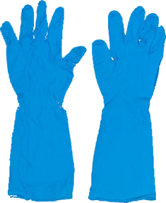
5 | PPE- Masks for Ebola Response in Yei county-Face Mask, N95/FFP2, without valve, duckbill-shaped(flat folded)(Medeline NONE24508) | 20.00 | Pc |  | 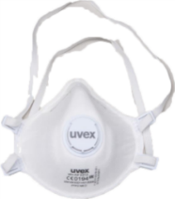
6 | PPE-Ebola Response in Yei County Head Cover for Ebola Response in Yei county-Headcover, hooded with integrated mask, xith laces, according EN 141265 (Indulex Cleanguard) | 20.00 | Pc |  | 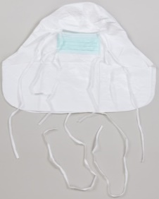
7 | PPE- Safety glasses for Ebola Response in Yei county-Safety Glass(Goggles), unventilated, wideview, clear polycarbonate lens, scealed fram (3M 2890S), Pair | 20.00 | pair |  | 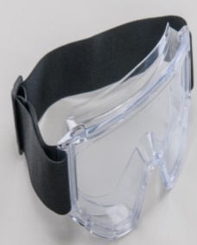
8 | PPE- Ebola Response in Yei county Screen facial form headband, full face length visor, disposable(Kimberly-Clark Guaedall shield 41204 | 20.00 | Pc
9 | PPE- Chlorine (Sodium Hydrochloride (65-70)%-Tablets | 15.00 | Pkt
10 | Gun thermometer with batteries for Ebola response in Yei county | 18.00 | Pc
11 | Tent (3mx4m) for Ebola response in Yei county | 18.00 | Set
12 | Ordinary Metallic Beds with PVC mattresses for Ebola response in Yei County | 9.00 | Pc
13 | Megaphones with batteries for Ebola response in Yei county | 9.00 | Pc
14 | Transport from Juba to Yei | 1.00 | Trip

Validity of tenders
Each company is bound to the tender submitted for a period of 30 days from the deadline for submission of tenders.

Language of tenders
All tenders, official correspondence between companies and MI, as well as all documents associated with the tender’s request will be in English.
- Terms of payment
The payment will be done in United States Dollar by bank transfer or cheque as specified below:
- 100% of shall be paid by the Malteser International 10 days after the invoices issued by the Contractor.

B BILL OF QUANTITY
For supply and delivery of PPEs and shelter items for Ebola response in Yei County to Yei County Hospital
No | Description of goods or services | Quantity | Unit | Unit price USD | Total USD
1 | PPE-Overalls for Ebola Response in Yei County-Coverallm yellow, size medium, level3/4/5/6b protection(Honeywell special 3000) | 20 | Pc
2 | PPE-Gumboot for Ebola Response in Yei County-(Boots, PVC, white, height 38,5 cm, size 44) | 20 | Pair
3 | PPE- Examination gloves for Ebola Response in Yei county-Gloves examination, nitrile, size medium, length 284 mm(11,18), powder free, non -stérile, disposable(medline-sensicare extended cuff MOSEXTM) | 9 | Pkt
4 | PPE- Utility gloves for Ebola Response in Yei county-Gloves Utility, nitrte, size 11 thickness 0,4mm, length 390-410 m, green catgory III, EN 388-3001(Honeyxell special) | 18 | Pair
5 | PPE- Masks for Ebola Response in Yei county-Face Mask, N95/FFP2, without valve, duckbill-shapped(flat folded) (Medeline NONE24508) | 20 | Pc
6 | PPE-Ebola Response in Yei County Head Cover for Ebola Response in Yei county-Head cover, hooded with integrated mask, xith laces, according EN 141265 (Indulex Cleanguard) | 20 | PC
7 | PPE- Safety glasses for Ebola Response in Yei county-Safety Glass(Goggles), unventilated, wide view, clear polycarbonate lens, sealed fram (3M 2890S), Pair | 20 | pair
8 | PPE- Ebola Response in Yei county Screen facial form headband, full face length visor, disposable(Kimberly-Clark Guaedall shield 41204 | 20 | Pc
9 | PPE- Chlorine (Sodium Hydrochloride (65-70)%-Tablets | 15 | Pkt
10 | Gun thermometer with batteries for Ebola response in Yei county | 18 | Pc
11 | Tent (3mx4m) for Ebola response in Yei county | 18 | Set
12 | Ordinary Metallic Beds with PVC mattresses for Ebola response in Yei County | 9 | Pc
13 | Megaphones with batteries for Ebola response in Yei county | 9 | Pc
14 | Transport from Juba to Yei | 1 | Trip
On behalf of Malteser International:
Date: 21 November 2022
Sincerely Yours,

Nermin Silajdzic
Country Logistics and Security Coordinator
Plot No. 246 Block 3k South 2nd Class
Behind Indian Embassy, Tong Ping
Central Equatorial State, Juba, South Sudan
M: +211 (0) 911 746 963 · M: +211 (0) 924 767 949
nermin.silajdzic@malteser-international.org · Skype: nsilajdzic
www.malteser-international.org
Malteser International Europe/Malteser Hilfsdienst e. V., County Court Cologne, VR 4726
Executive Board: Karl Prinz zu Löwenstein, Dr. Elmar Pankau,
Douglas Graf Saurma-Jeltsch, Verena Hölken
Legal advice: This communication is for use by the intended recipient and contains information that may be privileged, confidential or copyrighted under applicable law. If you are not the intended recipient, you are hereby formally notified that any use, copying or distribution of this e-mail, in whole or in part, is strictly prohibited. Please notify the sender by return e-mail and delete this e-mail from your systems.
Please consider the environment before printing this email

