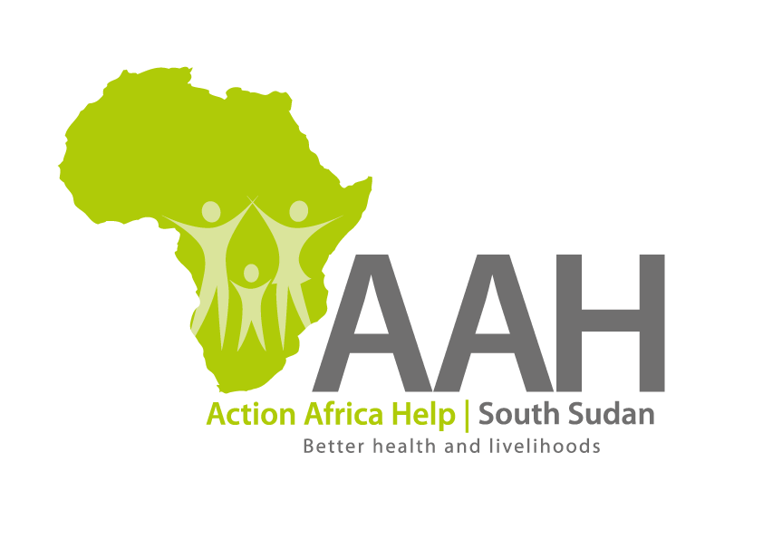
AAH South Sudan
Juba Office: Hai Gabat – Opp JIT Supermarket
Behind South Sudan Customs, Tel: +211 925 478 457
Email: ssudan@actionafricahelp.org
Website: www.actionafricahelp.org

INVITATION TO TENDER

Background
Action Africa Help International (AAH-I) is a nongovernmental Organization and nonprofit making operating in South Sudan with a mission to support disadvantaged Communities to sustainably improve their standard of living through Community empowerment approach in partnership with stake holders. AAH-I implements Primary Health Care, Agriculture, Humanitarian aid projects and Capacity Building.

The organization is inviting for bids from competent and reputable companies for provision of cargo airlifting services per kilogram across South Sudan with intention of getting into a one-year Frame work agreement.

 | ROUTES | Kgs | RATE PER KG
1. | Across South Sudan | 1kg

REQUIREMENTS

Administrative Requirement:
Contractors are required to submit the following documents;
- Valid registration Certificate
- Valid Tax compliance certificate
- Operation License
- Valid South Sudan aviation permit
Only registered company will be evaluated.
Technical Requirement
- Company Profile which should contain evidence of past experience in the
year 2020 and 2021
- Evidence of having own aircraft (6mt)
- Signed general terms and conditions
Financial proposal
- The rate should be on Company’s letterhead
- If the bidder’s aircraft tonnage is different from what is indicated on this ITB that should be clearly indicated on their quotation.
- Price and Currency: The prices shall be in United States Dollars (USD).

- Quotation should be on Company’s letter head

Submission of Quotes
The quotations shall be submitted in Hard copies in sealed envelopes, and there shall be no submission of quotes in soft copies. The bidders must adhere to this instruction to avoid inconveniences.

Submission Address
The bids shall be submitted to:

AAH-I/UNHCR Logistic Base Juba South Sudan
Near JIT Supermarket, the envelope should be labeled
Read: CARGO AIRLIFT SERVICES
AAH-I South Sudan.

Registration for submission:
Please ensure that, you register your hand delivered quotation with the Procurement department and drop it in the bid box yourself, before you leave the Procurement department.

Request for clarifications
Any request for clarification must be made in writing through the email: procurement.southsudan@actionafricahelp.org, Strictly and must be received not later than Friday the 11th March, 2022 at 4:00 pm local time.

Deadline for the submission of the quotation
The deadline for the submission of the quotes will be strictly on Friday the 18th March, 2022 at 12:00 pm local time.

Evaluation criteria
Evaluation will be based on administrative, technical and financial requirements. Bidders who will fail to submit any of the documents requested at administrative level will be disqualified from technical and financial evaluation.

Notification of the results
Only the successful and competitive bidder will be notified, and if you do not receive email communication within two weeks after the expiry of the dead line, consider your bids not successful.

Language for the bids
The language for the bids shall be English only, but no other languages to be used.

Disclaimer
This is only a Call for quotations and AAH South Sudan reserves the right to either amend or cancel it at any time with or without notice. In such cases, AAH South Sudan shall accept no liability whatsoever. The prospective bidder is wholly responsible for any and all costs related to the preparation and submission of their quotations.

The decision of the AAH South Sudan Procurement Review Committee shall be final.

