INVITATION TO TENDER
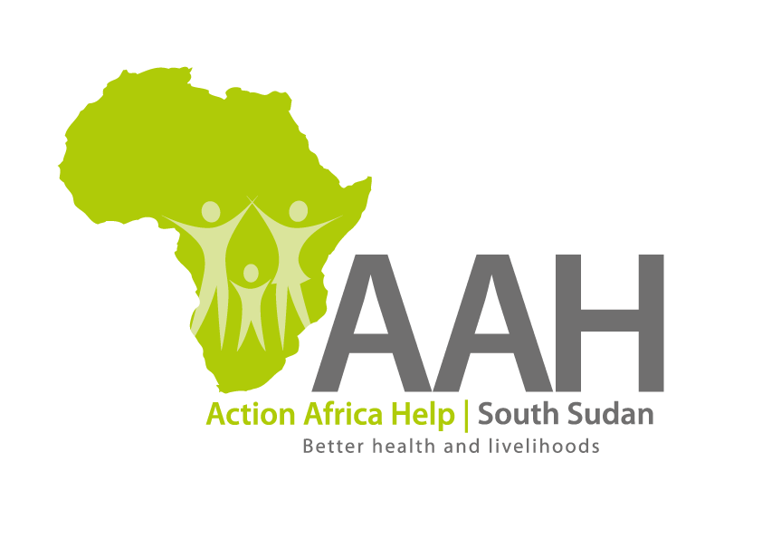
Background
Action Africa Help International (AAH-I) is a nongovernmental and nonprofit making Organization operating in South Sudan with a mission to support disadvantaged Communities to sustainably improve their standard of living through Community empowerment approach in partnership with stakeholders. AAH-I implements Primary Health Care, Agriculture, Humanitarian aid projects and Capacity Building.

The organization is calling for quotations from reputable companies for provision of casuals labourers’ management services at all AAHI warehouses in Maban, Jamjang, Juba, Wau, Yambio and Yei as per the following truck capacity and also arranging materials in the warehouse.

No. | Description | Capacity | Qty
1 | Offloading/loading truck | 7 ton | 1
2 | Offloading/loading truck | 12 ton | 1
3 | Offloading/loading truck | 15 ton | 1
4 | Offloading/loading truck | 20 ton | 1
5 | Offloading/loading truck | 25 ton | 1
6 | Offloading/loading truck | 30 ton | 1
7 | Offloading/loading truck | 35 ton | 1
8 | Offloading/loading truck | 40 ton | 1
9 | Casual laborer’s on need basis | Daily rate | 1

- Deadline of submission is 3rd June, 2022.

- Detailed tender document to be picked from AAHI Offices in the following locations:

AAH-I/UNHCR Logistic Base, Juba South Sudan
Near JIT Supermarket,
AAH-I South Sudan.

OR
AAH-I Jamjang Office
Jamjang Compound
Jamjang County
Ruweng Administrative Area

OR
AAHI Maban Office
Bunj.

