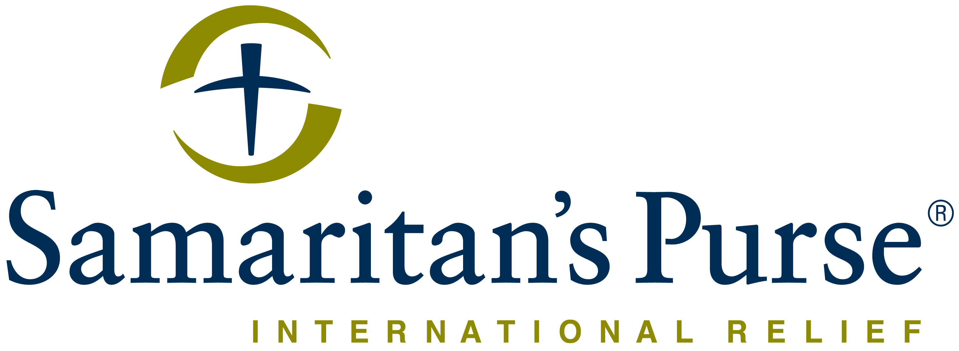
Franklin Graham President

REQUEST FOR QUOTE Date: 12-Nov-2021

Deadline for submission of Quotation is Thursday 18-Nov-21 before 5:00 PM

Samaritan’s Purse
Juba, South Sudan, Hai Cinema next to
Quality Hotel, Old Juba Town Road.

Samaritan’s Purse wishes to contract a legally recognized service provider (company) to supply: COVID WASH Handwashing facilities for Schools and Health Clinics

Reference number: COVID WASH Handwashing facilities for Schools and Health Clinics
If you are interested in bidding for this tender, please submit your competitive quotation by
- Email to: ssrfq@Samaritan.org with subject line COVID WASH Handwashing facilities.
- Or by Hand delivery to Samaritan’s Purse Juba office in sealed enveloped clearly marked: COVID WASH Handwashing facilities Attention to: ER Operations Manager
If the correct reference number is not included in the subject line of the email or on the envelope the quote will be subjected to rejection.
Do NOT copy anyone when submitting your bid
Photographs of the quoted items would be appreciated if attached with your quote.

Item Description |  | Qty | Unit of Measure | Estimate Unit Price | Total  Est. Price
1 | Supply of handwashing stations for institutions (Schools and Health Clinics) fabricated on a metallic frame foot operated mounted with a 200 liters PVC capacity tank fitted with tap (see attached picture for example of desired quality) | 316 | Pieces |  | -

Your Quotation MUST clearly indicate the following:

- Currency of offer – USD.
- Number of days required for delivery.
- Validity of the Quotation – Must be at least 60 days.
- Detailed specifications and brands of quoted items are requested.
- Unit Price and Total Amount.
- Payment terms will be within 30 business days after receipt of goods and invoice, by Electronic bank transfer.
- Terms of Delivery (Preference for DDP Juba).
- Delivery charges, if any, should be clearly stated on the quotation.
- Samaritan’s Purse South Sudan is not subject to VAT; therefore, all Quotations should be exclusive of VAT costs.
- Quotes must be stamped, signed and sent as a pdf/picture file or printed and submitted in a sealed envelope with the reference number clearly written on the sealed envelope
- Submit your quotation by email with subject name the reference number of this request for quotes or by physical submission in a sealed unmarked envelope with only the reference number of this request for quotes written on it.
- The subject line of the email or the physical copy has to be the reference number of this request for quote.
- Samaritan’s Purse South Sudan has the right to exclude any Quote that doesn’t meet all of the above.
- Samaritan’s Purse South Sudan might request for samples to be provided when the Request for Quote period ends. Failure to submit samples by the RFQ end date (if samples are requested) is grounds for disqualification of the bid.

TERMS AND CONDITIONS:

- Samaritan’s Purse accepts no responsibility and is under no obligation to reimburse applicants for the costs associated with preparation of their applications.
- Samaritan’s Purse reserves the right to award the most qualified service provider (contractor) regardless of the lowest price submitted.
- Payment is upon delivery and after preliminary verification of the services/items specified above.
- Samaritan’s Purse reserves the right to award to more than one bidder or to reject all applicants and cancel the solicitation at any time.

Quotations will be REJECTED if:

    - Submitted after the RFQ deadline.
    - Submitted separately to any other party.
    - Any coercive behaviour is suspected.

All bids are received directly by the Head of the department. It is not possible to influence the decision or outcome. No individual or group can influence decision making.

Questions?
If you have any questions or need further clarifications on this RFQ, please email: (lalex@samaritan.org) copying ssrfq@Samaritan.org and imakwangudze@samaritan.org

