INVITATION TO TENDER
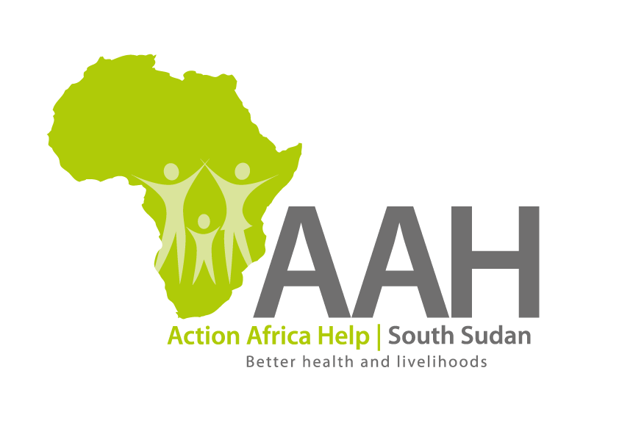
Background
Action Africa Help International (AAH-I) is a nongovernmental Organization and nonprofit making operating in South Sudan with a mission to support disadvantaged Communities to sustainably improve their standard of living through Community empowerment approach in partnership with stake holders. AAH-I implements Primary Health Care, Agriculture, Humanitarian aid projects and Capacity Building.

The organization is inviting bids from competent and reputable Companies for the Supply of Assorted tyres and Tubes

 | Description of Goods/Services | Part Number | QTY(Pcs)
1 | Tyre –Michelin | 12:00R24 | 25
2 | Inner Tubes with long Nozzle | 12:00-24 | 25
3 | Tyre-Good Year (Off road) | 14:00R20 | 6
4 | Inner Tubes with long Nozzle | 14:00-20 | 12
5 | Tyre, Tubeless discovery Cooper A/T3 (120/116R) | LT 235/85R16 | 14

More details on the said tenders can be picked from AAHI/UNHCR Juba Logistics base during working hours (Monday to Friday, 9:00am to 11.30am and 2:00pm to 4.00pm)

Deadline for submission of the bids will be on Monday 12th June, 2023 at 12:00pm.

