INVITATION TO TENDER
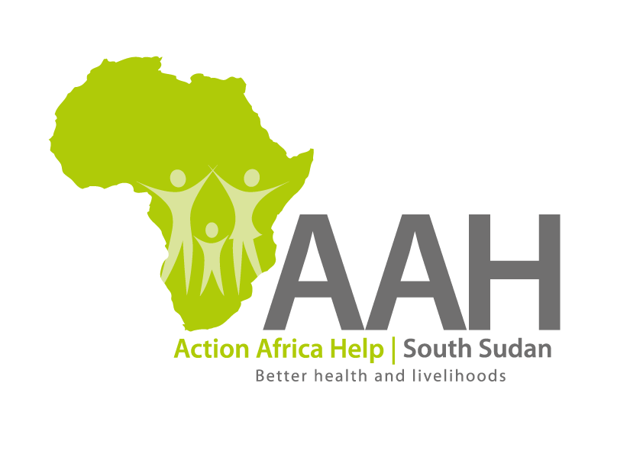
Background
Action Africa Help International (AAH-I) is a nongovernmental and nonprofit making Organization operating in South Sudan with a mission to support disadvantaged Communities to sustainably improve their standard of living through Community empowerment approach in partnership with stakeholders. AAH-I implements Primary Health Care, Agriculture, Humanitarian aid projects and Capacity Building.

The organization is inviting bids from reputable companies for supply of the following agricultural Equipment.

S/No: | Description: | specifications: | Unit: | Qty.
01 | Grinding Mill for flour | 20 HP Electric Power Grinding Mill for (Diesel Engine) | Pcs | 01
02 | Cassava Chippers | Manual Cassava Chipper (Made in India) | Pcs | 04
03 | Ground nut Shellers | Manual Ground nut Shellers (Made in India) | Pcs | 04
04 | Maize Sheller | Manual Maize Shellers (Made in India) | Pcs | 04

More details on the said tenders can be picked from AAHI/UNHCR Juba Logistics base during working hours (Monday to Friday, 9:00am to 11.30am and 2:00pm to 4.00pm)

Deadline for submission of the bids will be on 1st September, 2023 at 12:00pm.

