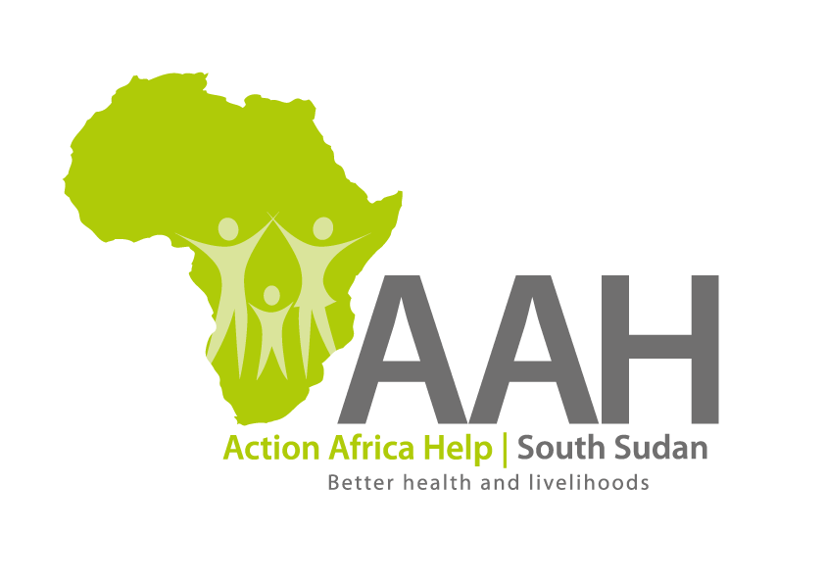
INVITATION TO TENDER – VARIOUS SERVICES

Background
Action Africa Help International (AAH-I) is a nongovernmental Organization and nonprofit making operating in South Sudan with a mission to support disadvantaged Communities to sustainably improve their standard of living through Community empowerment approach in partnership with stake holders. AAH-I implements Primary Health Care, Agriculture, Humanitarian aid projects and Capacity Building.

The organization is calling for quotations from competent and reputable suppliers for Provision of the following services and supply of construction materials with intention of getting into a one year Frame work agreement (2024).

Specific details on each tender should be picked from AAHI/UNHCR Juba Logistics Base during working hours.

 | Description of Goods/Services
1. | Internet Services
2 | Security Services
3. | Cargo Airlifting Services
4. | Road Transport Services
5. | River Transport Services
6. | Assorted Construction materials
7. | Garbage collection
8. | Sewage collection
9. | Supply of drinking water - 20 litres jumbo bottle
10. | Crane services
11. | Property Insurance
12. | Motor vehicle insurance
13. | Money Transfer Services
14. | Cash in premises

More details on the said tenders can be picked from AAHI/UNHCR Juba Logistics base during working hours (Monday to Friday, 9:00am to 11.30am and 2:00pm to 4.00pm)

Deadline for submission of the bids will be on 8th December, 2023 at 12:00pm.

