INVITATION TO TENDER
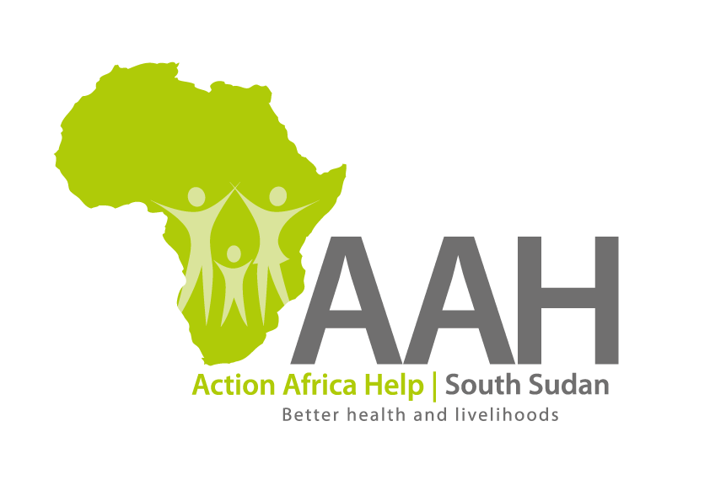
Background
Action Africa Help International (AAH-I) is a nongovernmental Organization and nonprofit making operating in South Sudan with a mission to support disadvantaged Communities to sustainably improve their standard of living through Community empowerment approach in partnership with stake holders. AAH-I implements Primary Health Care, Agriculture, Humanitarian aid projects and Capacity Building.

The organization is inviting bids from competent and reputable Companies for the Provision of labour and materials for grading, graveling and drainage works at Juba Jebel Warehouse waystation.

 | Description of Goods/Services
1 | PROVISION OF LABOUR AND MATERIALS FOR GRADING, GRAVELING AND DRAINAGE WORKS AT JUBA JEBEL WAREHOUSE WAY STATION.

More details on the said tenders can be picked from AAHI/UNHCR Juba Logistics base during working hours (Monday to Friday, 9:00am to 11.30am and 2:00pm to 4.00pm)

Deadline for submission of the bids will be on Wednesday 28th June, 2023 at 10:00Am.

