Malteser International Europe, Grüner Weg 14, 50825 Cologne, Germany

**Malteser International**

**Wau Office, Hai Daraja,**

**Block 21, Plot No. 183,**

**Wau, South Sudan**

**10 March 2020**

**Request for Quotations**

**RFQ/WAU/2019/0686**

Supply of **502 portable radios with straps, AM/FM, solar powered, hand crank generator, normal battery, flash light with a micro SD card slot** under project JUB_1323 with delivery to Malteser International Country Coordination Office in Juba in South Sudan

1. Annex 1: Specification of Bidding
2. Annex 2: Bill of Quantity

We look forward to receiving your tenders by or before the submission deadline on **19 March 2020 at or before 4:00pm** via E-mail to: [**mb.procurement-wau@malteser-international.org**](mailto:mb.procurement-wau@malteser-international.org).

Thank you for your cooperation.

Yours faithfully,

cid:image001.jpg@01D56ED5.F5A09950

|  |  |  |
| --- | --- | --- |
|  |  | Nermin Silajdzic  Country Logistics and Security Coordinator  Plot No. 445, Block 3, Kololo - US Embassy Road.  Central Equitorial State, Juba, South Sudan M: +211 (0) 911 746 963 · M: +211 (0) 924 767 949 [nermin.silajdzic@malteser-international.org](mailto:nermin.silajdzic@malteser-international.org) · Skype: nsilajdzic [www.malteser-international.org](http://www.malteser-international.org/) Malteser International Europe/Malteser Hilfsdienst e. V., County Court Cologne, VR 4726 Executive Board: Karl Prinz zu Löwenstein, Dr. Elmar Pankau, Douglas Graf Saurma-Jeltsch, Verena Hölken |
| Legal advice: This communication is for use by the intended recipient and contains information that may be privileged, confidential or copyrighted under applicable law. If you are not the intended recipient, you are hereby formally notified that any use, copying or distribution of this e-mail, in whole or in part, is strictly prohibited. Please notify the sender by return e-mail and delete this e-mail from your systems. | | |

**Please consider the environment before printing this email**

# A. SPECIFICATION OF THE TENDERS

Related to our RFQ/WAU/2019/0686MI herewith calls for supply of **502 portable radios with straps, AM/FM, solar powered, hand crank generator, normal battery, flash light with a micro SD card slot** under project JUB_1323 with delivery to Malteser International (MI) Country Coordination Office in Juba in South Sudan.

# Description of the organization and its activities

MI is a worldwide humanitarian relief service of the Sovereign Order of Malta and legally a division of Malteser Hilfsdienst e. V. based in Cologne, Germany. MI is a charitable organization recognize as a relief organization according to the Geneva Convention. In South Sudan, MI is running basic health care programs, a sleeping sickness control program and supporting people affected by leprosy. The activities implemented in Wau are focusing on food security, livelihood, and WASH.

**Objective of the RFQ:** In accordance with the overall targets of the above-mentioned operations, MI plans to order **502 portable radios with straps, AM/FM, solar powered, hand crank generator, normal battery, flash light with a micro SD card slot** under project JUB_1323 with delivery to MI Country Coordination Office in Juba. The technical specifications and conditions of the tender is fully described in Annex 2:

Competent and qualified companies are therefore invited to present bids complying with the requirements specified.

# Tender Presentation

The tender shall be sent via E-mail to: [**mb.procurement-wau@malteser-international.org**](mailto:mb.procurement-wau@malteser-international.org)

**The deadline for the submission of the tender is** **19 March 2020 at or before 4:00pm**

* The tender shall be written in English
* The tender should be valid for **60 days after the deadline**
* The formatted BOQ can be used or a clear separate one depending on supplier’s choice.

# General conditions

* The tender shall be typed or written and signed on each page by the legal representative of the supplier,
* The winning company might be requested to provide catalogues, pictures, technical descriptions and/or samples of items at the order stage when required,
* The prices of the tender will be expressed in United States Dollars. The prices must be on unit price and total basis.
* The prices will be considered fixed whereas MI will not process Tax exemption. No additional change of whatsoever nature and type will be accepted by MI,
* MI reserves the right to accept or reject all tenders depending on prevailing condition at the time,

# Technical specification

# Supply of 502 portable radios with straps, AM/FM, solar powered, hand crank generator, normal battery, flash light with a micro SD card slot under project JUB_1323 with delivery to MI Country Coordination Office in Juba

Below are two photos of portable radio sample:

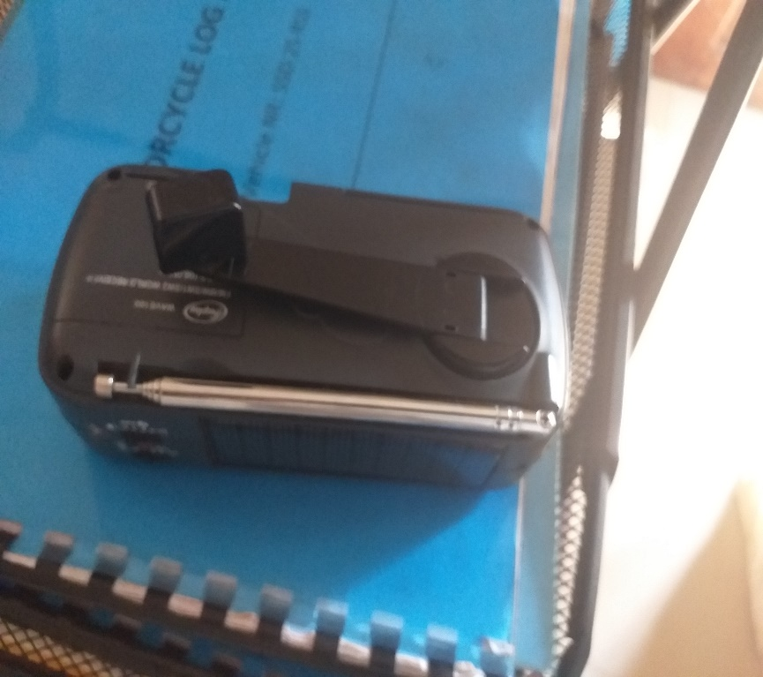

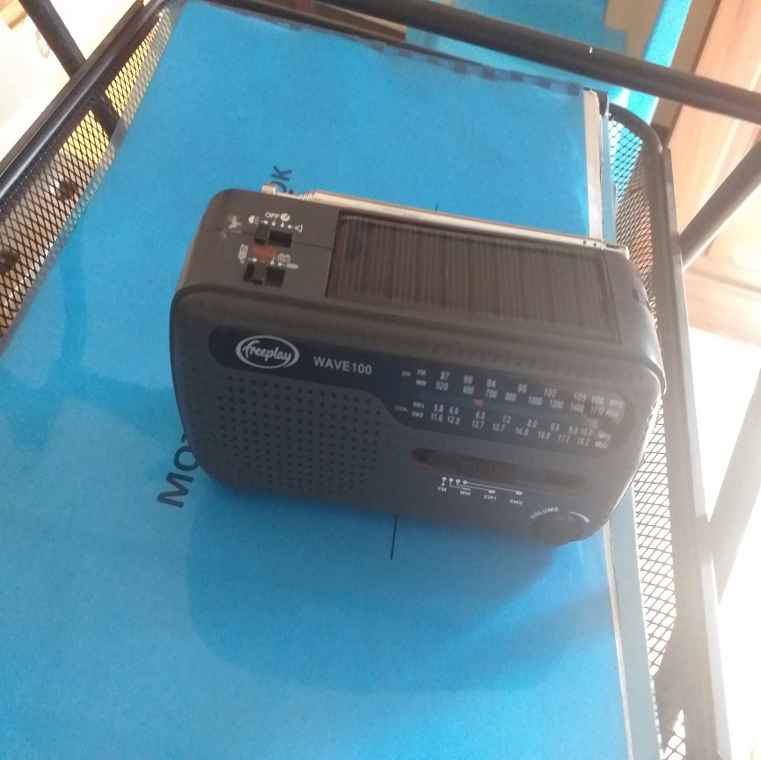

# Timetable

|  |  |  |
| --- | --- | --- |
| **Activities** | **Date** | **Time\*** |
| Deadline for submission of tenders | 19 March 2020 | 04:00 p.m. |
| Opening of submitted tenders | 20 March 2020 | - |
| Notification of award to the successful tenderers | 24 March 2020 | - |
| Signature of Contract Agreement | 25 March 2020 | - |

* All times are local time in Wau, South Sudan

# Validity of tenders

Each company is bound to the tender submitted for a period of 60 days from the deadline for submission of bids.

# Language of tender

All tenders, official correspondence between companies and MI, as well as all documents associated with the tender request will be in English.

# Submission of tenders

All tenders must conform to the following conditions:

# Each tender must be sent to [mb.procurement-wau@malteser-international.org](mailto:mb.procurement-wau@malteser-international.org) within the deadline on 19 March 2020 at or before 4:00 p.m. (local time).

# Content of tender

All submitted tenders must conform to the requirements mentioned in the RFQ. Furthermore, they must include the following documents:

**Part 1 - Tender:** A tender for supply of **502 portable radios with straps, AM/FM, solar powered, hand crank generator, normal battery, flash light with a micro SD card slot** under project JUB_1323 with delivery to MI Country Coordination Office in Juba. The formatted BoQ can be used or a separate one depending on supplier’s choice. Additional sheets may be attached for further details.

**Part 2 - Legal documents**

* Copy of the company’s certificate of incorporation,
* Copy of Chamber of Commerce registration,
* Copy Tax Identification Certificate,
* Copy of Certificate of Operation,
* Company’s Bank Statement of last three months,
* Company’s official address,
* Bank account details (where money would be paid)

# Ownership of tenders

MI reserves/funds ownership of all tenders received. Consequently, tenderers will not be able to stipulate requirements that their bids are to be returned.

1. **Opening of submitted tenders**

The Evaluation Committee will open the tenders on 20 March 2020 in MI Office in Wau, South Sudan in the presence of tenderers who chose to attend. The Evaluation Committee will record the selection process in writing.

# Tender evaluation

The criteria applied for the evaluation will be the legal conformity, the price, the technical experiences, the compliance with technical specifications and quality standards, and the capacity to deliver, delivery time and meet timeframes as specified. The supply will be awarded to the winning tenderer according to the timetable mentioned above.

1. **Specific Technical and Financial Evaluation Criteria to standards:**

* Comparative Bid Analysis and justification basing on responsiveness of the selected supplier by evaluation committee.
* MI will conduct independent seed germination test on the samples provided.
* Contract Agreement will directly be issued to the selected supplier upon passing germination test and approval.

1. **Delivery**

Delivery of **502 portable radios with straps, AM/FM, solar powered, hand crank generator, normal battery, flash light with a micro SD card slot** under project JUB_1323 with delivery to MI Country Coordination Office in Juba:

Country Coordination Office

Plot No: 445 Kololo Road 3k South

Tong Ping, Juba, South Sudan

1. **Terms of payment**

The payment for the agriculture seeds supplied will be in United States Dollar by bank transfer or cheque as specified below:

Payment will be done after 10 working days upon delivery of the goods and supporting invoices from the Supplier to MI Country Coordination Office.

**Annex 2: Bill of Quantity**

|  |  |  |  |  |  |
| --- | --- | --- | --- | --- | --- |
| No. | Description | Unit | Quantity | Unit price USD | Total price USD |
| 1 | **Portable radio with straps, AM/FM, solar powered, hand crank generator, normal battery, flash light with a micro SD card slot** | Pc | 502 |  |  |

On behalf of Malteser International Date: 10 March 2020

Yours faithfully,

cid:image001.jpg@01D56ED5.F5A09950

|  |  |  |
| --- | --- | --- |
|  |  | Nermin Silajdzic  Country Logistics and Security Coordinator  Plot No. 445, Block 3, Kololo - US Embassy Road.  Central Equitorial State, Juba, South Sudan M: +211 (0) 911 746 963 · M: +211 (0) 924 767 949 [nermin.silajdzic@malteser-international.org](mailto:nermin.silajdzic@malteser-international.org) · Skype: nsilajdzic [www.malteser-international.org](http://www.malteser-international.org/) Malteser International Europe/Malteser Hilfsdienst e. V., County Court Cologne, VR 4726 Executive Board: Karl Prinz zu Löwenstein, Dr. Elmar Pankau, Douglas Graf Saurma-Jeltsch, Verena Hölken |
| Legal advice: This communication is for use by the intended recipient and contains information that may be privileged, confidential or copyrighted under applicable law. If you are not the intended recipient, you are hereby formally notified that any use, copying or distribution of this e-mail, in whole or in part, is strictly prohibited. Please notify the sender by return e-mail and delete this e-mail from your systems. | | |

**Please consider the environment before printing this email**