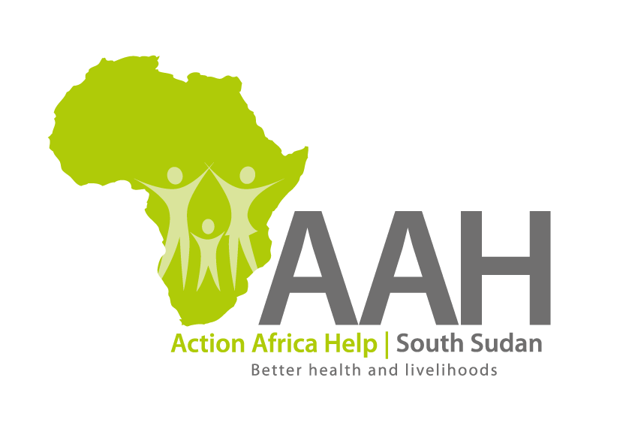
AAHI-South Sudan
Juba Office: Hai Gabat – Opp JIT Supermarket
Behind South Sudan Customs, Tel: +211 925 478 457
Email: ssudan@actionafricahelp.org
Website: www.actionafricahelp.org

INVITATION TO TENDER (RE-ADVERTISEMENT)

Background
Action Africa Help International (AAH-I) is a nongovernmental and nonprofit making Organization operating in South Sudan with a mission to support disadvantaged Communities to sustainably improve their standard of living through Community empowerment approach in partnership with stakeholders. AAH-I implements Primary Health Care, Agriculture, Humanitarian aid projects and Capacity Building.

The organization is calling for quotations from reputable companies for provision of a commercial bull dozier services for reclamation of marram borrow pit in Ajuong Thok.

All the rates quoted in all sections include cost for the provision of services of bull dozier for reclamation of marram borrow pit in Ajuong Thok.All rates to include provision all necessary services of mobilization and demobilization of bull dozer,costs of operator services, costs of fuel, costs of maintenance, any statutory requirements and all other allied costs not mentioned herein.

The bull dozier must be located within Jamjang operations area due to current road challenges.
The deadline for submission is 4th May 2022

More information concerning the bid to be collected at AAHI/UNHCR Juba Logistic base OR AAHI Jamjang Logistic base.

