INVITATION TO TENDER – CONSTRUCTION SERVICES
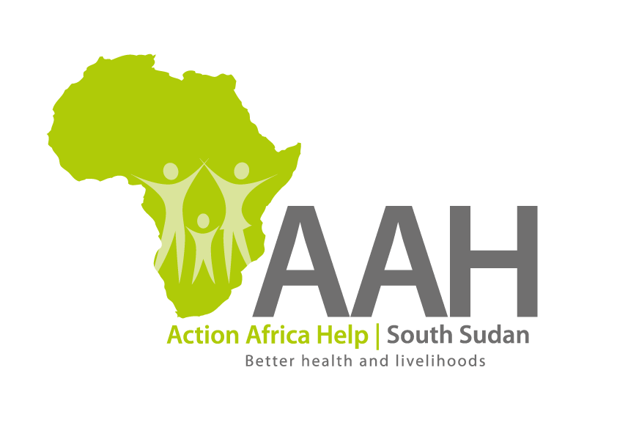
Background
Action Africa Help International (AAH-I) is a nongovernmental Organization and nonprofit making operating in South Sudan with a mission to support disadvantaged Communities to sustainably improve their standard of living through Community empowerment approach in partnership with stake holders. AAH-I implements Primary Health Care, Agriculture, Humanitarian aid projects and Capacity Building.

The organization is inviting bids from competent and reputable construction companies for the following construction services.

 | Description | Remarks
1. | Provision of labour and materials for renovation of oriny PHCU in Fashoda | BOQ to be picked from AAHI Juba Office/Fashoda Office/Manyo Office or to be requested through the following email: procurement.southsudan@actionafricahelp.org
2 | Provision of labour and materials for renovation of collapsed CHD office in Fashoda
3 | Provision of labour and materials for renovation of CHD office in Manyo
4. | Provision of labour and materials for renovation of 7 VIP latrines (Boal PHCU, Orinyi PHCC, Otego PHCC)
5. | Provision of labour and materials for renovation of 6 VIP latrines (Aweth PHCC, Kaka PHCC, Ogon PHCU, Thorgwang PHCC, Omar PHCU and Pen PHCU)
6. | Provision of labour and materials for renovation of Aweth PHCC

More details on the said tenders can be picked from AAHI/UNHCR Juba Logistics base and JAMJANG AAH/UNHCR log base during working hours (Monday to Friday, 9:00am to 11.30am and 2:00pm to 4.00pm)

Deadline for submission of the bids will be on 11th December, 2023 at 12:00pm.

