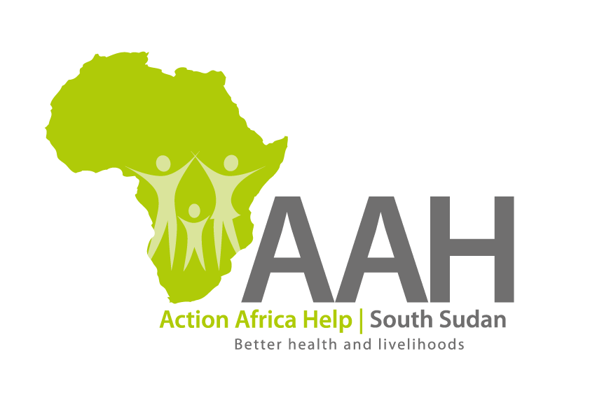
INVITATION TO TENDER

Background
Action Africa Help International (AAH-I) is a nongovernmental and nonprofit making Organization operating in South Sudan with a mission to support disadvantaged Communities to sustainably improve their standard of living through Community empowerment approach in partnership with stakeholders. AAH-I implements Primary Health Care, Agriculture, Humanitarian aid projects and Capacity Building.

The organization is calling for quotations from reputable companies for Supply of cement.

s/n | Item description | U o M | Quantity
1 | Cement (42.5) | Bag | 2400

Requirements

- Price and Currency: The monthly rate shall be in United States Dollars (USD).

- Interested suppliers should submit the following documents together with their quotation.

- Valid registration Certificate
- Valid Tax compliance certificate

- Quotation should be on Company’s letter head

- Must have a shop in Ruweng State

- The supplier should be based in Ruweng state and in a position to supply the cement immediately after the order. Suppliers are requested to give description on the location of the cement.

Important to note: Only suppliers whose cement is located in Ajuong thok or Yida will be considered.

Submission of Quotes
The quotations shall be submitted on Hard copies in sealed envelopes only there will be no submission of quotes in soft copies. Suppliers must adhere to this instruction to avoid inconveniences.

Submission Address

The bids shall be submitted to:

Jamjang AAH-I/UNHCR Logistic Base
Ruweng State

OR

Submission Address
bids shall be submitted to:
AAH-I/UNHCR Logistic Base, Juba South Sudan
Near JIT Supermarket,
AAH-I South Sudan.

Registration for submission:
Please ensure that, you register your hand delivered quotation/bid with the Procurement/Logistics Department and drop it in the bid box yourself, before you leave the Procurement/Logistic department.

Unregistered quotation/bid will not be considered even if it is dropped in the tender box.

Deadline for the submission of the quotation`
The deadline for the submission of the quotes will be strictly on Thursday the 16th December,2021, at 12:00 pm Local Time

Notification of the results
Only the successful and competitive bidder will be notified, and if you do not receive email communication within two weeks after the expiry of the deadline, consider your bid not successful.

Language for the bids
The language for the bids shall be English only.

Disclaimer
This is only a Call for quotations and AAH-I South Sudan reserves the right to either amend or cancel it at any time with or without notice. In such cases, AAH-I South Sudan shall accept no liability whatsoever. The prospective bidder is wholly responsible for any and all costs related to the preparation and submission of their quotations.

The decision of the AAH-I South Sudan Procurement Review Committee shall be final.

