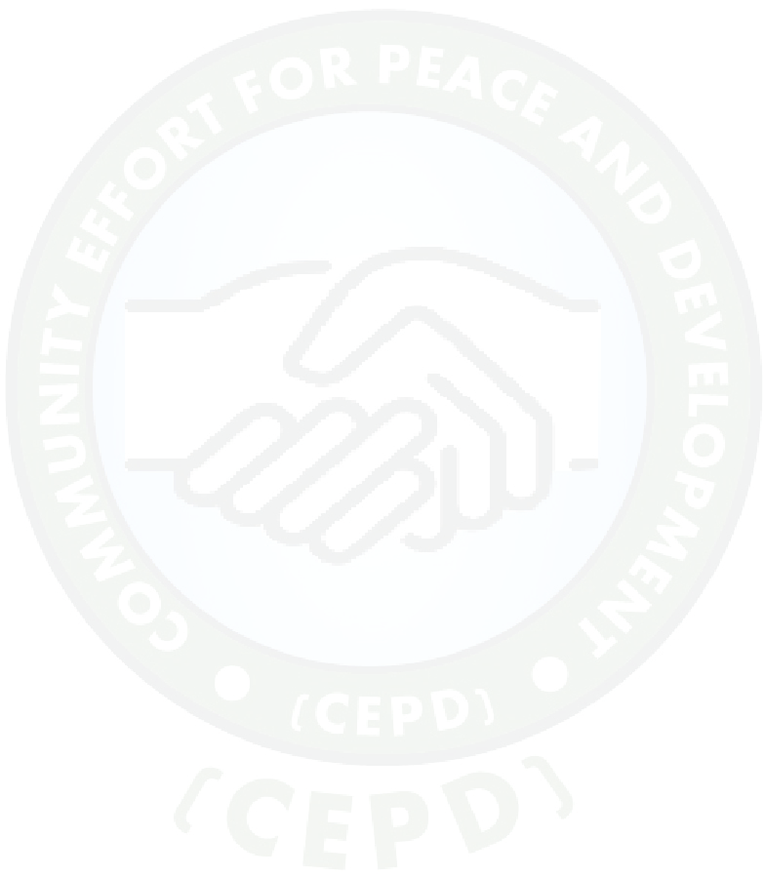  **Date: 18th September, 2017**

TO Interested INGOS/NNGOS.

Re: Request for partnership.

Dear Sir/ Madam:

Community Effort for Peace and development (CEPD) is concerned about the number of scholastic materials that are donated to various schools and are kept in school stores not been distributed to the students, some of these materials such as exercise books, pens etc been destroyed by rates, mates in the stores without meeting its objective in the schools. To address this topic CEPD have suggested to support direct distributions of this scholastic materials into the hands of the students rather than to be kept in the stores by the teachers.

1. The goal of the direct distribution is to ensure students’ have received the materials aimed for them
2. These materials are not sold out in the market but have met their objectives and goals aimed at.

The distributions will be done by CEPD’s team and CEPD will be responsible for their payments

.If your organization champions provision of School materials for schools and already faced this case before, why not partnering with us to do this for you, CEPD have the expertise in this area and would want to work as we don’t have much to do at the moment.

If you think this is worthy an opportunity we would appreciate a chance to discuss this program further with you, just set up a time that would meet your schedule and we meet to discuss the plan further.

Meanwhile you can also take a time to visit our Facebook page at <https://www.facebook.com/CEPDSS/> or visit our website at <https://www.cepd-ss.org> or you can just drop us an Emil: at [etaban@cepd-ss.org](mailto:etaban@cepd-ss.org)



Sincerely,

Pastor. Paul Manasseh

Chairman - CEPD