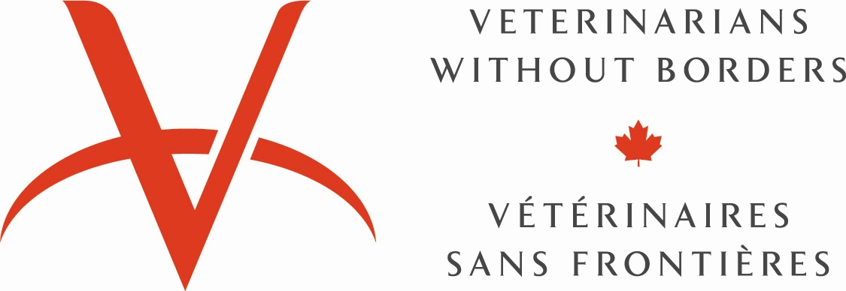 | 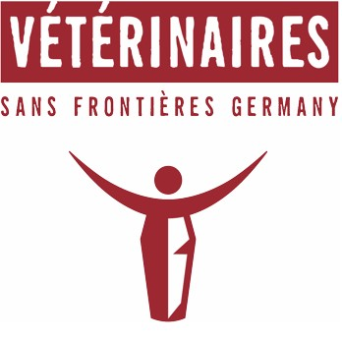 | 

Expression of Interest for Project Engendered Value Chain Analysis

Project Title | VWB/VSF ‘Strengthening food security and livelihoods of vulnerable populations in South Sudan’
Donor | Government of Canada (Global Affairs Canada)
Implementing Partners | VSF Canada in partnership with VSF Germany and VSF Suisse
Grant Contract No. | D-001643

- Overview
VSF Canada, through VSF Germany and VSF Suisse is implementing a two-year project funded by the Government of Canada (Global Affairs Canada - GAC). The project aims to support the livelihoods of vulnerable populations in the targeted areas of Northern Bahr El Ghazal and Warrap States, South Sudan. The project targets directly 11.000 Households (66.000 individuals) in the two project locations. As a food security and livelihood project, it is required that a detailed Engendered value chain analysis be conducted to assess actors, participation, barriers and opportunities for women, men, and girls and boys in the production, marketing process through to the final consumer. This is to identify potential opportunities of mainstreaming gender in the value chain process which requires paying constant attention to the gender perspective at every step, from production to the sharing of benefits, and not only in relation to products and services in which women and girls are dominant but also others where women could expand their participation to increase their economic benefits

- Project Goal (ultimate outcome)
The Ultimate Outcome of the project is to strengthen the food security and livelihoods of vulnerable populations in the target areas. It is designed to increase food production in the short-term to help avert a food crisis that is threatening South Sudan, and it will increase sustainable food production capacity and household incomes from agriculture and fisheries products. The project has three Intermediate Outcomes (Results)
- Result 1: Increased crop/livestock/fisheries production for vulnerable populations (women, men, girls and boys) through improved access to agriculture and fisheries inputs, training and extension services
- Result 2: Increased income from agriculture and fisheries for vulnerable populations (women, men, girls and boys) through improved post-harvest technologies, marketing capacity and facilities
- Result 3: Strengthened capacity of local and regional organizations to protect livelihoods and increase resilience and food security of vulnerable populations (women, men, boys and girls)

- Location of the Survey
The Engendered value chain analysis will take place in both projects’ targeted areas at the same time in the below specified counties:
3.1 Warrap State
- Gogrial East County (Pathuon East and Toch East Payams)
- Gogrial West (Kuac North and Kuac South Payams)
- Tonj North County (Manlor and Awul Payams)
3.2 Northern Bahr El Ghazal State
- Aweil North County (MayenUlem, Malual East and/or Malual Centre Payams)
- Aweil East County (Mangar Tong, Madhol and/or BaacPayams)
- Aweil West County (GomJuer West, Ayath East and/or GomJuer East Payams)
NB: Note all the places project activities will be covered in the assessment. Final locations will be determined by the project teams and consultant’s interest.

- Period and Duration of the Analysis
The whole analysis will be conducted within the period of three weeks starting from the 24 Oct. 2016 to 11th Nov. 2016, of which a total of maximum 21 days with the completion and submission of the final and revised report (including Annexes) no later than 18th Nov. 2016.

- Objectives/Scope of Assignment
Through the study, VWB/VSF is looking forward to determine which farming enterprise and livelihood activities hold potential of better livelihood opportunities, product expansion, market viability, value addition opportunities, quality improvement and input availability for women, men, girls and boys. The study is expected to provide information about extra-market factors such as power relations, division of labor, and control over resources to help make visible the differential contributions and potentials of women and men in a particular economic activity, thereby providing the basis for developing strategies and actions for promoting equitable benefits from the production process. Also to provide information about women’s and men’s roles in the production, processing, and marketing processes for enhancing the skills and upgrading the knowledge of both women and men to increase efficiency in the production process and improve the quality of the product, and, hence, to extract more benefits from the project for all gender groups especially women.

The engendered value chain analysis should help in determining and profiling the most appropriate commodity chains to upgrade in each of these counties and propose a detailed plan of interventions to address the constraints identified among women, men, girls and boys and how to address them

The study would involve conducting a field survey, interviews with stakeholders, market survey and look at the market environment, value chain and market services. It would also involve review and incorporation relevant assessment results from the recent conducted VSF Gender Analysis findings, the baseline survey and the Environmental assessment and relevant Government policies that affect market access, market institutions for credit, transport etc.

The specific objectives of the Engendered Value Chain Analysis include:

The focus of the study is to analyse and document each commodity value chain and livelihood activities which includes chicken, small ruminants, sorghum, groundnuts, vegetable products and fish and other on-going livelihood activities from production through to the final consumer. Specifically, the analysis should:

- Identify all actors in value chains including details on rural businesses and small holder farmers disaggregated by gender;
- Select products and services in which women, men and girls and boys are involved;
- Identify products about which women, men and girls and boys would like to be more involved;
- Determine the involvement of women, men, girls and boys in different steps of the value chain;
- Integrate gender while mapping all steps in the value chain; including main actors - women, men, girls and boys, flows of products, money and information, and supporting organizations;
- Based on gender differential effect, identify the winners and losers in each value chain—who is making most money in the value chain and how can the project help in enhancing equity and the percentage end price at various nodes of the value chain. This will be achieved by undertaking quantitative and qualitative analysis to inform conclusions.
- Identify mechanism to ensure meaningful participation of women, men, girls and boys in the negotiation and decision making process;
- Assess the state of institutions, technology, service providers, policies, and other production conditions;
- Inventory the existing infrastructure, assess its state, its capacity usage, its adequacy or gaps and if there will be a need to invest in additional infrastructure. The analysis must show what type of infrastructure is needed, where it should be installed, by whom and how it could be managed and sustained;
- Detail the constraints at each value chain encountered by the different gender groups;
- Identify the gender gaps in the value chain;
- Indicate actions to address each constraint/gap or investments needed to overcome these constraints among different gender groups;
- Indicate the benefits of addressing major constraints in terms of project results among gender groups;
- Assess the potential difficulty in overcoming each competitive constraint in a sustainable manner;
- Construct scenarios of the economic impact (change in market share, increased incomes, profits) that the proposed changes would have among the gender groups;
- Identify key policy constraints limiting particular gender groups from benefiting;
- Develop detailed recommendations and specific value chain interventions on how to upgrade the selected value chains and maximize VSFs project impact;
- Assess the resources, skills and capacities of farmers related to procurement of inputs and production of target crops/ livestock;
- Assess the existing market situation and nature of bargaining taking place between different market players’ women men, girls and boys in the study area (relationships, attitudes and behaviors);
- Analyse the capacity of farmers and their groups or organizations to access services, credit, information and resources;
- Suggest improvements in the value chain system to ensure direct linkages of the farmers with the major markets and increased incomes from their produce and/or livestock.

- Methodology
The consultant shall select the most suitable methodology to conduct, analyze and present, initially as a draft, the proposed approaches to the assignment to the VSFs. VSF staff may be accessed for direct data gathering in coordination and in accordance with their project work plans. The consultant will be in the position to peruse through all the handouts and any available information from the VSFs and local counterparts concerning the project and the assignment.

- Output of the Assignment/Deliverables
The consultant is expected to provide a draft/preliminary and a final report with annexes. The final report will be of a maximum 25 pages (including all annexes); the format of the report will be shared and discussed directly with the CDs and the VSFC Program Manager, Gender specialist, field Team Leader and Area Coordinator. The final report will address the objectives and topics described in the paragraphs above, giving special attention to the overall data analysis and recommendations for current and future similar food security interventions. The report shall be presented in both hard and soft copy. The consultant will also complement electronic reports with visual images from the results of field assessment tools, include photographs or other materials that visually illustrate gender equality differential effects as a results of the project.

The following deliverables are expected from the consultant:
- Methodology and appropriate data collection tools;
- Preparation and presentation of the inception report prior to field work;
- Field study in the respective states/Counties/Payams;
- Debrief of the team on the progress of the study;
- Two stakeholder workshops including presentations on the proposals for upgrading and introducing innovations into each value chain based on gender;
- A final report that addresses these terms of reference for each of the selected value chains.

- Qualifications/Necessary skills and Experience of the Consultants
- A post-graduate degree in Business Administration, Social Science, Economics or other relevant field of study;
- Alternatively a training in the field of Gender and development , food security or market based approaches to livelihood programming;
- At least 5-10 years’ experience in conducting similar studies
- Ability to work in a team;
- Proven track record and ability to liaise with many different groups at different levels; including policy makers, grass-root civil society organizations, field workers, technical experts; etc.
- A broad knowledge on food security and livelihood programs in relation to gender equality and female empowerment;
- Conceptual and analytical skills;
- Knowledge of participatory approaches and tools;
- Fluency in English is a must, Arabic an asset;
- Excellent time management skills, with an ability to deliver high-quality outputs on time;

- How to Apply
Interested and qualified professionals (individuals, Consulting Agencies, Firms or Institutions) should submit their technical proposal not exceeding 15 pages on or before 17th Oct. 2016, which should include the following:
  - Technical Proposal (including detailed Work plan sequencing events and activities;
  - Methodology (Develop and demonstrate a good understanding of engendered value chain analysis Methodology);
  - Financial Proposal (An itemized and detailed budget, indicating the unit costs for consultancy fees in ($);
  - Profiles of Firm/Consultants/Key personnel together with their qualifications and experience, (CVs) and Introduction Letters;
  - References (including a list of previous work).

The documentation requested above shall be sent via e-mail to: johnbosco@vetswithoutborders.ca cc careers@vetswithoutborders.ca

- Deadline for Applications 17th of Oct. 2016
Notes:
- Please DO NOT send original documents and/or heavy attachments.
- Additional information will be required only in case of pre-selection and short-listing.
- Applications will be assessed on a continuous basis and once a qualified individual or institution is identified the opportunity will be closed.

