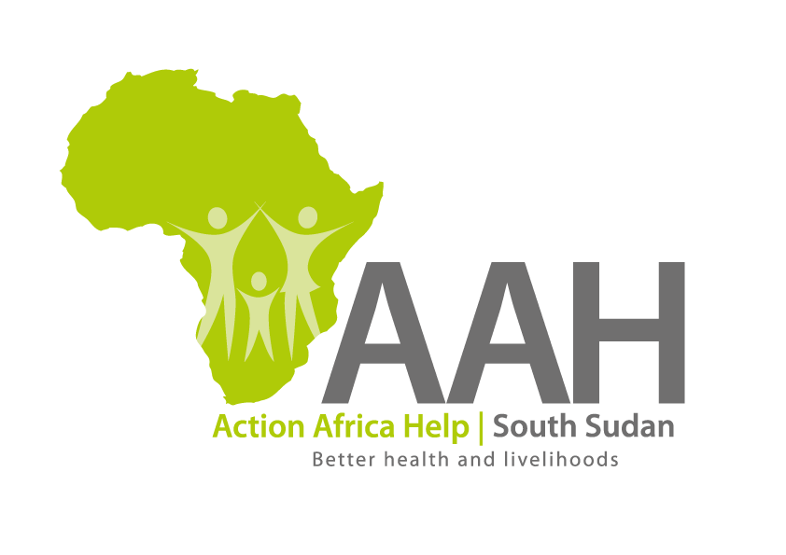
Call for Pre-qualification of Suppliers and Service Providers
Re-advertised

- Introduction

The Action Africa Help International (AAH-I) South Sudan is calling for applications for pre-qualification from competent and qualified suppliers and service providers for the provision of various categories of goods and services. The pre-qualification will be followed by a Request for Quotations (RFQ), Invitation to Bid (ITB) and/or Request for Proposal (RFP) which may result in Long Term Agreements with the successful bidders.

Companies that wish to participate in the process are required to complete the application forms indicating the categories for which the applications are being submitted. In addition to requirements in the pre-qualification application form, the interested applicants must provide the following documents/information:

- Mandatory documentation and information:

- Certificate of registration of business (in Country where company was registered)
- Revenue Authority Tax Registration Certificate (Indicating TIN)
- Tax Clearance Certificate (Must be Valid for the period ending 31st May 2015, or later)
- Certificate of registration with South Sudanese Chamber of Commerce (for South Sudan registered companies)
- Valid Operation and/or Trading Licence (whichever is applicable)
- Articles and Memorandum of Association (complete document)
- Audited Accounts for at least the last three years indicating the annual turnover (in case of a Joint Venture or Partnership, Audited Accounts of one of the principle partners will suffice)
- Official Business physical, postal, telephone and email addresses
- Proof of Business Insurance and workman’s compensation or GPA (where applicable)
- Certified Bank Statement for the period ended 31st June 2015
- Reference and recommendations from at least 5 present and 5 past clients
- Submission of applications:

- Hard copy submissions: AAH-I/UNHCR Logistics Base,
Hai Ghabat,
Juba Town, Near JIT Super Market

- Soft copy submissions: procurement.southsudan@actionafricahelp.org

It is the responsibility of the applicant to ensure that the online submission is successfully delivered; AAH-I South Sudan shall not accept any responsibility for the failure of the applicant’s email submission.

- Labeling and marking of submissions:

Hard Copy Submissions MUST be contained in a Single large Envelope clearly labeled “Application for pre-qualification as a Supplier/Service provider (whichever is applicable)” and MUST indicate the category for which you are applying. For online submissions, you MUST indicate the purpose of your submission (“Application for prequalification as a Supplier/Service Provider (whichever is applicable, and the specific category for which you are applying)” in the subject line of the email. All attachments MUST be submitted in PDF Format and Zipped in one folder. You may submitted several emails in the event that your attachments are bulky, in which case you should clearly advise in the body of the email thus “ part 1 of xxxx” (where xxxx is the number of emails). Any online submission/email which does not indicate the purpose (application for prequalification) in the subject line shall not be considered.

- Deadline for request for clarification and submission of documentation:

Any requests for clarifications should be made in writing only and addressed to the Procurement Coordinator at the following address: pmukisa@actionafricahelp.org and copied to: aagono@actionafricahelp.org; mleoba@actionafricahelp.org . Any request for clarification MUST be received before or not later than 15th April 2016, 11:00am (East Africa Standard Time). Feedback will be given not later than 18th April 2016 by email only.

The closing date for submitting a complete pre-qualification application form is
20th April 2016, 1600hrs, East Africa Standard Time.

- Accessing the prequalification forms and details:

Detailed pre-qualification application forms are available at the following website: www.actionafricahelp.org

- Selection criteria:

ONLY companies that fully and satisfactorily meet the requirements listed in Section 2 above (Mandatory information and documentation), the Vendor Prequalification Form and any other criteria which the Procurement Review Committee shall deem necessary for this purpose, shall be pre-qualified and shall be invited to participate in the subsequent bidding process.

- Feedback to successful/unsuccessful applicants:

A list of successful applicants will be drawn and posted on the AAH-I website (www.actionafricahelp.org) and at AAH-I South Sudan Offices in South Sudan and successful applicants will be advised by email within six (8) weeks from date of closure of receipt of applications.

In case you submit an application form for pre-qualification but don’t hear from us after 8 weeks of the closing date, please consider your application unsuccessful; no separate or individual communication to this effect shall be made by AAH-I South Sudan.

