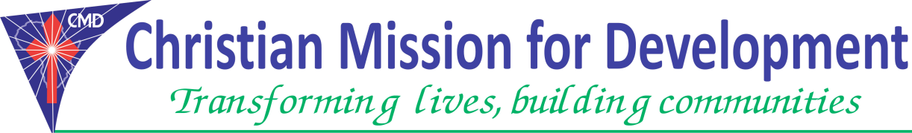
Position : | Nutrition Field Officer
Job Location: | Juba and Jonglei State-Ayod County
Reporting to | Nutrition coordinator.
Starting date | 1st March 2018

OVERALL DESCRIPTION.
About CMD:
Christian Mission for Development (CMD) is a registered non-profit, non-governmental, multi-sectoral relief and development organization dedicated to fighting poverty and injustices; and to enhances provision of holistic social services to reduce human suffering. CMD works with others to reach hard-to-reach areas with very little or no basic services and significantly in regions brutally hits by wars, poverty, extreme hunger and illiteracy. Over the past years, the organization has increased its capability with an increase in staff, partners and volunteers to match the increase in its programs and projects as it spreads widely to different parts of East Africa region.
General Description of the Role
In coordination with other OTP/SC staffs (Clinical officer, Nutrition nurses, Nutrition assistants), provide support in nutrition activities including screening, activity implementation and monitoring.

Key Duties
Job responsibilities:
The role of the Nutrition Officer is to conduct all Nutrition activities and provide support to Nutrition Coordinator and ICCM Program Manager in program operational areas. He/she will particularly work with the Nutrition Coordinator and ICCM program Manager.
- Support ICCM/Nutrition trainings, workshops at the counties/county level and community level, but is not limited:-
- Take patients history on admission, conduct clinical/malnutrition examination and administer treatment
- Screen all patients with malnutrition status admit all malnourish children under 5, provide nutrition care and follow up cases according to the nutrition guidelines and protocols.
- Fill the Outpatient Therapeutic Program (OTP) and Stabilization Center patient’s registers, record cards; provide overall Nutrition programmatic support to Nutrition Coordinator or ICCM Program Manager on daily management of Outpatient Therapeutic Program (sites) and stabilization care unit.
- Work closely with Health facility in-charges, CHD SMOH, Nutrition department on the establishment of OTP/SC sites in the areas of operation;
- Provide Nutrition treatment with supplementation medicines as per the guidelines and protocols.
- Ensure complete assessment, anthropometric of CMAM/SAM cases in children under 5 years old.
- Monitor, analyze and participate in writing weekly reports to provide Nutrition (CMAM) updates and progress
- Supervise and manage Nutrition Community Volunteers (NCV’s) to ensure effective and efficient implementation of CMAM/SAM programme in operation areas.
- Prepare and submit timely progress reports on CMAM/SAM activities to relevant Managers.
- Represent CMD organization in Country participating in Nutrition Cluster meetings with partners and stakeholders and maintain excellent relation with State, County Ministry of Health Department of Nutrition.
- Able/knows procedure of requesting nutritional foods and non-food items (NFI’s) or products and ensure complete accountability of all Plumpy Nut,RUFT supplies
- Responsible for the capacity building of department staff on Nutrition related topics
- Flexible in doing any task assigned by the Nutrition Coordinator/supervisor or child survival program manager as sees fit.
Other Duties
- Attend meetings, workshops and training as required.
- Disseminate knowledge and skills to clinic staff
- Report any challenges to the Clinical Officer and/or CHD and partner
- Maintain CHD/CMD’s good reputation through your work.
- Assist in any other area of CMD/MOH activity as assigned by Clinical Officer in charge and/or CHD/partner
Requirements (Person Specification)
- He/she must be a south Sudanese national
- Should be a diploma holder in Nutrition and food technology or certificate in comprehensive Nursing
- Should be fluent in both English and Arabic languages.
- Should be at least having 2 years’ experience in working with NGO in Nutrition related programme.
- Should have experience in community mobilization, training, facilitation and excellent communication skills and the ability to cooperate with others as part of the team.
- Should be willing to work independently through line management under supervision
- Should have excellent written and verbal communication skills and the ability to cooperate with others as part of the team
- FEMALE CANDIDATES ARE ENCOURAGED TO APPLY.

Submission on or before: 28th February 2018

CHRISTIAN MISSION FOR DEVELOPMENT JUBA-NABARI.

TONGPINY RESIDENTIAL AREAS – OPP CATHOLIC UNIVERSITY.
Email: hrcmdsouthsudan@gmail.com. cmdsouthsudan@gmail.com,

