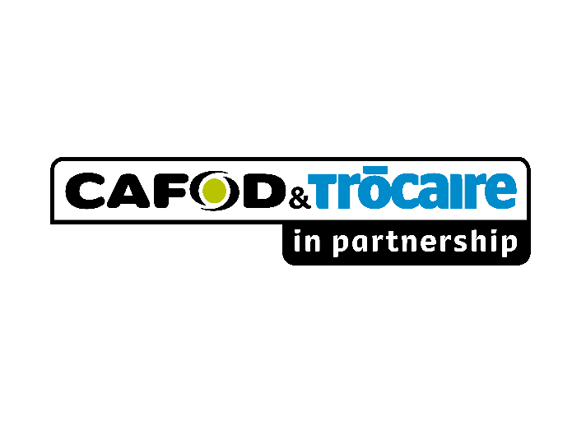

|  |  |
| --- | --- |
| **Project evaluation - Consultancy Terms of Reference** | |
| **Dates** | April 2018, 20/21 days evaluation consultancy in total, including preparation, data consolidation, analysis and reporting |
| **Agency** | Catholic Development Office (CDO) – Maban & Renk, South Sudan |

1. **Background**

Catholic Development Office is the Relief and Development wing of the Kosti Pastoral region, Catholic Archdiocese of Khartoum. CDO is autonomous and was established to cater for the needs of people in Renk and Maban Counties of Upper Nile State. Since its establishment, CAFOD/CTP have been a partner to CDO, supporting their humanitarian interventions in the two areas.

CDO have been implementing CAFOD/CTP supported projects since 2007, after the signing of Comprehensive Peace Agreement (CPA). First, it was supported to implement an Emergency Response programme focusing on WASH and NFIs in Maban in from 2007 - 2009. Then the implementation of a 3-year (2010 – 2013) Livelihoods program titled: “**Recover, Reintegration, and Sustainable Livelihoods Program for South Sudan”** in both Maban & Renk. Mid-term evaluation for this program was conducted in 2013 and the evaluation report is available. This was called Mid-Term evaluation because the programme was implemented by other partners in other regions extending to 5 years. However, for CDO this could be considered end-of programme evaluation because its programme was only for 3 years.

CDO then embarked on the implementation of another 3-year (April 2013 – March 2018) Livelihoods program (currently subject of evaluation) in title: **Improving Food, Nutrition & Livelihoods Security of women and men, including PLWHA in Maban County.** This time round, the project was supported by CAFOD & Trocaire in Partnership (CTP).

1. **Purpose**

Catholic Development Office (CDO) is looking for a reputable consulting individual with professional expertise in undertaking project evaluations to evaluate its Projects in Maban and Renk, Northern Upper Nile State, South Sudan. CDO have been implementing CAFOD & Trocaire supported projects in the two areas since 2007. However, the recently implemented projects have been the Livelihoods project in Maban 2016/17 and 2017/18, and WASH project in Renk 2016/17. The purpose of this evaluation is therefore to document lessons learned (could be negative or positive) and to present the findings to the stakeholders (CDO and CTP) to enable them make decisions in future.

***NB: All project documents (proposals, log frames, reports…etc) are available in project files and will be provided to consultant for review as secondary data.***

1. **Evaluation methodology**
   1. **Proposed evaluation design:** Before developing the evaluation plan and guideline for interview, the consultant will need to study all important project documents ranging from the base line study report (actually it is a need assessment report), project document/proposal, project annual plans and reports, and analyse the logic relation between the need of and major issue faced by the villagers in their livelihood, the project strategy and approach, and the project objectives and outputs as well as their measuring indicators. Based on this understanding and analysis, the consultant will then follow the evaluation ToRs requirement to base his plan and guideline on the outcomes and outputs and their measuring indicators as specified in the logic framework.
   2. **Data sources:** Evaluation data will be gathered from the following groups/institutions and or individuals:

* Village representatives in respective project locations (Payams).
* Payam administrators
* Women representatives in project locations.
* Representatives from the county Relief & Rehabilitation Commission (RRC)
* Representatives from the county agriculture department.
* Parish development committees
  1. **Evaluation Ethics:** The evaluation will be guided by the following ethics:
* Guarantee the safety of respondents and the research team.
* Apply protocols to ensure anonymity and confidentiality of respondents.
* Ensure any other evaluation team members are briefed on ethical issues.
* Provide referrals to local services and sources of support for women that might ask for them.
* Ensure compliance with legal codes governing areas such as provisions to collect and report data, particularly permissions needed to interview or obtain information about children and youth.
* Store securely the collected information

1. **Key Deliverables of the evaluator and timeframe**
   1. **Evaluation inception report:** The evaluation inception report will be presented 5 days after the signing of contract by the consultant. The consultant Is expected to present in this report, his methodologies, tools, expected outcome, outputs …etc. In this inception report, stakeholders will have an opportunity to make inputs and adjust the document where those adjustments are needed. The following two methods are however recommended to complement the findings. **DAC Criteria** (Relevance, Effectiveness, Efficiency, Impact and Sustainability) and **BOND Evidence Principles** (Voice and Inclusion, Appropriateness, Triangulation, Contribution, Transparency).
   2. **Draft evaluation report:** The consultant will be required to produce draft evaluation report for comments/inputs and or deletion of some areas by the stakeholders before the final evaluation report is finalised. The draft evaluation report will present preliminary findings of the evaluation
   3. **Final evaluation report:** This will be the detailed and last report to be produced by the consultant after gathering the views, comments and inputs from all the stakeholders.
   4. **Presentation of findings:** CTP and the partner CDO will organize a stakeholder meeting that bring together key personnel from both partners. The consultant will then be required to present the key findings in this meeting/workshop.
2. **Required competencies**

* Demonstrated experience in project evaluations, and writing report (sample of the previously evaluation reports could be requested);
* Training and facilitation skills;
* Good English, oral communication and written skills;
* Good knowledge of Arabic (spoken) – given the cultural background of the two areas.
* Ability to work in a difficult context;

1. **Proposed timeline of the evaluation process**

|  |  |
| --- | --- |
| **TYPE OF WORK/ACTIVITY** | **NUMBER OF DAYS** |
| Data consolidation | 2 |
| Preparation | 1 |
| Travel | 2 |
| In- the field (training, enumerators, data collection and debriefing) | 10/11 |
| Report write up (including consolidation of comments + summary presentation) | 5 |
| **TOTAL** | 20/21 |

**The evaluation is expected to start on May 14th, 2018.**

1. **Annexes**
   1. Key stakeholders to be consulted

* RRC County director, Maban & Renk Counties
* CDO interim Coordinator
* Director, County Agriculture Department – Maban/Renk
* Director, Country Department of Cooperatives – Maban/Renk
* Community leaders in project locations
* Project beneficiaries
  1. **Documents to be consulted**
* Needs assessment report
* Project proposal
* Project budget/work plan
* Project reports (Financial/Narrative)
* Beneficiaries registration lists
  1. **Required structure for the inception report**

The Inception Report is expected to respond to these requirements:

* Describe the activities during the inception phase and key issues which were discussed between consultant, counterparts and beneficiaries.
* Give information on the final project model, as formulated jointly in the inception phase. In this section an overall work plan is presented, as well as suggestions for human resources inputs and project management
* Provide detailed plan for the activity (evaluation), specified per expected results. Logical framework and Gantt chart are expected to be incorporated.
* methods for the study

1. **Resources Required**

CTP/CDO will provide the following resources:

* Vehicle and the driver for field visits (own)
* One project staff to support the consultant
* Community mobilization in the field
* Facilitation of focus group discussions where language is a burrier
* Air travel to and from Maban & Renk
* Where appropriate, accommodation in the field

1. **Management arrangement**

The whole process will be supervised/managed by CTP Livelihoods Programme Officer, based in Juba in consultations with CDO administrator based in Kosti, Sudan.

1. **Applications**

Applicants CV and cover letter mentioning availability and daily rate to jobs_sudan@cafod.org.uk, with “CTP/CDO End-of project evaluation” as subject line. Considering the emergency of this position, applications will be reviewed as they are being received. The applicant will include in the application the following important documents:

* 1. Technical offer
  2. Financial offer
  3. Example of similar work in South Sudan