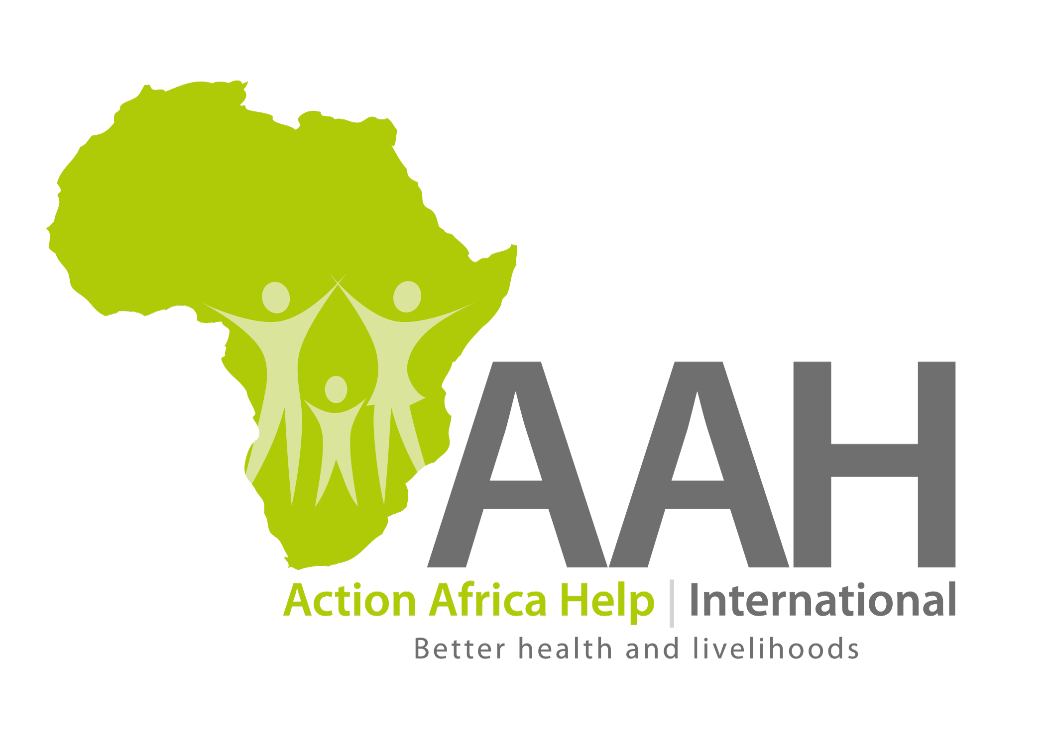

JOB OPENING

Country Director, South Sudan
April 2018
Job Title: Country Director
Grade: AH 2
Reports to: Executive Director and AAH Sudan Board
Supervises: Programme Manager; Country Finance and Administration Manager; Human Resource Manager; Procurement Manager
Liaises with: AAH-I Directorate, AAH South Sudan National Board, Donors in the country, Government Authorities, Agency representatives as well as other stakeholders in South Sudan to ensure appropriate mechanisms of efficient coordination are in place and adequately functional.
Duty Station: Juba
Purpose of the role: To implement AAH South Sudan’s strategic goals and objectives. To provide leadership to the AAH South Sudan programme team towards advancement of AAH-I’s mission, philosophy and country programme goals and objectives in a complex, active conflict setting.
Duties & Responsibilities
- Programme Development and Management:
With overall responsibility for programme development and management, works in consultation with the AAH-I Directorate and the AAH South Sudan Country Board to develop the country strategy in line with the overall AAH-I strategy. Keeps abreast of the country priority development areas and ensures that the country strategy addresses them so that AAH-SS remains relevant to its stakeholders. Takes the lead in identifying new projects and gap areas in existing projects with a view to soliciting new funding. Ensures that programme and project activities outlined in the overall AAH-I and AAH South Sudan Country Strategic Plans and donor contracts are effectively implemented in accordance with contractual obligations and AAH-SS’s goals and mission. Ensures that the quality of AAH-SS programs and services delivered is continuously improved upon.
- Human Resource Management:
Effectively manages the human resources of the AAH South Sudan programme according to the approved HR policies and procedures, and ensures that AAH-SS fully conforms to the South Sudan labour laws and regulations. Effectively manages the programme team and partners by setting performance targets and continuously monitors to ensure the attainment of the programme objectives and country strategy.
- Financial Management
Has an oversight responsibility to ensure appropriate management of the AAH South Sudan programme budgets in compliance with both AAH-I’s and Donor policies and procedures and ensures the agreed reporting deadlines are fully complied with. Works with the team to draw up annual work plans and budgets for the country and seeks AAH-I Directorate approval and monitors implementation.
- Risk Management
Take leadership in developing and executing action plan to resolve audit findings in an agreed and timely manner; undertake appropriate reporting of audit results and actions to the Board and Directorate; Ensure maintenance, monitoring and reporting of a sound Risk Management System for the Country Office, including implementation of the Security Policy.
- Representation
As the senior staff in South Sudan, advocates on behalf of AAH-SS’s operations in the field and maintains a strong profile of the organisation in appropriate coordination and other external fora. Works with the Team Leaders in deciding on the development network the programme should invest time in. Represents AAH-SS with Local Authorities, Donors, and NGOs fora and assists in the management of both internal and external communications.
Expected Outcomes
            - Create a shared vision among all staff on programme/project objectives, and ensure that their role in achieving these is facilitated
            - AAH South Sudan Country Strategic Plan in line with the overall AAH-I Strategic Plan is regularly reviewed, implemented and monitored.
            - Programme and project annual and quarterly operational plans developed, regularly updated and followed.
            - Agreed AAH-I institutional policies, systems and procedures are followed in all country programmes and projects.
            - Overall coordination, networking and strategic partnerships to programme implementation established and made functional.
            - Oversight responsibility for finance management and systems compliance to AAH-I guidelines, donor requirements and locally applicable laws and procedures.
            - Programme and project monitoring and evaluation (based on programme and project indicators) regularly carried out, and timely reporting (monthly, quarterly and annual) to the Directorate, the AAH South Sudan Board, donors, and important stakeholders ensured.
            - Appropriate programme documentation and reporting systems further developed and implemented.
            - In-country contacts with existing donors and potential new donors maintained/explored and funding proposals in support of existing and/or new projects developed in consultation with the AAH-I Directorate.
Professional qualifications
- A Master’s degree in the social sciences, or other relevant area, with significant experience in humanitarian relief and either public health or development projects management.
Minimum relevant experience required
- Proven track record of leadership, with at least 10 years progressive senior management experience, supervising complex programs funded by major multilateral or bilateral donor agencies;
- A very good understanding of the three AAH‘s main programme sectors; public health, food security/livelihoods and humanitarian emergency.
- Proven ability to design and write competitive project proposals for major institutional donors.
- Ability to provide strong project M&E support and oversee donor reporting.
- Substantial knowledge and experience of effective financial and budgetary control and supporting projects to stay on course with implementation.
- Exceptional general management and communication skills, including ability to communicate effectively with people of varied professional and cultural backgrounds.
Additional Skills & Competences
- Commitment to promote AAH-I’s Vision, Mission and its strategic goals
- Demonstrated leadership in strategic programme and project development, implementation, and evaluation;
- Proven track record in resource mobilization;
- Networking and representational skills;
- Inspiring leadership with excellent communication and interpersonal skills;
- Able to set up and lead humanitarian emergency response
- Able to cope with demanding work situations.
Application Instructions
Interested candidates should email application letter and CV (with 3 referees) addressed to recruitke@actionafricahelp.org to be received by 4th May, 2018. The email Subject Line must show the job title of the position applied for. AAH-I is an equal-opportunity employer. We thank candidates for their high interest in the opportunities we publish on our website. Due to the high number of applications we receive, we will only get back to shortlisted candidates.

