Drawings of shallow wells
Pictures
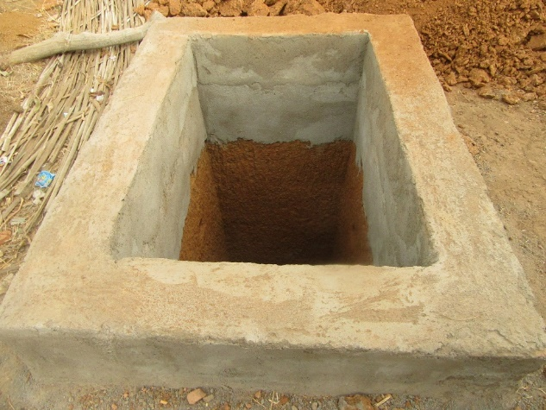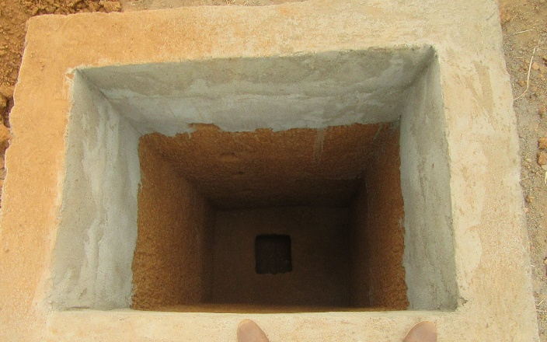

Sketches
Cross section through top layer: Cross section through rocky layer:

<-----1.5 m ------------>
X
X
<------------2 m------------------>
X
X
<-----1.5 m ------------>

<----1 m------->
<----1 m------->
<-------1.5 m----------->

Cross section X-X
Rim 50 cm above ground
Apron around the well: 1 brick high and about 30cm wide
Ground water level
Estimated depth 12 m
Rocky underground
Top layer 1 – 2 m

Legend:
Top layer
Liner/ rim
Rocky underground
Water
Timber
GI pipe with handle
Cover
Hinges
Pad locks

Lever:
<-------1.5 m------------>
<-----1.2 m ------>
<0.3m>
<-----1.4 m ---------->

Cover:

<0.5m>
<------------2 m------------------>

<-------1.5 m----------->

