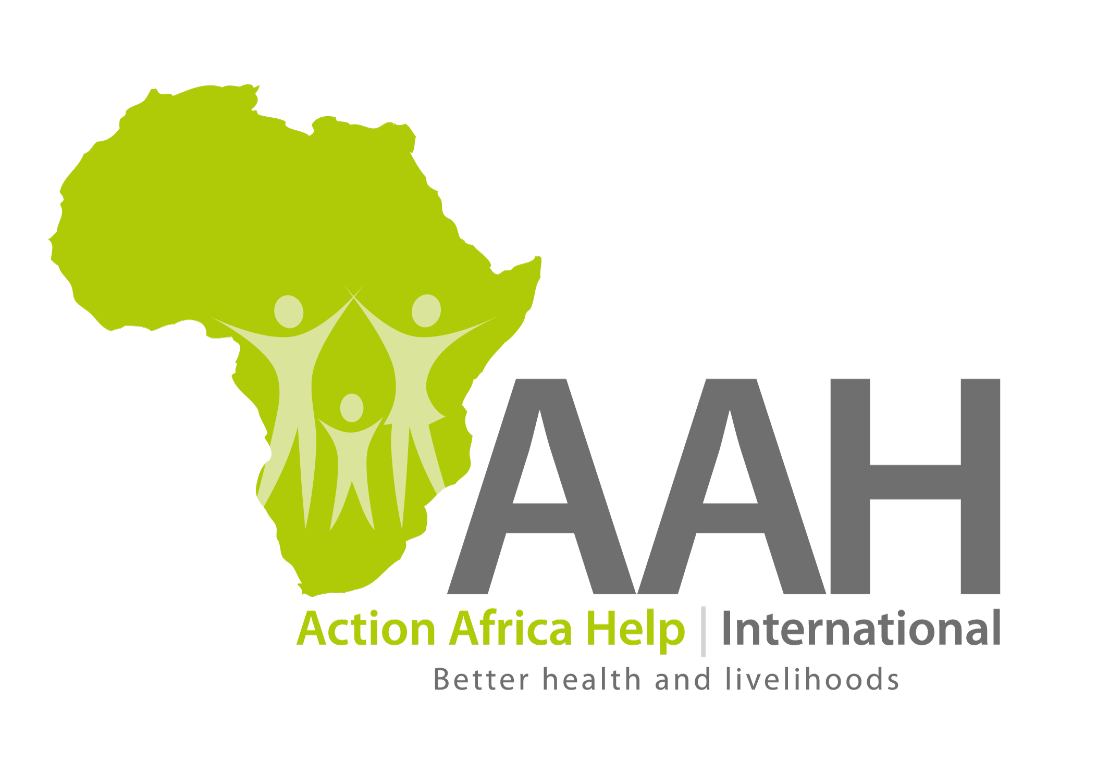

JOB OPENING

Health Project Manager

Job Title: Health Project Manager

Reports to: Head of Health and Nutrition Sector. Externally-working with the State Ministry of Maridi and Amadi States, State Ministry of Health and CSOs in Maridi and Amadi States.
Duty Station: Maridi.

Action Africa Help International (AAH-I), is an international non-profit making agency that implements humanitarian relief, recovery and development projects in Africa, with over 31 years’ experience in implementing Health Programs in South Sudan. AAH-I with funding from Bread for the World is supporting the Regional Primary Health Care Project and Maridi School of Nursing and Midwifery (MSNM). Since its’ inception in 1992, Maridi School of Nursing and Midwifery has trained over 900 graduate nurses and midwives who are serving the rural communities in providing quality healthcare.

Job Summary:
The Health Project Manager serves as the principal AAH-I’s representative in Maridi and Amadi States and provides comprehensive technical and administrative leadership and guidance in planning, implementation, reporting, monitoring and evaluation of Primary Health Care service delivery, Nursing and Midwives Training and other projects in project area. The position is also responsible for developing and implementing PHC and Maridi School of Nursing and Midwifery’s capacity building interventions in the region of operation; he/she ensures and maintains cordial and trustful relations with State Governments of Maridi and Amadi States, State Ministry of Health and County Health Departments in both States through effective participation in State coordination meetings, participation in State Planning meetings, etc.

The person will provide advice and assistance to all AAH-I’s programming and related grants, contracts, and activities. The person will need to understand the political environment surrounding health and development parameters and find ways to diplomatically navigate and succeed in it. The person must be highly motivated and creative in searching for, proposing, and obtaining grant and other types of funding to support health and other activities. The person must be proficient at grants and project management, budgeting, program design and development, and review and evaluation. He/She will supervise health and other program staff as assigned. He/She will assess staffing needs, create job descriptions, advise Executive Leadership on staffing needs and how they serve health mission of AAH-I in South Sudan. The person will do strategic relationship development and maintenance. The Health Project Manager also will be responsible for grant compliance, building the AAH-I’s health programming and other development portfolio.

Duties & Responsibilities
Key responsibilities:
- Programme Implementation
- Ensure RPHC, Maridi School of Nursing and Midwifery College and other related projects’ work plans are effectively implemented in close collaboration with the CHDs/ SMOH, ensuring that agreed upon reporting deadlines are fully complied with
- The incumbent will provide managerial level support to the Tutor in charge of the Maridi Nurses Training School.
- Serves as the AAH-I’s health and other projects’ representative in dealings with County and State governments and with various public, nonprofit, and private organizations, agencies, and institutions.
- Maintains currency in advancements in the health field and other programming areas and accurately projects the impact of these changes on programs in the States of Maridi and Amadi States
- Conducts grant/contract assessments and prepares reports necessary to program continuity and reporting. Monitors compliance with grant/contract requirements. Identifies problems and negotiates corrective action concerning programmatic issues and basic budgetary management.
- Plans, promotes, and develops health projects and other programs by stimulating activity and providing leadership.
- Develops budgets, staffing plans, and action plans to ensure proper personnel, facilities, and supplies to meet grant/contract deliverables and reporting.
- Provides technical assistance, consultation, and guidance to staff, CHDs and State authorities, agencies, health and other programmes related to AAH-I, collaborating organizations, research entities, and institutions to develop, extend, and improve health studies, programs, systems, infrastructure, strategies, and services.
- Assists with the development and implementation of effective communication strategies to disseminate health and program information in collaboration with Head of Health and Nutrition Sector, Regional Communications Specialist, Quality Assurance team and other entities as needed.
- Performs work related to the initiation, administration, and close-out of contracts, grants, or cooperative agreements.

- Financial Management
Has an oversight to ensure proper management of programme budget and compliance with donor contractual requirements and AAH-I policies and procedures.

- Representation
Represents AAH-I with local authorities and in health coordination forums (meetings) at regional level, and assists in the management of both internal and external communications at regional level
- Resource Mobilization
Take field level leadership in mobilization of resources through gathering data, information, partnership building and all the necessary field level support for proposal writing.

Specific roles/duties.
- Ensure that the RPHC, MNTS and other projects remain within the scope of its modified design, budget and purpose and fully complies with donor contractual requirements.
- Oversee operational budget and purpose and fully complies with donor contractual requirements.
- Ensure management systems in support of project implementation are adequately functional.
- Facilitate the M&E system (DHIS) in support of project implementation and ensure adequate functionality.
- Ensure there is a regular documented meetings for all stakeholders to discuss work plans, and assess performance based on agreed upon benchmarks including county coordination meetings and Programme Management Team Meetings (Meetings)
- Ensure management reports and donors progress reports (both monthly statistical and narrative as well as quarterly progress reports) are prepared and submitted on time.
- Ensure that appropriate plans are in place for dealing with emergencies, and provide leadership to staff in handling emergencies.
- Identify bottlenecks to project implementation and take appropriate remedial action.
- Representation of AAH-I in official forums at county and state levels.
- Participation in AAH-I internal management meetings and other coordination for both within and without the country.
- Participate in drug management and capacity building on that line
- Any other relevant duties that may be assigned by immediate supervisor from time to time.

Level of Authority
- Represents AAH-I in official functions and coordination meetings at State level.
- Coordinate activities with other interventions implemented by AAH-I in the region.
- Manage and appraise staff directly reporting to her/him
- Can hire and discipline (including recommendation of termination) of AAH-I staff.
- Recommend termination of contracts of subordinate staff on disciplinary grounds or performance related issues.
- Overall responsible for allocation and management of project as well as AAH-I resources.

Expected Results
- Monthly activity schedules and quarterly work plans are developed regularly updated and adequately implemented in line with the Joint Counties/States Work plans.
- Agreed AAH institutional policies, systems and procedure are followed at project level.
- Create a shared vision, among all staff, on program objectives and their respective roles in achieving program targets facilitated.
- Support and guidance to staff under his/ her direct supervision is provided to facilitate adequate project implementation and achievement of desired targets.
- Overall coordination, networking and strategic partnerships to program implantation established and made functional.
- Oversight responsibility for finance management and system compliance to AAH-I guidelines, donor requirements and locally applicable laws and procedures.
- Program monitoring and evaluation (based on agreed indicators) regularly carried out, and timely reporting to important stakeholders ensured.
- Appropriate program documentation and reporting systems further developed implemented.
- Mutual and trustful relations with State, CHDs and SMOs as well as Governors’ Offices and other key stakeholders including the community established and sustained.
- Support to CHDs, SMOHs, other Government Departments to investigate any investigated any reported disease outbreaks provided (including regular morbidity surveillance reporting based MOH tools.
- Ensure the Maridi Nursing and Midwives Training School’s operations are well supervised and supported.

Key Performance Indicators (KPI’s)
- Timely Reporting
- Reports (both management and donor) submitted on time.
- Overall 80% implementation rate of work plan in accordance with the set out time frame.
- Numbers
- Number of county coordination meetings facilitated and state coordination meetings attended.
- Over 85% project performance rate (in terms of achievement of indicators/ targets)

Qualifications
- Bachelor’s degree in Health, Social Sciences, Development Studies, Community Development, or related fields.
- Masters of Public Health, Epidemiology or Health Systems Policy and Planning mandatory.
- At least 10 years’ professional work experiences with International Health Implementing NGOs and knowledge of key donors’ requirements.
- Prior work experience in South Sudan is preferred.
- Strong Community Based Health Programming experience, with evidence of implementing programs that targets community structures eg Boma Health Initiative, Home Health Promoters, Peace building and reconciliation teams.
- Experience in implementing integrated programmes.
- Additional certification in Project Management or Humanitarian Response is a plus.
- Excellent computer skills with profound knowledge of Microsoft Office applications, internet and basic data management software.

Skills and Competencies
- Demonstrated knowledge of financial and administrative tools.
- Demonstrated leadership and management skills.
- A good command of both written and spoken English.
- Understanding of monitoring and evaluation techniques.
- Supervisory and mentoring skills.
- Good budget monitoring skills and expertise.
- Experience in managing complex project activities and budgets.
- Excellent management skills with good interpersonal relationship and communication ability.
- Ability to capacity build, coach, mentor and develop others including identifying performance development needs.
- Commitment to and understanding of AAH’s values.
- Negotiation skills to manage diplomatic and political solutions.

Application Instructions
Please send your cover letter outlining how your skills and experience meets the Person Specification along with your CV to Human Resource Department through recruitss@actionafricahelp.org and copy jadede@actionafricahelp.org or Submit your hard copy application to the Human Resource Department AAH-I office across the road from Indian Embassy before 26 February, 2019.

Title of the position/ vacancy must be clearly indicated in the application and on the envelope.

Note: This position is open for both South Sudanese Nationals and International Candidates who meet the requisite qualification and experience.

Female Candidates are highly encouraged to apply. Applications will be reviewed on a rolling basis.

