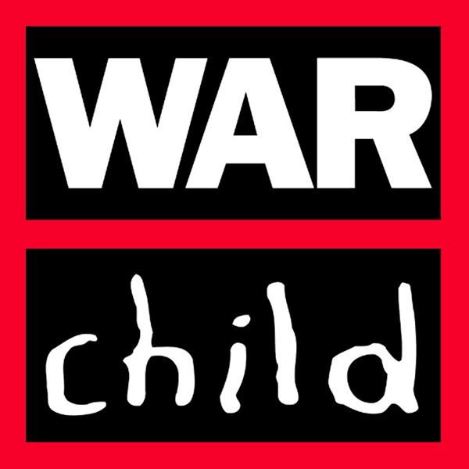

Terms of Reference

Consultancy Services
for the Process and Results Documentation
of the Building Sustainable Futures (BSF) Project

Introduction
War Child Holland has been implementing the project Building Sustainable Futures (BSF) since 2014. The first round of implementation was in Torit, Eastern Equatoria which was cut short and suspended because of the eruption of conflict in June 2016. In consultation with its funding donor, IKEA Foundation, the BSF Project was moved to Bor, Jonglei and Juba, Jubek. Implementation was re-started in January 2017 in eight new communities namely: Arek, Tibek, Lenguet, Agorbaar, Malek, Panpandiar and Pariak, whilst in Juba, it was implemented in the community of Jondoki.

The overall objective of the Building Sustainable Futures (BSF) project is to contribute to positive, healthy and economically secure futures for children, young people and their communities in South Sudan. War Child Holland (WCH) contributes to this objective by establishing safe, protective and child friendly environment for children. This includes assisting communities in creating opportunities for learning, development of life and vocational skills, as well as income generating activities for youth and their families. The project is guided by War Child’s Theory of Change and the project’s Logical Framework.

Objectives of the consultancy
The main objective of the consultancy is to document the processes and methodologies used in the project, including but not limited to the identification of factors that facilitated (or hindered) the results and outcomes, both intended and unintended.

Another objective is to develop short stories for public information about the positive results of the project through compelling human interest stories accompanied by good quality photos.

Specific objectives are:
- To document the project processes including, but not limited to, planning and preparation phase, community entry, community engagement, community participation, and other processes involved in carrying out the community-based child protection and psychosocial support/CFS project in Bor County (e.g. child protection committee, community dialogue, CFS, children’s group meetings, radio program, review meeting, case management, supportive supervision and M & E tools).
- To document key results, good practices, challenges and lessons learned in implementing the child protection and psychosocial support project in Bor County, through qualitative analysis and evidence supported with pictures , video and case studies; and analyzed based on standards in child protection and psychosocial support.
- To provide recommendations particularly on sustainability, community ownership and way forward for War Child Holland interventions in Bor County.
- To develop a public information material that contains compelling case studies, with pictures, demonstrating good practices and key results.

Methodology
Documentation of results, learnings and program implementation approach will be done based on (a) desk review of project documents including reports; (b) focus group discussion with project participants (children, adults, community leaders, and stakeholders); (c) at least five case studies;
(d) individual interviews with members of the project team and key stakeholders/project participants; and (d) observation of selected activities.

Duration and timeframe
Twenty (20) calendar days, including field work and travel time to/from field locations in Bor. First draft of the full report and the public information material is expected ten (10) calendar days after field work; Final Report and Final public information material expected 5 days after receiving feedback from War Child.

Deliverables
- Process and Results Documentation Report
- Public Information Material

Minimum qualification and experience of main evaluator
- Post graduate degree in social science or related field
- Experience in doing similar work with international organizations

Application and selection procedure
Individual consultants or firms who meet the minimum requirements shall submit 3 to 5-page proposal outlining their plan along with consultancy fee supported with budget breakdown to War Child Holland-Juba Office in sealed envelope. A selection committee led by the Program Manager will evaluate the applications both in terms of qualification, experience and value-for-money.

