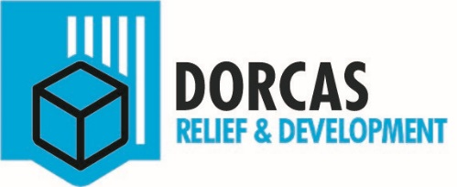

Job Re-advertisement Monitoring & Evaluation Officer

Job title Monitoring & Evaluation Officer
Organization Dorcas
Location: Wau
Salaryscale 9
Date 8th July 2016

Jobdescription

Context
Dorcas is a Christian development and relief organization which operates from the Netherlands through different field offices within Eastern Europe and Africa.

Dorcas is committed to fulfill the command of Jesus Christ to care for and empower the poor and oppressed. Dorcas accomplishes this by promoting self-reliance through development, the provision of social care and assisting in emergency situations.
The Monitoring & Evaluation Officer is responsible for the monitoring and evaluation of the projects.

Main Tasks
Result 1 –Plan and monitor projects evaluations (for self-implemented projects)
Activities:
- Prepare an annual project, monitoring and evaluation plan and budget;
- Form and coordinate an evaluation team for every evaluation;
- Prepare, coordinate and conduct evaluations of projects.

Result 2 – Initiate, design and guide project evaluations
Activities:
- Design monitoring tools to measure the project indicators and yields accurate findings to record.
- Select data collection methods and lead evaluation team throughout the evaluation.
- Analyze data collected, generate findings, recommendations and lessons learnt,
- Prepare evaluation reports;
- Communicate evaluation reports with different stakeholders.

Result 3- Stimulate evaluative thinking throughout the organization
Activities:
- Training project staff on administering the toolkit;
- Identify deficiencies and discuss it with program managers and come up with possible solutions;
- Collect and disseminate lessons learned from evaluations and incorporate them into new concept notes and project proposals.

Result 4 – Participate in different tasks and taskforces
Activities:
- Join special taskforces to be able to innovate and improve the work;
- Be available to support in other areas if necessary.

Framework, power &responsibilities
- Decides on: following up on planning and coordination of project evaluations, how to write evaluation reports and raising awareness of evaluative thinking within the organization;
- Framework: specifically formulated policies, indicators depending on donor regulations and local law;
- Responsibility: either to the team leader or directly to the country director in regard to the implementation and monitoring of the project evaluations, reporting and raising awareness of the importance to evaluate.

Knowledge and Skills
- BSc degree in a subject related to Development Aid/ Management/ Project planning/Business administration;
- Minimum of 3 years relevant (international) working experience;
- Proactive attitude, accurate personality, strong interpersonal, communication and analytical skills;
- Excellent understanding of project cycle management and how to translate this to the organisation.
- Good command of English language

Contacts
- With the program manager and partner organizations on executing project evaluations;
- With staff members and project members to train them how to use the monitoring tools and to raise awareness of the importance of evaluation;
- With the country director about the planning of the project evaluations and performing the work in an effective and efficient manner.

How to apply
Please submit your application (including CV and contact details of 3 referees) at Dorcas office (SikkaHaddid, Wau) or send your application to office@south-sudan.dorcas.org. Please indicate clearly the fact that you are applying for the abovementioned position by mentioning the position in the subject and in your covering letter.You are invited and encouraged to write about your Christian identity.

Closing date: Not later 21st July 2016. Only shortlisted candidates will be contacted.

