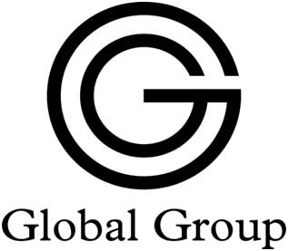
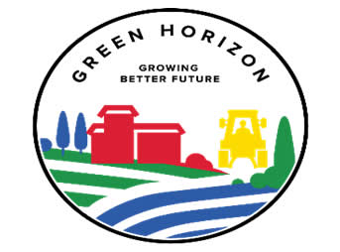

REQUEST FOR QUOTATION
Global Group was established in 2016. The company has been involved in various projects such as: water projects, agriculture and other civil constructions around the world, especially in South America and Africa.

In South Sudan, Global Group is doing three major activities, and the main activity is Agriculture Projects (Green Horizon). It introduces modern technology in agricultural sector "commercial farming" in most of States especially, Jubek State, Bor, Torit and it engages in community farming in Rumbek, Gok State, and Wau.

Please urgently send a quotation for these chemicals:

Material | Active ingredient | USD/liter
FUSILADE | Fluazifop-p-butyl (Fusilade)
SELECT MAX | CLETHODIM
 | Fostiazate
 | CHLORTHAL DIMETHYL
 | PYRAFLUFEN-ETHYL
 | CLOPYRALID
Furadan | Carbofuran
 | Bensulide

HERBICIDES:

Trade name | A.I. | USD/ LT
STOMP | PENDIMETHALIN
DACTHAL | DCPA

