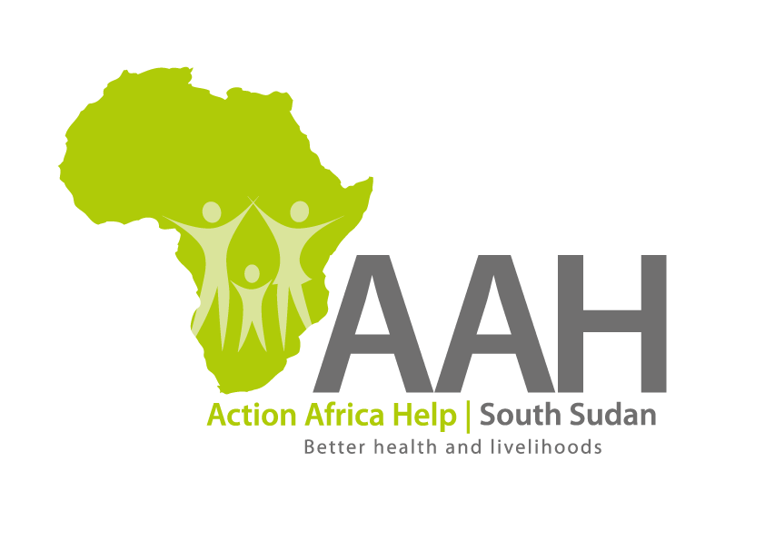
AAH-I South Sudan
Juba Office, off Munuki Road,
Next to South Sudan Civil Service Commission

ALL FOR QUOTATIONS

Background
Action Africa Help International (AAH-I) is a nongovernmental and nonprofit making Organization operating in South Sudan with a mission to support disadvantaged Communities to sustainably improve their standard of living through Community empowerment approach in partnership with stakeholders. AAH-I implements Primary Health Care, Agriculture, Humanitarian aid projects and Capacity Building.

The organization is calling for quotations from reputable companies for supply of assorted spare parts as per the information below:

1. | Supply of Toyota Prado spare parts | List attached
2. | Supply of Toyota land cruiser spare parts | List attached

REQUIREMENTS

Price and Currency: The prices shall be in United States Dollars (USD).

Submission of Quotes

The quotations shall be submitted in Hard copies in sealed envelopes, and there shall be no submission of quotes in soft copies.

Submission Address

Bids shall be submitted to:
AAH-I/UNHCR Logistic Base Juba South Sudan
Near JIT Supermarket,
Read: (Indicate the category of spare parts being applied for on the envelope)
AAH-I South Sudan.

Registration for submission:

Please ensure that, you register your hand delivered quotation/bid with the Procurement department and drop it in the bid box yourself, before you leave the Procurement department.
Each hand delivered quotation/bid must be registered individually on the bids submission forms which will be available at Procurement department. Unregistered quotation/bid will not be considered even if it is dropped in the tender box.

Request for clarifications

Any request for clarification must be made in writing through the email: procurement.southsudan@actionafricahelp.org strictly and must be received not later than Friday the 8th March, 2019 at 12:00 pm Local Time.

Deadline for the submission of the quotation

The deadline for the submission of the quotes will be strictly on Tuesday the 12th March, 2019, at 4:00 pm Local Time.

Notification of the results r
Only the successful and competitive bidder will be notified, and if you do not receive email communication within two weeks after the expiry of the deadline, consider your bid not successful.

Language for the bids

The language for the bids shall be English only.

Disclaimer

This is only a Call for quotations and AAH-I South Sudan reserves the right to either amend or cancel it at any time with or without notice. In such cases, AAH-I South Sudan shall accept no liability whatsoever. The prospective bidder is wholly responsible for any and all costs related to the preparation and submission of their quotations.

The decision of the AAH-I South Sudan Procurement Review Committee shall be final.

