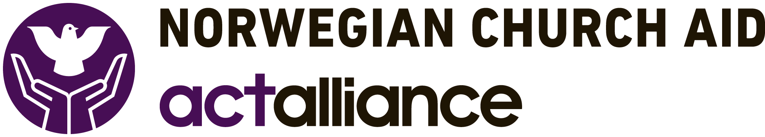

NCA SOUTH SUDAN PROGRAM

ADVERTISEMENT

Position : Temporary Cashier/Fuel Attendant

Reporting to : Senior Accountant
Geographical Area of responsibility : Jubek State, Republic of South Sudan
Duty Station : Jubek State, Juba
Date Advertised : 10th January 2019
……………………………………………………………………………………………………………………………………………………………………….

Organization Profile
Norwegian Church Aid (NCA) is an ecumenical, diaconal, humanitarian and non-profit, Non-Governmental Organization (NGO) mandated by churches and Christian organizations in Norway to work for global justice, by empowering the poor and challenging the wealthy and powerful. Together with our constituency and our partners, NCA commits to the vision: Together for a Just World. NCA provides assistance to the people of South Sudan and has been present in the country continuously since 1972.

The Position
NCA is looking for a suitably qualified and experienced candidate to fill the position of Temporary Cashier/Fuel Attendant, to be based in Juba.

Areas of Responsibility
The Temporary Cashier/Fuel Attendant is responsible for cash, cheque books and preparing payments. He/she will supervise fuel consumption for vehicles and generators.

Place in the Structure
The Temporary Cashier/Fuel Attendant is responsible for issuing cheques, paying out cash and fueling NCA cars allocated on journeys and receiving fuel stock.

Main Tasks
- Make payments and receive funds in accordance with finance procedures.
- Collect and examine supporting documents to payment requests and approval.
- Ensure that supporting documents and signatures are valid.
- Prepare payment vouchers, and receipt vouchers.
- Prepare cheques/payments and ensure that they are properly delivered.
- Record all transactions, on manual/computer systems as appropriate.
- Prepare petty cash vouchers.
- Be responsible for petty cash held in the office.
- Preparing bank reconciliations.
- Prepare vouchers for final checking.
- Scan and electronically file copies of all documentation supporting financial transactions.
- Prepare summary voucher by PID, Task and Activity to be booked in Maconomy system in Juba
- Ensure fuel stocks are maintained at pre-agreed levels.
- Issue fuel to vehicles and generators as required, ensuring correct procedures are followed and accurate records are kept, and all quantities issued are recorded in log books
- Prepare and distribute monthly fuel reports.
- Ensure fuel is stored securely and in such a manner to avoid loss through leakages or spillage.

Other tasks
- Assist in any other related matters necessary for the execution of NCA South Sudan activities.

Qualifications, Experience and Skills
- Bachelor’s Degree or Diploma in Accounting and Finance or Business Administration.
- 1-3 years’ experience in a similar position in a related field.
- Excellent attention to detail, with good organisational skills, mature, and have ability to work under pressure.
- Professional and friendly communication style, with the ability to communicate with a wide range of stakeholders.

The closing date for receipt of applications is Friday, 18th January 2019.

Interested candidates should submit the following documents along with their application:
- A cover letter with full contact details, explaining why they feel they are suitable for the position.
- A current CV with Copies of academic and professional certificates.
- Three references, which should include their current or most recent Supervisor.

Applications should be submitted by email to:

vacancies.ncass@nca.no with a copy to Azima.Arkanjelo@nca.no
and Nigda.Philip@nca.no

Or delivered to NCA Office in Buluk, Juba, near UNDP Office.

This position is open to South Sudanese citizens only. NCA is an equal opportunity employer, and qualified female candidates are encouraged to apply. Only short listed candidates will be contacted.

