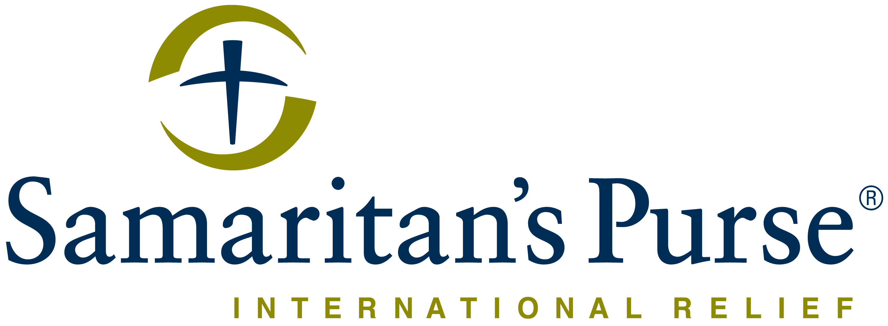
Franklin Graham President

REQUEST FOR QUOTE NOTICE Date: 19th July 2017

Deadline for submission of bids is July 21st Before 11:30 AM

Samaritan’s Purse
Juba, South Sudan, Hai Cinema next to
Quality Hotel, Old Juba Town Road.

E-mail: SouthSudanSealedBid@samaritan.org

Reference number: RFQ FOR SUPPLY OF AIR TRANSPORTATION SERVICES JULY 2017-AUGUST 2018

Samaritan’s Purse wishes to contract a legally recognized service provider (company) to provide Air Transportation Services for the South Sudan Program from July-December 2017

S/N | CATEGORY |  | DETAILED SPECIFICATION
01 |  | Air Transportation Service-South Sudan | Multiple pay loads will be requested at different times.  - All the Bid documents MUST be on the Official company LEETER HEADs and STAMPED.

NB: The quantities indicated will be purchase over a period of 12 MONTHS

WE PRACTICE PROCUREMENT WITH INTEGRITY.

All bids are received directly by the Tender committee. It is not possible to influence the decision or outcome except by offering the best value. No individual or group can influence this decision. No Samaritan’s Purse employee will solicit you outside this tender except if you are being awarded this tender.

EMAIL UNETHICAL BEHAVIOR TO SouthSudanSealedBid@Samaritan.org FOR CONFIDENTIAL REPORTING.

Manner of Submission
- By hand delivery to Samaritan’s Purse Juba office reception in a sealed envelope clearly marked:
RFQ FOR SUPPLY OF AIR TRANSPORTATION SERVICES JULY 2017-AUGUST 2018
ATTN: Tender Committee
- By Email to the Tender committee email: SouthSudanSealedBid@samaritan.org
with the subject stating the Reference number noted above.

Sealing and Marking of Bids
- Hand Delivered bids shall be securely sealed in a plain envelope and dropped into the tender box located at the Samaritan’s Purse office reception.
- No other markings than stated above should be on the envelope. Not adhering to this practice will result in rejection.
Communication
- Bidders with questions regarding this notice should post them to the same location where this tender was posted at http://comms.southsudanngoforum.org/c/tenders. Direct communication with Samaritan’s Purse staff will result in disqualification. If questions remain unanswered, please submit with your bid for consideration by the committee

Your bid MUST clearly indicate the following:
- Currency of offer -USD
- Net price after deduction of discounts:
- Number of days required for delivery to each location:
- Validity of the offer should be minimum of 12 months.
- Detailed specifications and brands provided (if different from stipulated specifications):
- Limitations.
- NOTE: Tax exemption and Duty free clearance will be facilitated by Samaritan’s Purse unless requested as Delivered and Duty Paid (DDP) above.

Conditions of bidding:
- Validity of the offer should be minimum of 12 months.
- Payment terms will be within 30 business days after receipt of goods and invoice, by Electronic bank transfer or by Cheque.
- A reference list with current contact information.
- Business Contact details including President/Owners of the company.
- Samaritan’s Purse is not subject to VAT; therefore all offers should be exclusive of VAT costs.
- Meet the Deadline noted at top of RFQ.
- Provide proof of being a legally registered company in the country in which the bid is being submitted.
- Having a track record and experience in the requested Category.
- Ability and capacity to supply the specified quantities above and deliver to Samaritan’s Purse Juba office or specified field location.
- Detailed knowledge of the Category bidding upon.
- All the bidding documents MUST be on the Company LETTER HEAD and STAMP
- If submitting in an EMAIL format, only bids submitted solely to SouthSudanSealedBid@samaritan.org will be accepted.
  - Emailed Bids will be REJECTED if:
    - Another Samaritan’s Purse email is in copy
    - Submitted separately to any other party.
    - Any coercive behaviour is suspected.
- NB: No tender documents are to be requested from the office. You only need to submit your quotation as instructed above. Speaking directly with Samaritan’s Purse staff members can result in rejection of your bid.

Terms & Conditions:
- SAMARITAN’S PURSE accepts no responsibility and is under no obligation to reimburse applicants for the costs associated with preparation of their applications;
- Time of delivery is very important; the service provider should therefore indicate a reasonable time for delivering the vehicle and associated accessories, otherwise delay penalties will be strictly implemented and no time extension would be granted unless for reasons beyond the contractor’s control
- SAMARITAN’S PURSE reserves the right to award the most qualified service provider (contractor) regardless of the lowest price submitted;
- Payment is upon delivery and after preliminary verification of the items specified above; their functionality and originality
- SAMARITAN’S PURSE reserves the right to award to more than one bidder or to reject all applicants and cancel the solicitation at any time.
Hai Cinema next to Quality Hotel
Juba, South Sudan
"All we have comes from God and we give it out of His hand.”

