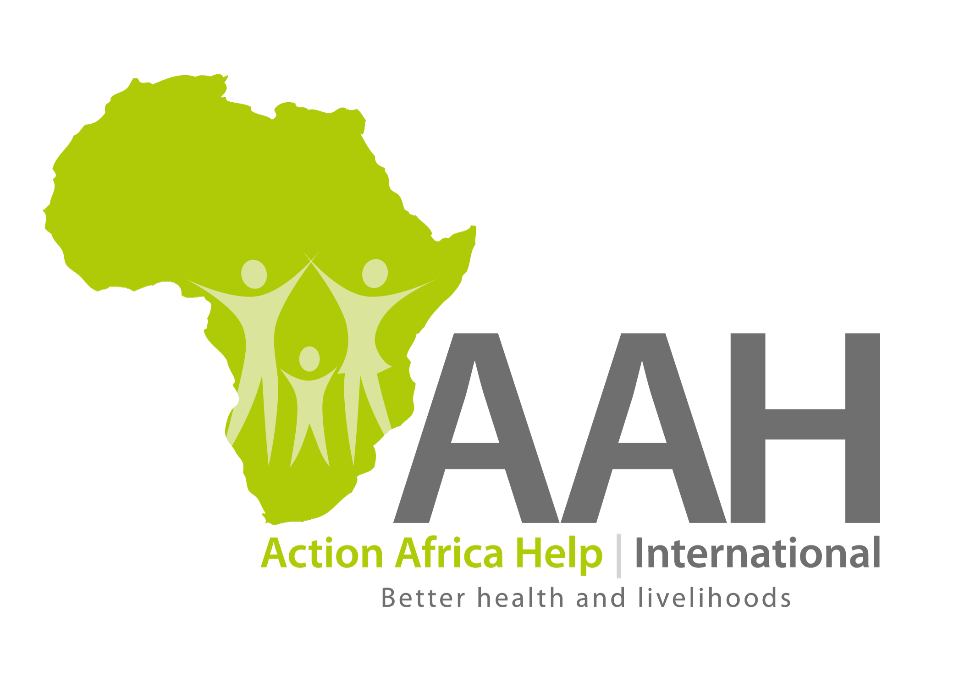

JOB OPENING

TUTOR

Job Title: Tutor, Maridi School of Nursing and Midwifery

Reports to: Principal Maridi nursing training School, AAH-I Maridi (Administratively) and Health Project Manager, (and technically to Head of Health and Nutrition Sector).Externally-working with Board of Governors of the school.
Duty Station Maridi

Action Africa Help International (AAH-I), is an international non-profit making agency that implements humanitarian relief, recovery and development projects in Africa, with over 31 years’ experience in implementing Health Programs in South Sudan. AAH-I with funding from Bread for the World is supporting the Regional Primary Health Care Project and Maridi School of Nursing and Midwifery (MSNM). Since its’ inception in 1992, the school has trained over 900 graduate nurses and midwives who are serving the rural and urban communities in providing quality healthcare in South Sudan.
Job Summary:
The Tutor will be based in Maridi School of Nursing and Midwifery Training and will work closely with Tutors, Dean of students, Academic master, Admin office, Class captains and Departmental Heads. He/she will work under the overall leadership of the School Principal with technical support from the Health and Nutrition Sector Head based in Juba.
Duties & Responsibilities
Key responsibilities:
Teaching students:
- Teach the required knowledge, skills, theories and attitudes to the Nursing and midwifery students, according to the national curricula, using a variety of teaching methods as time tabled.
- Conduct practical skills teaching to students in the skill lab, hospital and any other clinical placement site.
- Supervises students’ research work and practical attachments.
- Participate in the planning process for students learning together with other tutors
- Identify gaps in the learning of students and participate with the team to develop methods that will ensure proper learning of the students is achieved
- Participate in the mentorship and supervision of students at the school and any other clinical placement site
- Work in partnership with the course team, practice staff, students and service users to deliver high quality education within the school and practice, that is relevant to maternal and child health service.

Administrative Duties:
- Ensures he/she sets key performance objectives and annual performance appraisals done with the immediate line manager in line with AAH-I institutional policies.
- Ensures Adherence to AAH-I finance policies and compliance to the guidelines set
- Actively promote Prevention of Sexual Exploitation and Abuse standards within Maridi Nursing training School and AAH-I and amongst beneficiaries served by Maridi Nursing training School and AAH-I
- Provide guidance and counselling to students as need arises.
- Any other duties assigned by the management of AAH-I as may be deemed necessary.

Networking with SMOH, partners and Partners:
- Work closely with AAH-I program management, the school principal, fellow Tutors and the school department heads to ensure effective implementation of the school curriculum
- Liaise between the school, students, partners and stakeholders to ensure proper and smooth coordination.
- Attending coordination meetings, senior management Team meeting, representing AAH-I and ensuring there is visibility of the school among partners and State ministry of health, State ministry of Education etc, in Maridi state.
- Organizing students’ participation in national and International Health events, like world AIDS day, World Malaria Day, World Pneumonia Day, World Breastfeeding week etc.

Reporting and monitoring progress:
- Conduct continuous formative and summative performance assessment of the students
- Undertake the personal tutor roles, monitoring students’ progression and academic development
- Promote professional academic and research profile of Nursing and midwifery, within the College of Nursing and Midwifery.
- Participate in the generation of monthly and quarterly evidence based data or Information
- Work closely with the dean, academic master, tutors and other supports staff to plan, develop, implement and monitor the school operational plan.

Resource Mobilization and Fundraising:
- Contribute to proposal development for Maridi Nursing Training school and other related health projects.
- Provide leadership and guidance on tracking funding for the school as well as developing concept notes.
- Participate in development of fundraising proposals for other health projects as and when assigned, providing technical support to Regional Primary Health Care project team.
Qualifications
- Bachelor of Science in midwifery or comprehensive Nursing, Tutorship training in Nursing -Midwifery with Diploma or Bachelor’s degree from a recognized institution may be considered.
- Professional registration certificate with South Sudan Nurses and Midwives Council, having valid practicing licence.
- At least 3-5 years post qualification experience in Tutorship, managerial roles, clinical work and program management in Health Teaching Institutions.
- Must be South Sudanese national with valid national identification documents.
- Strong English language skill (Written and oral Ability to work within cross cultural dynamism) Local Arabic is an asset.
- The Candidate should be well verse with the microsofte word computer packeges

Application Instructions
Please send your cover letter outlining how your skills and experience meets the Person Specification along with your CV to Human Resource Department through recruitss@actionafricahelp.org and copy astephen@actionafricahelp.org or Submit your hard copy application to the Human Resource Department AAH-I office across the road from Indian Embassy before 26 February, 2019.

Title of the position/ vacancy must be clearly indicated in the application and on the envelope.

Note: This position is open for South Sudanese Nationals Only. Female candidates are highly encouraged to apply. The applications will be reviewed on a rolling basis.

