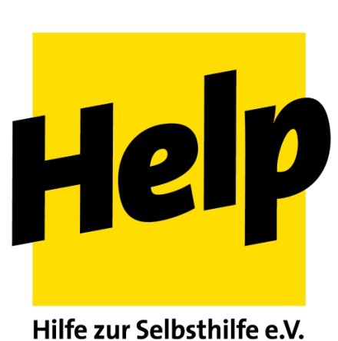

Country Director South Sudan

For the coordination of our country programme in South Sudan, Help - Hilfe zur Selbsthilfe is looking for a

Country Director

for initially 18 months starting preferably on the 15th of June, 2017.

Location of employment is Juba, South Sudan

The Country Director is responsible for the strategic management of the projects and of the Help-Team in South Sudan. He/she ensures optimal coordination of duties on an internal level and with partners in the country as well as with local authorities, German and international donors, UN-organizations and other international and national NGOs.

Duties and responsibilities:
Project management and strategic project development
The Country Director is responsible for the strategic orientation, conceptualization and planning of the projects, as well as the implementation of Help’s project activities for the guarantee of quality and transparency. He/She is responsible for an efficient management as well as implementation, monitoring and evaluation of the project activities and reports comprehensively to Help in Germany. Further does the task include ensuring a smooth, transparent internal communication and close cooperation with all project partners and Help-HQ, as well as human resource management of the national team in South Sudan. The Country Coordinator provides proactive support for an efficient quality management approach for Help’s project activities in South Sudan.
Cooperation and coordination with German and international donors
The Country Director is responsible for fundraising within the country and primary contact person for donor representatives. He/She retains an overview of all donors active in South Sudan and takes part in their meetings on a regular basis. Additionally, he/she stays informed about current donor regulations.

Finance management
The Country Director is responsible for the proper financial management of all projects and works closely with Help-HQ regarding this topic. He/She is responsible for the budgeting, financial management and control, and ensures that diverging project developments are considered in timely manner and challenges are reported promptly and solved. The Country Director ensures a regular, comprehensive and transparent financial reporting towards Help in Germany as well as donors according to their guidelines and in cooperation with the Desk Officer for South Sudan.
Logistics and procurement
The Country Director warrants the logistical necessities in order to implement to project activities, ensures the compliance with the respective donor and internal regulations, particularly regarding the procurement processes. In doing so an effective contract management, as well as a smooth procedure and coordination between all involved departments and team members is ensured.
Representation and cooperation with partners
The Country Director represents Help in the country of deployment towards all authorities, national international organizations and UN- institutions. He/She works closely and collaboratively with Help’s local partner organizations and actively networks with all required contacts for a regular exchange on all levels.
Requirements:
- An advanced university degree in the field of development aid, humanitarian aid, anthropology, social sciences, or similar
- at least 5 years of experience in the coordination and management of humanitarian aid-, rehabilitation- and development programmes
- Experience in working in a conflict zone and manage a large team effectively in a high-stress environment
- Solid experiences in the design, planning and implementation of projects (project cycle management) including development of projects and proposal writing and acquisition of donor funds
- Solid experience in human resources management for international and national staff
- Solid experiences in monitoring and evaluation
- Fluency in English orally and in writing, knowledge of German is a distinct advantage
- Experience in the implementation of assessments and risk hazard assessments;
- Partner orientated and experience in capacity development for local partners;
- Solid knowledge in finance management (budget planning, financial control and documentation)
- Solid experiences in logistics, procurement and contract management
- Solid knowledge of international humanitarian standards (Sphere, Core Humanitarian Standards);
- Experience in quality management
- Experience in the cooperation with German and international donors according to their respective guidelines and regulations
- Experience in negotiations with donors and national authorities
- Experience in risk management
- Experience in security management for international and local staff
- Analytical skills
- Excellent communicative and conflict resolution skills, intercultural empathy
- Experience with the accounting programme WINPACCS is an advantage

Qualified candidates are invited to submit their complete application (file not larger than 5MB, at least letter of interest and CV) by 07th of May 2017 in German or English to: bewerbung@help-ev.de
More information about Help: www.help-ev.de.

