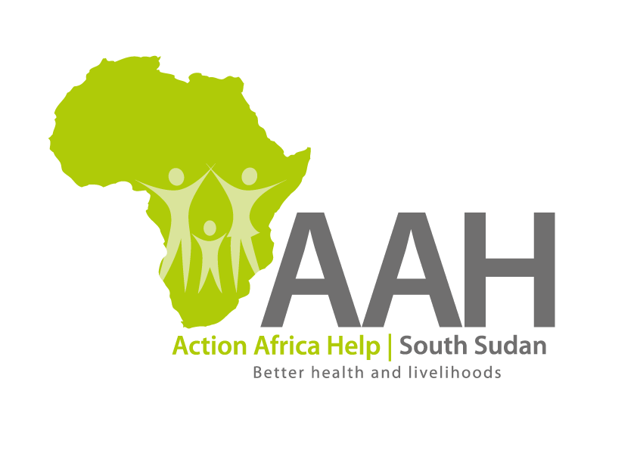
AAH-I South Sudan
Juba Office, off Munuki Road,
Next to South Sudan Civil Service Commission

CALL FOR QUOTATIONS

Background
Action Africa Help International (AAH-I) is a nongovernmental and nonprofit making Organization operating in South Sudan with a mission to support disadvantaged Communities to sustainably improve their standard of living through Community empowerment approach in partnership with stakeholders. AAH-I implements Primary Health Care, Agriculture, Humanitarian aid projects and Capacity Building.

The organization is calling for quotations from reputable companies for provision of the following construction services.

1. | Provision of labour for renovation of existing classrooms in Pariang secondary School. (3 class rooms) and a fence | BOQ to be picked from AAH-I/UNHCR Logistic base or Jamjang Office in Pariang County
2. | Provision of labour for construction of two classrooms block in Pariang Secondary School | BOQ to be picked from AAH-I/UNHCR Logistic base or Jamjang Office in Pariang County
3. | Provision of labour and materials for renovation of Wau Logistic base. | BOQ to be picked from AAH-I/UNHCR Logistic base.

REQUIREMENTS
Price and Currency: The prices shall be in United States Dollars (USD).

Submission of Quotes
The quotations shall be submitted in Hard copies in sealed envelopes on the address indicated below.

Submission Address
bids shall be submitted to:
AAH-I/UNHCR Logistic Base, Juba South Sudan
Near JIT Supermarket,
AAH-I South Sudan.

OR
AAH-I Jamjang Office
Jamjang Compound
Pariang County
Ruweng State.

Envelope should be labeled based on the works being applied for.

Site visit/Inspection
The bidder is strongly advised to visit and examine the site(s) of works and its surrounding and obtain for himself, at his own expense, all information that may be necessary for preparing the tender and entering into contract. The bidder shall be fully responsible for the reliability and accuracy of all information so obtained. A site visit register shall be available for signing by the contractors upon the said visit.

Registration for submission:

Please ensure that, you register your hand delivered quotation/bid with the Procurement department and drop it in the bid box yourself, before you leave the Procurement department.
Each hand delivered quotation/bid must be registered individually on the bids submission forms which will be available at Procurement department. Unregistered quotation/bid will not be considered even if it is dropped in the tender box.

Request for clarifications

Any request for clarification must be made in writing through the email: procurement.southsudan@actionafricahelp.org strictly and must be received not later than
5th June, 2019 at 12:00 pm Local Time.

Deadline for the submission of the quotation
The deadline for the submission of the quotes will be strictly on Thursday the 6th June, 2019, at 12:00 pm Local Time.

Notification of the results
Only the successful and competitive bidder will be notified, and if you do not receive email communication within two weeks after the expiry of the deadline, consider your bid not successful.

Language for the bids

The language for the bids shall be English only.

Disclaimer

This is only a Call for quotations and AAH-I South Sudan reserves the right to either amend or cancel it at any time with or without notice. In such cases, AAH-I South Sudan shall accept no liability whatsoever. The prospective bidder is wholly responsible for any and all costs related to the preparation and submission of their quotations.

The decision of the AAH-I South Sudan Procurement Review Committee shall be final.

