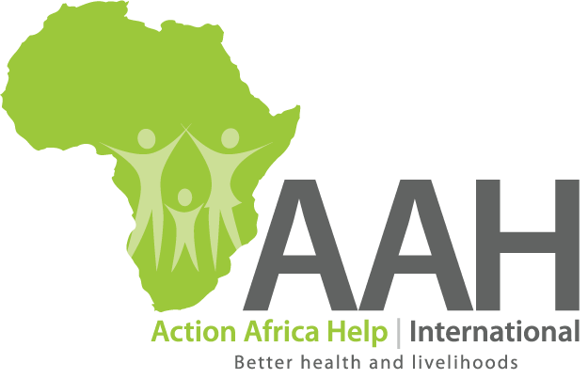
ACTION AFRICA HELP INTERNATIONAL
Head Office – P. O. Box 76598 00508
FAWE House, Chania Avenue
Nairobi, KENYA

Phone: +254 20 300 77 55
Mobile: +254 722 20 77 26
Fax: +254 20 300 77 68
E-mail: recruitke@actionafricahelp.org
Kenya, Somalia, South Sudan, Uganda, Zambia

JOB ADVERT
Area Coordinator AAH-I South Sudan
Work Location: Maban, South Sudan

About Action Africa Help International
AAH-I, an international non-profit making agency that implements humanitarian relief, recovery and development projects in Africa, seeks to qualified candidate for the position of Area Coordinator for its program in South Sudan. Under the overall leadership of the Humanitarian Logistic Sector Head/Project Manager, the Area Coordinator (AC) is responsible for leading and managing AAH operational team in Upper Nile state. As the most senior representative for AAH in the project location, the Area Coordinator is responsible for representation to the local authorities and to donors, and for coordination with other NGOs and UN agencies. The Area Coordinator is responsible for coordinating the implementation of all AAHI projects within the location and ensuring adherence to quality and accountability commitments. The area Coordinator ensures that AAH policies and procedures are adhered to by staff. As a member of the AAH Program’s Senior Management Team the Area Coordinator contributes to strategic decision making and shaping of the overall strategy for AAH South Sudan country Programme.
The full Job Description is available on the AAH-I website. (www.actionafricahelp.org)
Required Qualifications:
- University degree or equivalent in an area that is related to the project objectives, with a focus on a relevant field
- Proven track record of leadership, with at least 5 years progressive senior management experience
- Demonstrated field leadership in strategic program and project development, implementation, and evaluation;
- Inspiring leadership with excellent communication and interpersonal skills;
- Excellent diplomatic skills and ability to create positive relations with senior government officials, international organizations, NGOs and CBOs to enhance AAH-I’s programs;
- Experience with financial management and compliance with donor requirements.
- Entrepreneurial orientation, self-starter able to work independently and cope with demanding work situations in complex setting.

Application Instructions
Interested candidates should email application letters and CVs (with 3 referees) addressed to recruitss@actionafricahelp.org to be received by November 7, 2017 The email Subject Line must show the job title of the position applied for. AAH-I is an equal-opportunity employer. Only shortlisted candidates will be conducted. South Sudanese Nationals are specifically encouraged to apply.

