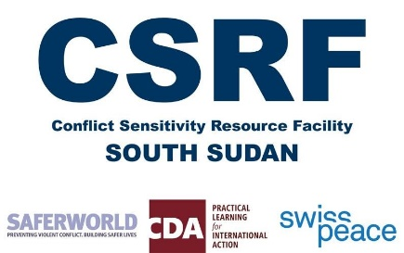

**Livestock and Conflict**

**Desk Researcher (Consultant)**

**Background**

The Conflict Sensitivity Resource Facility (CSRF) was initiated in 2016 by the British, Swiss, and Canadian donor missions to provide technical analysis, services and advice in support of integrating conflict sensitive principles and practices into donor strategies and donor-funded programming in South Sudan. The facility, which is implemented by a consortium of NGOs comprising Saferworld, swisspeace, and CDA, provides guidelines, research and analysis, capacity development and training, and institutional learning to participating donors and implementing partners over an initial two year period.

The CSRF intends to synthesise recently-conducted research on the impact of the conflict on the livestock economy. Between 2015 and 2017, various research has been conducted on this subject, but the international community has not effectively translated the data into improved programme design or delivery. Some of the research has not been released publicly and other research is likely too long and technical for busy aidworkers to absorb. The aim of this desk research therefore, is to synthesise the key findings that are relevant for the aid community regarding how the conflict, which has been continuing for 3 years, has impacted the livestock economy, and what this means for options for humanitarian and development programming.

**Statement of Need**

The CSRF seeks a field researcher with expertise in economics, political economy, anthropology, or related field, strong analytical skills, and extensive South Sudan experience to examine the relationship between conflict and livestock. The researcher will work closely with CSRF/Saferworld senior advisors and research advisor to conduct desk research, interpret findings, and prepare and present the final report.

**Level of Effort**

The assignment is expected to take 3 weeks depending on schedule set up with researcher. The bulk of the desk research can be done remotely. The researcher is expected to travel to Juba for a week to validate and present research findings.

**Deliverables**

* List of reviewed and synthesised existing literature
* First draft of 10-15 page paper due before travel to Juba
* Final draft of 10-15 page paper with 2 page executive summary and recommendations
* 1 or 2 presentation(s) to relevant parties (CSRF team and/or donors)

**Qualifications**

* Advanced degree in anthropology, gender studies, or related social science
* Extensive experience conducting analysis in South Sudan on livelihoods, or livestock.
* Excellent communications and analytical skills
* Excellent English required.
* Strong understanding of livelihood issues and conflict in South Sudan
* Ability to coordinate remotely with technical experts and research advisor

**To apply, please send an Expression of Interest to CSRF Research Advisor, Ranga Gworo at** [**rgworo@csrf-southsudan.org**](mailto:rgworo@csrf-southsudan.org) by close of business on **5th May 2017.**

**The EoI should include:**

* **Updated CV**
* **A short note outlining your proposed research approach to this task**
* **An example of past research or analysis**

**NB: This is an urgent call, Shortlisting will be ongoing as we receive applications. Saferworld reserves the right to fill this position prior to the deadline.**