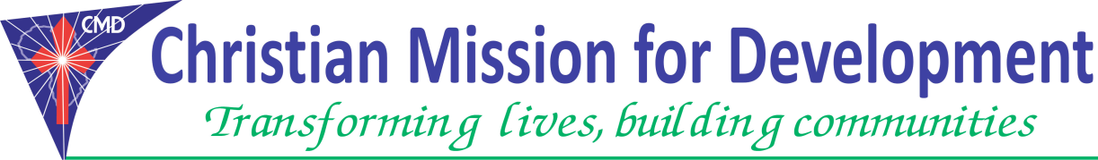
Position : | Nutrition Coordinator
Job Location: | Juba and Jonglei State-Ayod County
Reporting to | Nutrition Manager
Starting date | 1st March 2018

OVERALL DESCRIPTION.
About CMD:
Christian Mission for Development (CMD) is a registered non-profit, non-governmental, multi-sectoral relief and development organization dedicated to fighting poverty and injustices; and to enhances provision of holistic social services to reduce human suffering. CMD works with others to reach hard-to-reach areas with very little or no basic services and significantly in regions brutally hits by wars, poverty, extreme hunger and illiteracy. Over the past years, the organization has increased its capability with an increase in staff, partners and volunteers to match the increase in its programs and projects as it spreads widely to different parts of East Africa region.
General Description of the Role
In coordination with other OTP/SC staffs (Clinical officer, Nutrition nurses, Nutrition Assistants, registers/ recorders, and more): The Nutrition Coordinator will be responsible for supporting the Health Manager in the implementation of nutrition activities, reporting and reinforcing the capacity of the technical staff through day-to-day supervision, mentoring and coaching as well as training.
Key Duties
The role of Nutrition Coordinator is to oversee all nutrition activities and provide leadership and management with the Interrelated Community Case Management (ICCM) Manager. He/she will work closely with the nutrition officer, ICCM team which includes M&E, Nutrition Manager and ICCM Manager. He/she will be under the direct supervision guidance of ICCM Manager but is not limited to:-
- Manage a remote team to effectively meet programme targets and objectives of Nutrition Program within the ICCM structure.
- Responsible for the capacity building of CMD and Ministry of Health, Nutrition staffs and the community Nutrition workers at the facility at the community level.
- Provide technical support to the Nutrition team, Ministry of Health personnel’s and Community Volunteers responsible for implementation of Outpatient Therapeutic Program (OTP) and Stabilization Centers (SC) services.
- Work closely with ICCM Manager on financial resources/budget management including expenditure or advances approvals, timely submission of forecasts budget monitoring and financial accountability.
- Contributes to the development and implementation of work plans and programmatic resource materials
- Develop UNICEF proposal; Program Cooperation Agreement (PCA) for continuous Nutritional Supplies for the OTP/SC programme
- Plan and Monitor the project implementation to ensure quality service delivery as per South Sudan CMAM guidelines/Protocol
- Represent CMD in Nutrition related activities participate in Nutrition key forums and meetings with all partners (Cluster meetings, Health and nutrition technical working group)
- Leadership of senior management team including departmental heads of team for CMD Integrated Community Case Management of Nutrition and Health projects.
- Perform any other related duties and activities that may be assigned by their supervisor.
- Fundraising for existing and new activities
- Development of annual Performance and operational plans together with long term strategic plans;
- Support the country representative in external relation and positioning of CMD with multiple Donors, Government and NGO’s.
- Demonstrate and promote an ethical environment in line with CMD’s values of honesty and acting with integrity
- Program development including further innovation within existing program areas and expansion into new areas.
Other Duties
- Attend meetings, workshops and training as required.
- Disseminate knowledge and skills to clinic staff
- Report any challenges to the programs Manager/Clinical Officer and/or CHD and partner
- Maintain CHD/CMD’s good reputation through your work.
- Assist in any other area of CMD/MOH activity as assigned by Clinical Officer in charge and/or CHD/partner
Requirements (Person Specification)
- He/she should be a National of South Sudan
- He/she should at least have university degree in food and Nutrition, Food Technology, Public Health or advance Diploma in Comprehensive Nursing. Master’s degree in Nutrition or Public Health is an added advantage.
- He/she should have at least 3 or more years of experience in Nutrition related programme
- Should have experience in conducting CMAM trainings
- Should be fluent in both written and spoken English. (Additional Local Arabic will be preferred)
- Should have excellent written and verbal communication skills and the ability to cooperate with others as part of the team.
- FEMALE CANDIDATES ARE ENCOURAGED TO APPLY.

Submission on or before: 28th February 2018

CHRISTIAN MISSION FOR DEVELOPMENT -JUBA NABARI.

TONGPINY RESIDENTIAL AREAS – OPP CATHOLIC UNIVERSITY.
Email: hrcmdsouthsudan@gmail.com. cmdsouthsudan@gmail.com,

