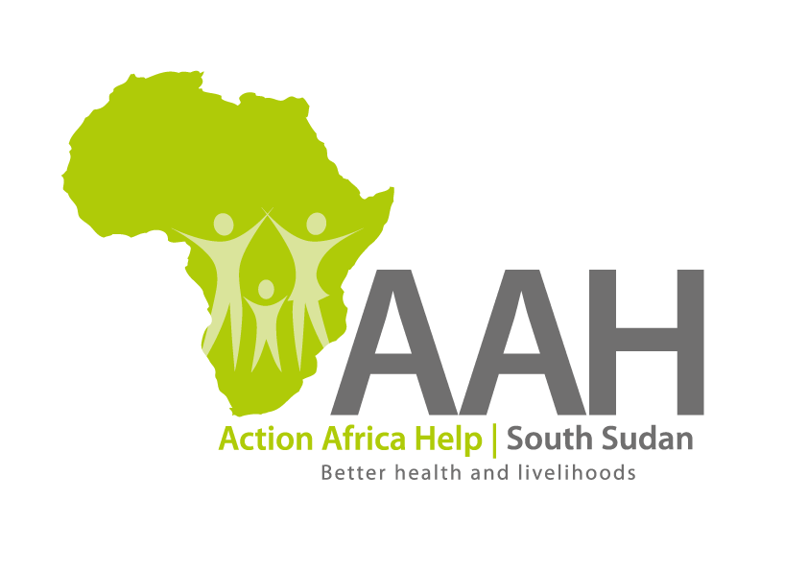
AAH-I South Sudan
Juba Office, off Munuki Road,
Next to South Sudan Civil Service Commission

REQUEST FOR PROPOSAL

Introduction to AAHI

Action Africa Help International (AAHI-I) is a not-for-profit organisation that bridges the humanitarian–development divide. Its mission is to improve the quality of life of livelihood-challenged communities. AAHI-I provides high-quality, community-centred development approaches in fragile states and emerging market settings across Africa. This includes work with both refugee and host communities. It has its headquarters in Nairobi, Kenya, and country programmes in Somalia, South Sudan, Kenya, Uganda, and Zambia.

Conceived in South Sudan and originally registered in Germany, the organisation has over 20 years’ experience working with communities in conflict and post-conflict situations. AAHI works hand-in-hand with government and other development partners, while facilitating communities to play a lead role in their own development, providing technical assistance, support to system and infrastructure set up, training, and mentorship. Activities focus on: increasing quality and access to basic services (health, water, hygiene and sanitation, and education), improving food security and livelihoods, environmental management, and responsiveness to climate change; humanitarian relief and logistics, and governance, civil society strengthening and peace building, and research to support these other themes. AAHI-I strives to mainstream gender and disability equity, and HIV/AIDS in its work.

Humanitarian Logistics and Recovery Project
The Humanitarian relief and recovery project is implemented by AAH-I South Sudan with funding from UNHCR. The project is implemented in collaboration with partners that include Non-Governmental Organizations, the ministry of humanitarian affairs, RRC and commission for refugee affairs. This project has intervened in areas most affected by population displacements like the former States of Unity, Upper Nile, Jonglei, Lakes and Western Bahr-el-Ghazal, Western Equatoria and Central Equatoria. The project responds to the needs of refugees, asylum seekers, Internally Displaced Persons (IDPs) and host communities. This response is in line with AAHI strategic objectives.
The project goal is to “To facilitate humanitarian relief and recovery programs for displaced and returnee populations to attain sustainable solutions”.
Project activities include the following; Warehouse Management; Fleet Management, Fuel Management, Infrastructural development and transit centre management.
- Objectives of the Training
In the AAH-I implementation of humanitarian logistics and infrastructure project on behalf of UNHCR in Ruweng State, South Sudan a number of heavy duty fleet made of IVECO Trakker 380 Model is currently in use for transportation of humanitarian relief cargo from location to location and a quite a number of drivers have been recruited locally to use the trucks.
AAH-I wishes to up-skill these drivers and equip them with more knowledge, sufficient to achieving their work more professionally, handle the trucks appropriately in order to avoid accidents and any other incident that may injure or be fatal to human, or cause unnecessary damages on property and the fleet itself.
In that respect, AAH-I wishes to engage the services of a qualified consultant or firm to train the drivers for a period of five (5) days. The training should be both theoretical and practical, and be transmitted in a language that can be easily understood by the target group who generally speaks local Arabic and a little English.

2. Terms of Reference
Interested individual trainers/consultants or firms are invited to prepare and present their proposal offers based on the following TORs. Hand-outs, final training report and recommendations will be part of the necessary requirements for the training documentation to be presented to AAH-I. The training courses should be prepared around the following subjects:
- General introduction on truck driving principles and techniques indicating most commonly known “Dos” and “Don’ts” that can be understood by the target group.
- Prepare a course on road safety, basic technical knowledge of the vehicle and preventive maintenance.
- Way of driving and its implication to fuel consumption, maintenance and repair cost as well as life span of the vehicle.
- Behaviors and roles of professional drivers.
- Practical demonstration on use of 6WD.
- Practical demonstration of proper and safe use of IVECO Truck; checking, starting, moving, acceleration, RPM, gear-shifting, breaking, crane use and some specific warnings that have to be strictly observed.
- Moving on convoy: “must dos” and “don’ts”

- Expected benefits for the target-group/training outputs:
  - Improved on- and off-road driving knowledge.
  - Enhanced knowledge of basic vehicle maintenance and daily responsibilities of a professional driver.
  - Improved understanding of vehicle recovery and operation of a Crane Truck.
  - Increased knowledge in road safety.
  - Basic knowledge in reduction of fuel consumption and maintenance costs.
  - Increased knowledge of prolonging lifespan of vehicles.
  - Improved knowledge on IVECO Trucks driving skills.
  - Issued with a “Certificate of Attendance”.
4. Timeline, Target - Group and Venue
The training should last for not more than 5 days, and should be conducted within or no later than the 30th June 2019. The training shall be held in Ruweng State, South Sudan at AAH-I Jamjang Logistics base and on the roads within the State. The targeted group should be regrouped into two groups to attend the training in turns, such that there will be no stoppage of operation as their service will be needed during the training days.
AAH-I South Sudan shall arrange and meet the costs of the training venue and provide the following:

AAH-I Responsibilities:
AAH-I will meet the travel costs and transport costs for field travel, as well as accommodation costs in the field. AAH-I shall also avail necessary training requirements: Iveco truck for training, refreshments, translator to Arabic if required and relevant stationery.

- Key Competencies Professionalism
The interested consultant or firm should have demonstrable technical qualifications to prepare both theoretical and practical courses as mentioned above and be able to transmit the knowledge and necessary skills and tips to the target group within the aforesaid time limit.
The Target Group shall comprise of Drivers, Mechanics and Non-driving Supervisors
Communication
- Proven ability to prepare handouts in Basic English and be in position to give understandable explanations or practical demonstrations.
- Ability to prepare usable training report and recommendations at the end of the training.
Work experience
- Proven experience in the areas of training with a minimum of five (5) years working experience.
Other skills
- Familiarity with South Sudan terrain, realities and environment.

- APPLICATION PROCEDURE
The interested Trainers are requested to submit:
a. Technical proposal showing how the consultant intends to carry out the training.
b. Financial proposal.
c. Samples of previous work on projects evaluation.
d. Curriculum Vitae of the consultant

Payment
Will be based on the offer to be made based on TORs and the number of target group. The number of drivers to be trained may increase or decrease depending on value of the offer compared to the available funds. It is therefore necessary to prepare an offer showing a cost per person trained so that final adjustments are made where necessary. The currency of the offer should be US Dollars (US$).
Payment shall be made after satisfactory completion of the assignment. Payment shall be made in the names of the Trainer/Firm, by TT or Cheque.
- Submission Address
Submission (Hardcopy):
The offer should be submitted to the address below:
AAH-I/UNHCR Logistics Base, Juba South Sudan
Hai Gabat
Juba Town (Near JIT Supermarket)
Online submission should be made via the following email address procurement.southsudan@actionafricahelp.org
NB: For online submission, please indicate the reference in the subject line of the email.
The offer should be contained in a securely sealed envelope, clearly labelled “Provision of Truck and Vehicle Driving Skills Training”
- Registration for submission:
Please ensure that, you register your hand delivered quotation/bid with the Procurement department and drop it in the bid box yourself, before you leave the Procurement department. Each hand delivered quotation/bid must be registered individually on the bids submission forms which will be available at Procurement department. Unregistered quotation/bid will not be considered even if it is dropped in the tender box.

- Request for clarifications
Any request for clarification must be made in writing through the email: procurement.southsudan@actionafricahelp.org strictly and must be received not later than Friday the 5th June, 2019 at 12:00 pm Local Time.

- Deadline for the submission of the quotation
The deadline for the submission of the quotes will be strictly on 7th June, 2019, at 12:00 pm Local Time.
- Notification of the results
Only the successful and competitive bidder will be notified, and if you do not receive email communication within two weeks after the expiry of the deadline, consider your bid not successful.
- Language for the bids
The language for the bids shall be English only.
- Basis of award of Contract
The award of the contract to the successful bidder will be based on the evaluation of the offers received and will based on the following criteria:
1. Comprehensiveness and quality of training proposal (technical): 40%
2. Competence and skills of the trainer(s): 20%
3. Proven Experience and Expertise in providing similar trainings: 20%
4. Financial Terms: 20%
Disclaimer
This is only a Call for quotations and AAH-I South Sudan reserves the right to either amend or cancel it at any time with or without notice. In such cases, AAH-I South Sudan shall accept no liability whatsoever. The prospective bidder is wholly responsible for any and all costs related to the preparation and submission of their quotations.
The decision of the AAH-I South Sudan Procurement Review Committee shall be final.

