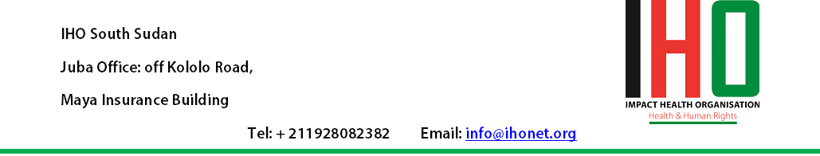

Call for Quotations: Supply of Bicycles
Ref: IHO/PS/122
- Introduction

Impact Health Organization (IHO) South Sudan is calling for quotes from competent and reputable suppliers for the supply of bicycles for one of its projects as per details below:

- Specifications of the bicycles:

Brand/Make: Phoenix
Country of Make: China

Other standard specs: Size: 24
Single Frame
Black Color
Supplied Complete with standard tool kit and pump

Quantity: 15 Units.

- Scope of Quotes:

Quotation should include the cost of assembling the bicycles.

- Submission of quotes:

Interested Suppliers may submit their quotes by email: procurement@ihonet.org with the Subject line “Quotation Ref: IHO/PS/122”

- Submission deadline:

The deadline for submission of quotes shall be 29th Feb 2016, 18:30hrs (East African Standard Time). Any late submission shall be rejected.

- Terms of trade and details of quotes:

Currency: Quotes should be drawn in US Dollars Strictly

Delivery: Delivery shall be made at IHO South Sudan Office in Juba, South Sudan. The successful supplier shall be required to make and complete delivery within 10 days from date of Order.

Payment: Payment shall be made via Bank Cheque within 10 days from date of completion and acceptance of delivery.

- Award of Order:

IHO South Sudan is not obliged to award the order to the lowest priced quotation or any Supplier. A comprehensive evaluation criteria (including but not limited to; comprehensiveness of quotation, proposed delivery terms, indicated quality details, warranty period and nature, plus price), shall be followed in determining the Supplier to whom the Order shall be awarded. The decision of IHO South Sudan’s Procurement Review Committee shall be final.

