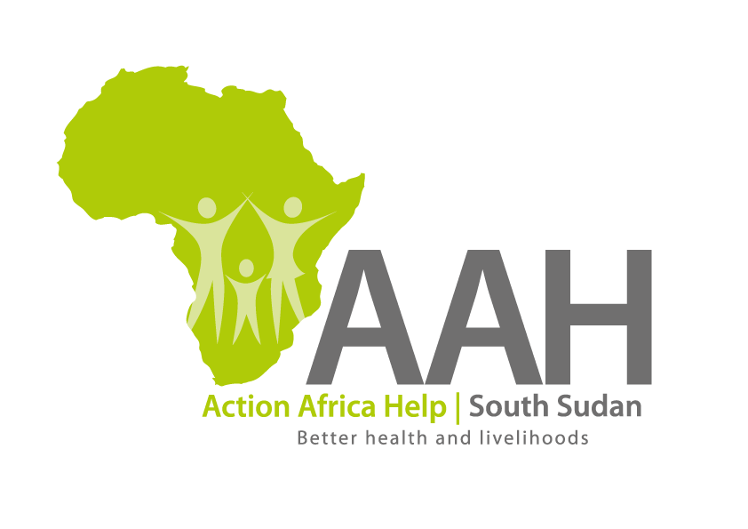
Call for Quotations:
Supply and installation of Generator Set
Ref: AAH-SS/JUB/6138

- Introduction

The Action Africa Help (AAH) South Sudan is calling for quotes from competent and reputable suppliers for the supply and installation of a generator, at its Country Programme Office located as per details below:

- Specifications of generator:

Brand/Make: Perkins or Olympia
Country of Make: United Kingdom or USA
Power Rating: 50KVA
50Hz @ 1500 RPM
400/230V
Fuel: Diesel Engine
Tank: Bunded base tank; at least 150 litres(or more) complete with 3 way valve
Other standard specs: Super Silent (Noise level: 63dBA@7 meters 88LWA)
Engine: 4 cylinder, Water cooled
Electric Start/Stop, with low oil pressure and high engine temperature shut down,
12V Battery Charge System, Battery Isolator Switch,
500 hour service interval
Control Panel,
Canopy: Zintec Steel (Corrosion resistant) paneled acoustic/weather proof enclosure with large access doors, heavy duty slam locks
and hinges, lifting beam/eye and skid base with fork lift pockets

- Scope of Quotes:

Quotation should be on DDP 2010 (Incoterms), Juba, South Sudan basis, and should include the cost of off-loading, installation (and materials and labour) and commissioning.

Note: The quotation should clearly indicate the warranty (nature and duration).

- Submission of quotes:

Interested Suppliers may submit their quotes using one of the means advised below:

Hard Copies/Hand delivery: AAH Humanitarian Project
Hai Gabath, Juba Town
Behind Customs Head Office
Next to JIT Super Market

Online Submissions: procurement.southsudan@actionafricahelp.org

- Marking and Labeling of submissions:

Hard Copy Submissions MUST be contained in securely sealed envelopes, clearly marked and labeled as follows:

“Quotation for supply of Perkins generator”

Ref: AAH/SS/6138

For online Submission, the same marking and labeling MUST be contained in the Subject line of the email and the attachments MUST be in pdf format strictly.

- Submission deadline:

The deadline for submission of quotes shall be 16th November 2015, 1130hrs (East African Standard Time). Any late submission shall be rejected.

- Terms of trade and details of quotes:

Currency: Quotes should be drawn in US Dollars Strictly

Delivery: Delivery shall be made DDP Incoterms 2010, at AAH South Sudan Office in Juba, South Sudan. The successful supplier shall be required to make and complete delivery within 20 days from date of Order.

Payment: Payment shall be made via TT or Bank Cheque within 20 days from date of completion and acceptance of delivery.

- Award of Order:

AAH South Sudan is not obliged to award the order to the lowest priced quotation or any Supplier. A comprehensive evaluation criteria (including but not limited to; comprehensiveness of quotation, proposed delivery terms, indicated quality details , warranty period and nature, plus price), shall be followed in determining the Supplier to whom the Order shall be awarded. The decision of AAH South Sudan’s Procurement Review Committee shall be final.

- Requests for clarifications:

Any request for clarification must be made in writing and addressed to the following email address: pmukisa@actionafricahelp.org , and should be received before or not later than 12th November 2015, 1130hrs (EAST)

Clarifications will be given within 24 hours from receipt of such request

