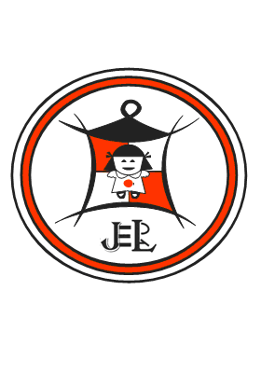

**SMECOSS**

**(Small and Medium Entrepreneurship Capacity Building Consult South Sudan)**

***EMAIL****:smecossltd@gmail.com*

[*administration@smecoss.com*](mailto:administration@smecoss.com)

**Vacancy Announcement**

**Position: – Security Guard**

|  |  |
| --- | --- |
| **Organization** | **SMECOSS,** [www.smecoss.org//jobs](http://www.smecoss.org//jobs) |
| **Position Title** | **Security Guard** |
| **Reporting to** | **Food Security and Livelihood Officer** |
| **Location** | **Abyei** |
| **Duration** | **12 Months** |
| **Closing date** | **27th January, 2016 to 15th February, 2016** |

**Position Summary**

The security Guard will be expected to support operations and the Administration Smecoss in Abyei and will be reporting to the Food Security and Livelihood Officer.

**RESPONSIBILITIES**

* Ensure proper management of the security in the compound and the surrounding area,
* Regulate the movement of visitors in and out of the compound by screening them.
* Opening of office gates and closing of the main gate when required.
* Operating the compound generator effectively and monitoring the running efficiency of the generator for timely maintenance and repair.
* Carry out daily checks on office facilities not limited to drainage system and water pipelines in the house.
* Security Guard will record the running time and fuel consumption record for the office generator on the generator Log Sheet on daily basis and submit the sheet to Food Security and livelihood Officer at the end every month.
* He will inform Food Security and livelihood Officer on any service requirements for the general facilities not limited to electrical fixing and fittings, plumbing needs, generator servicing needs etc.
* He will handle the daily staff reporting book and the daily visitors book and ensure there is sign off in the books at the main gate.
* He will screen visitors through a visiting

He will be in charge of waste management in and around the office compound

**Skills and Qualifications**

1. A minimum of senior four or an equivalent
2. A minimum of 1 years’ experience as a Security Guard
3. Excellent written and spoken English/Arabic is essential
4. Demonstrated ability to manage processes and maintain accurate records
5. Demonstrated effective organizational skills and ability to handle work in a timely manner
6. Ability to work in a multi-cultural, multi-ethnic environment with respect for diversity

**Application Process**

Applications should be address to [humanresource@smecoss.org](mailto:humanresource@smecoss.org) copy [teamleader@smecoss.org](mailto:teamleader@smecoss.org), [projectoffice@smecoss.org](mailto:projectoffice@smecoss.org) or drop a hard copy to HR and Administrative Officer SMECOSS Juba. The selection committee will review all applications as they are received. All applicants must meet the minimum requirements described above, and those unable to meet these requirements will not be considered. **SMECOSS is an equal opportunity employer.**

**This position is for south Sudanese nationals and qualified women are strongly encouraged to apply.**

Each application should include the following:

* Cover letter including the applicant’s suitability for the position and current contact information
* CV, including detailed work experience, education/degrees and other Certificates
* Professional references (minimum of three, with complete contact information)

Application Start **27th January, 2016 Deadline 15th February, 2016**

We are located at Munuki - Hai Kuwait Bilpam Road opposite Rambo playground.