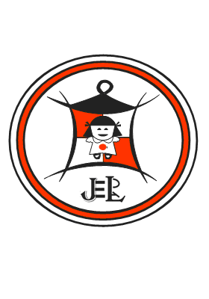
SMECOSS
(Small and Medium Entrepreneurship Capacity Building Consult South Sudan)
EMAIL: smcossltd@gmail.com
administration@smecoss.com

Vacancy Announcement

Position: – Business and Finance Trainer
Organization | SMECOSS, www.smecoss.org//jobs
Position Title | Business and Finance Trainer
Duration | 1 year but renewable according to Funds Availability
Start Date | Immediate
Application deadline | 27th January, to 15th February, 2016
Context

SMECOSS is a registered Institution, established in 2009 by South Sudanese professionals in entrepreneurship, Microfinance and Community Development. It was registered with the Ministry of Legal Affairs and Constitutional Development in the Government of Southern Sudan in 2010 with the registration Number 8117. It is also licensed by International Finance Corporation (IFC) to carry out specialized capacity building trainings in South Sudan.

RESPONSIBILITIES
- Develop work plan for teaching Youth in Business and Entrepreneurship
- Develop VSLA mechanism for trained Youth and outreach VSLA grouping
- Develop income generating strategy plan for graduated youth
- Development of small business component of the program
- Development of business plan templates
- Conducting training sessions on business and finance management
- Development of appropriate monitoring and tracking mechanisms
- Conducting market surveys and assessments
- Represent SMECOSS at appropriate fora

Skills and Qualifications
- A minimum of Degree/Diploma in Business Administration, Business Management or equivalent
- A minimum of 2 years’ teaching experience and working with local communities – experience in South Sudan will be an advantage
- Experience in training on business and finance
- Knowledge in Community Mobilization.
- Experience in conducting surveys and analyzing market systems
- Excellent written and spoken English is essential
- Demonstrated ability to manage processes and maintain accurate records
- Demonstrated effective organizational skills and ability to handle work in a timely manner
- Demonstrated ability to coordinate tasks to meet deadlines
- Ability to work in a multi-cultural, multi-ethnic environment with respect for diversity
- Experience and skills in the use of software programs such as MS Word, PowerPoint, Excel, MIS
- Knowledge of Arabic or local Language will be an advantage
- Experience teaching Youth will be added advantage
- Experience riding and having a validate riding permit is added advantage

Application Process
Applications should be address to HR/Admin Officer or humanresource@smecoss.org, teamleader@smecoss.org projectoffice@smecoss.org. The selection committee will review all applications as they are received. All applicants must meet the minimum requirements described above, and those unable to meet these requirements will not be considered. SMECOSS is an equal opportunity employer.

This position is only for south Sudanese nationals and qualified women are strongly encouraged to apply.

Each application should include the following:
- Cover letter including the applicant’s suitability for the position and current contact information
- CV, including detailed work experience, education/degrees and Diploma Certificates
- Professional references (minimum of three, with complete contact information)

All applications should be delivered to HR and Administrative Officer SMECOSS
Application deadline is 27th January, to 15th February, 2016
We are located at Munuki – Hai Kuwait Bilpam Road opposite Rambo playground.

