Juba Town, Jebel Nyokan, Near Chamber of Commerce
World.focus @yahoo.com

Contact person:- Mr. Gaanun Puok
Marketing & Sales manager
Tel: +211 955575503 /+211 957700094
May 1, 2017
Compound for rent

World Focus International Hotel Premise Leasing Summary
World focus International Hotel was established in 2013 as a state of the art venture in South Sudan Hotel industry. The management of the premises obtained a land lease for 25 years to legally operate its venture since 2010; the establishment has 18 years remaining to transact its services on the said parcel of land. The premise is situated in a strategic location with a very friendly community around it’s environ with no record of its visitor victimized or any threat to their security. World Focus International Hotel is strategically merited with the following:
- Premises ample space plan built on 11,000 sq/m parcel of land.
- Secured Environ and Location.
- Its proximity to the Central Business District (CBD) and Services.
- Well infrastructure access routes to and from the premise.
- 62 bed rooms of which :-
  - Ten VIP bed rooms.
  - Six special self-contained bed rooms
  - Forty six self-contained bed rooms & all bed rooms well equipped with ‘’AC’’ & ready For use
- One Reception with size of 33 m²
- Three Conference halls. / 2 Conference halls with 105 m² & the other with 215 m²
- 1 Big Kitchen with a big open plan
- One Big bar with the size of 215 m²
- One Restaurant with the size of 215 m²
- One big open relaxed & grassed house cafeteria
- Two big open gates & one back side security gate access to Nile River
- Well designed & attractive plantation including big trees which shades areas of the compound
- One Security guard room.
- Big Parking lot that can take between 60-70 Vehicles.
- 3 heavy duty electrical power generators.
- Well secured perimeter wall.

- Location :- 1 . Opposite to Residential Apartment of :-
-World vision
- Save the children
- Plan organization
2. Near Hamzain & Notos Hotel
The management of world Focus International hotel would welcome any questions, suggestion and ready for negotiations with interested party regarding the said premises. Thanks in advance.

Regards !!

Romman Lemma
Owner of the Hotel

Hotel Profile
Location:- World focus international hotel (WFIH) is a magnificent 4 star international hotel outstandingly located in Juba Town next to Chamber of commerce office, Notes and Hamza Inn hotels. It is the biggest of the entire hotels in Juba compounded with total area of 11,000 m². The setting of WFIH compounds is fenced with UNMISS standard concrete building topped by security wire.

Marketing:- Even though this newly emerged hotel has managed to become very popular, due to the existing current situation of the country the management of the Hotel want to rent out the compound for any interested party.
1 .Hotel compound Features
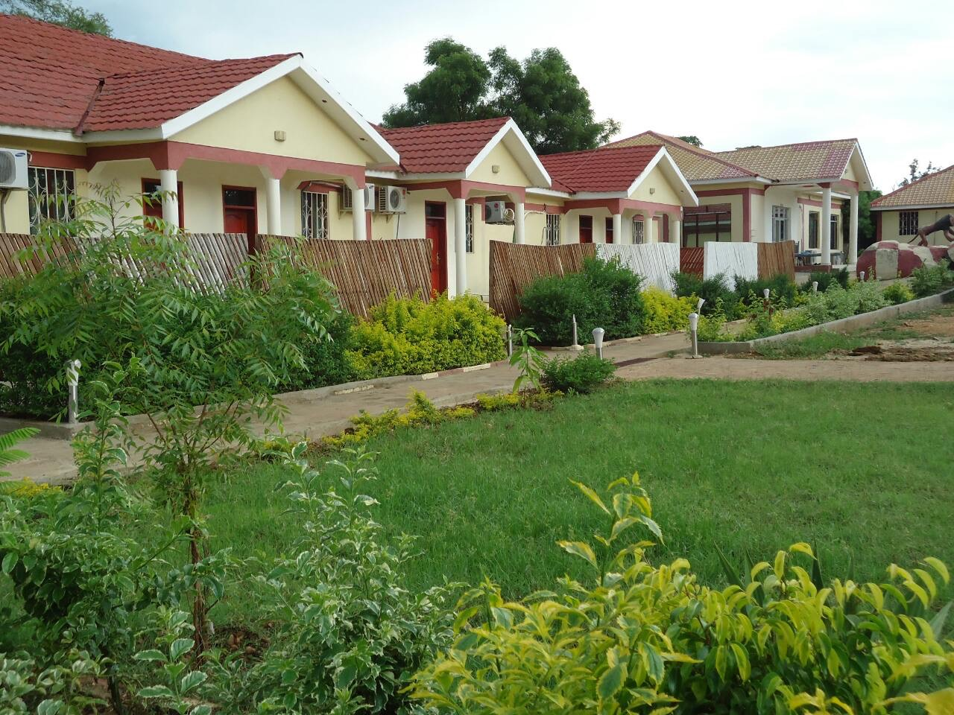
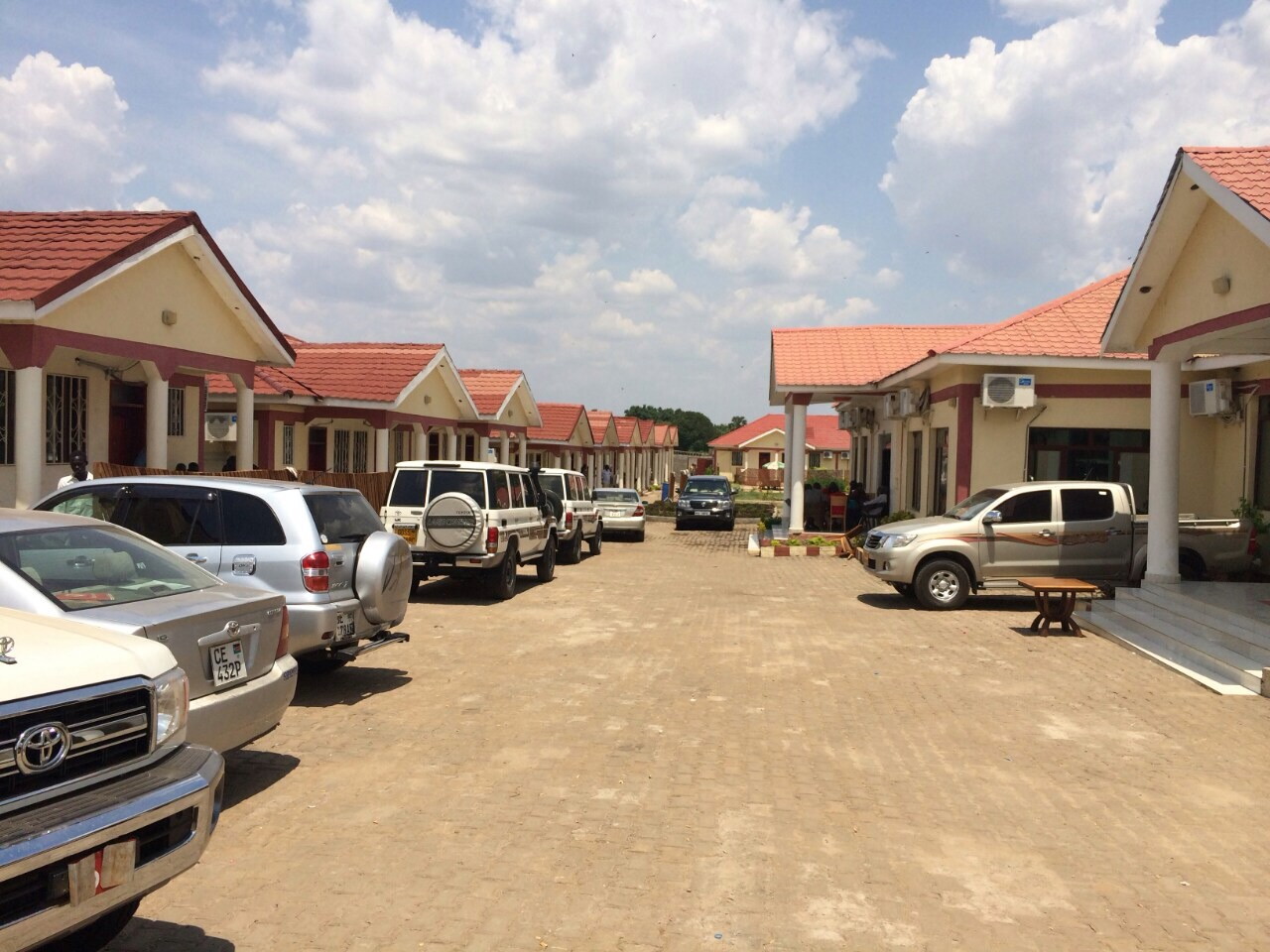
2 .Big open relaxed & grassed house cafeteria
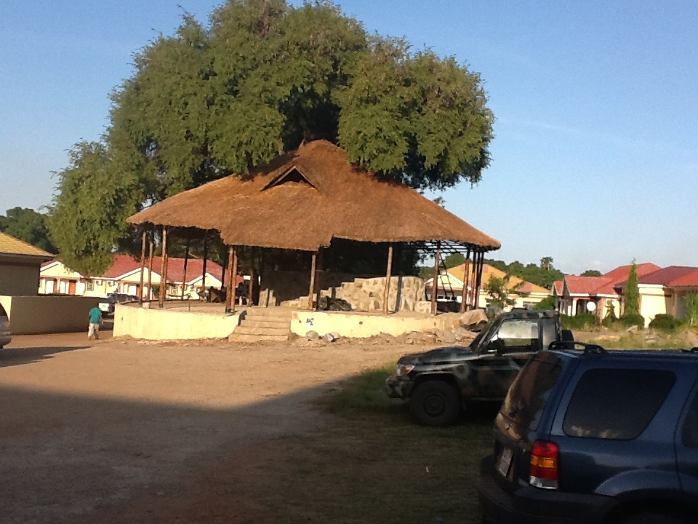
3 . VIP bed room
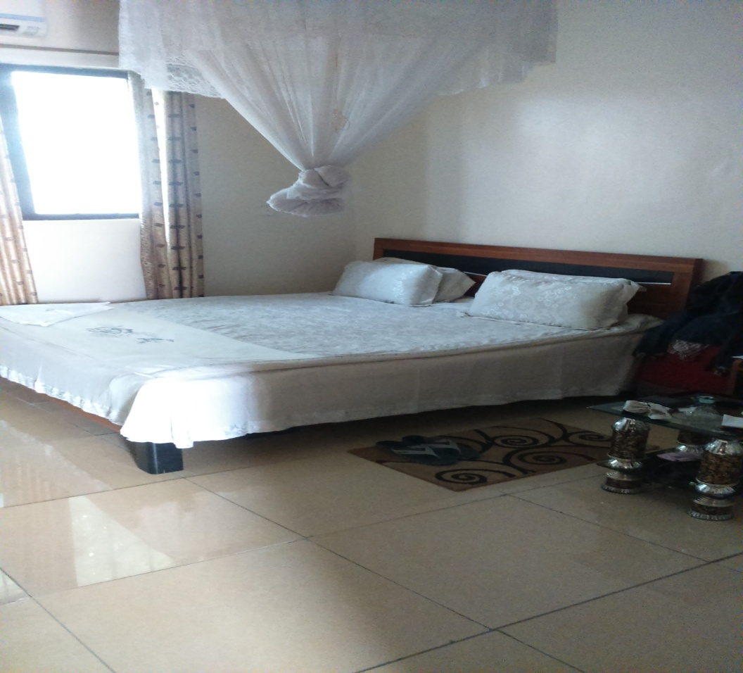

4 .VIP Lobby
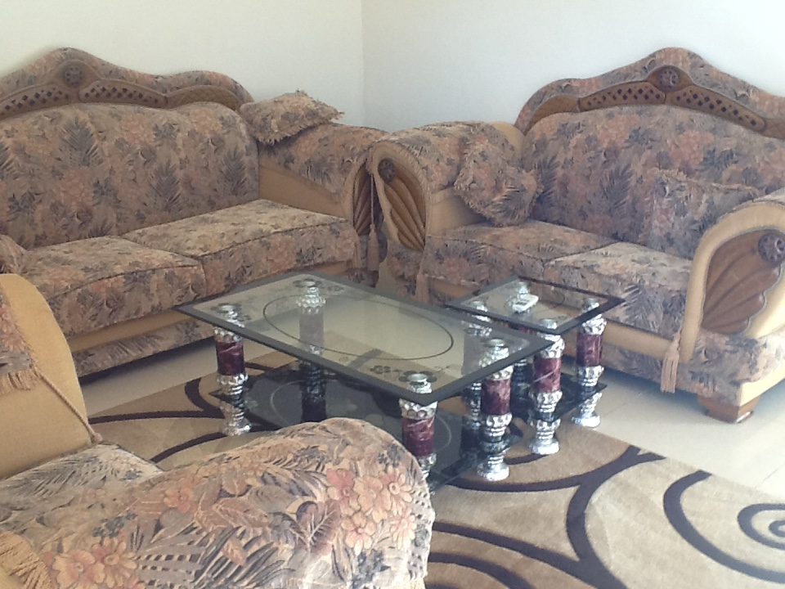
WFIH is new classic array of establishment built to accommodate every guest in a personalized setting in its more than 62 comfortable rooms to the convenience of each guest with spacious accommodation that ranges from luxurious executive suites to twin and double bedrooms each with their own balcony to a guest’s utmost comfort.
5. Conference Hall:
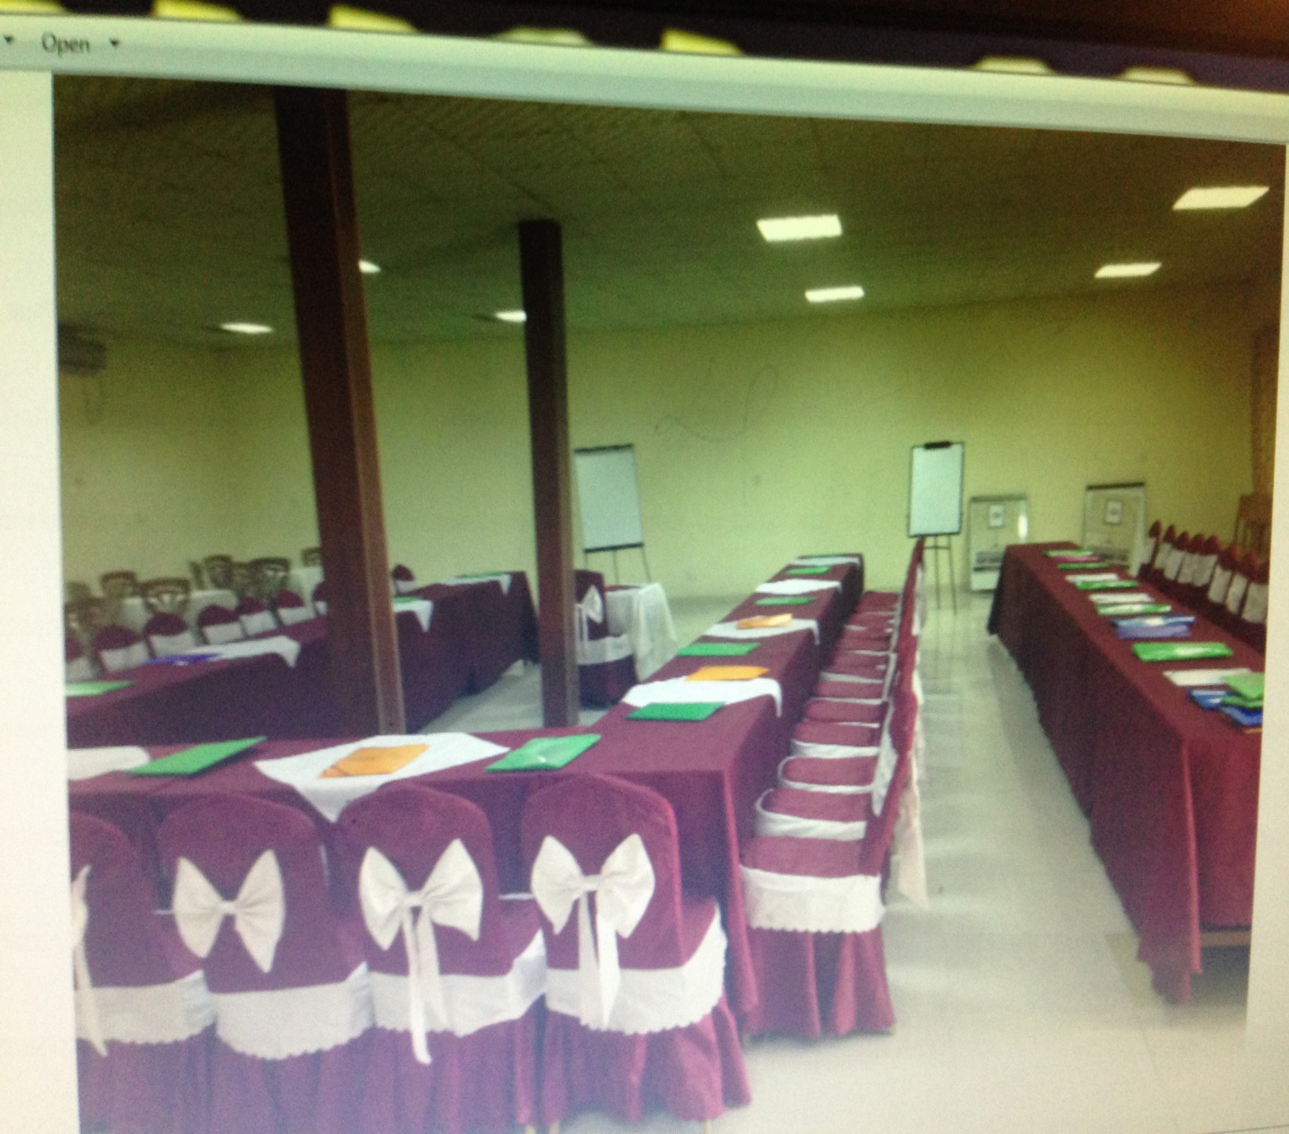
WFIH has three convenient conference halls equipped with the state of the art sound system, LCD projectors. White boards, and flip charts. The halls are organized to accommodate participants ranging from 40, 80 and 250 respectively from small sixe to the largest. Therefore, whatever numbers of participants you may come with we are sure you leave the hotel when you are happy with what we have at hand.
6. Bar:-
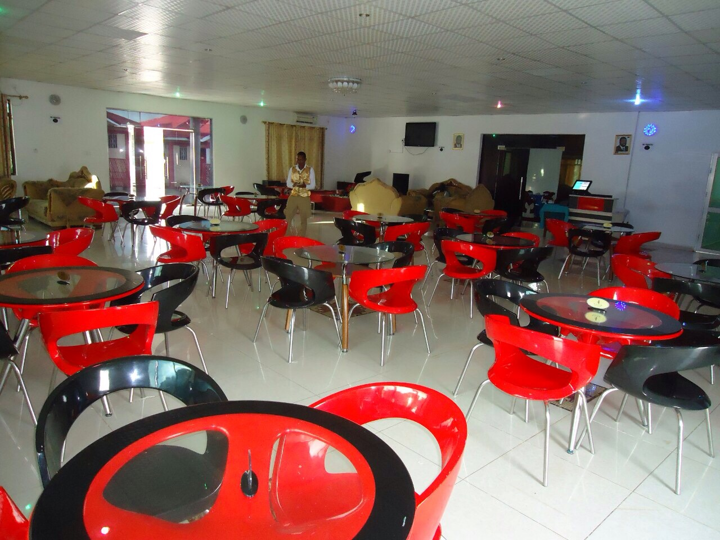
7. Restaurant:-
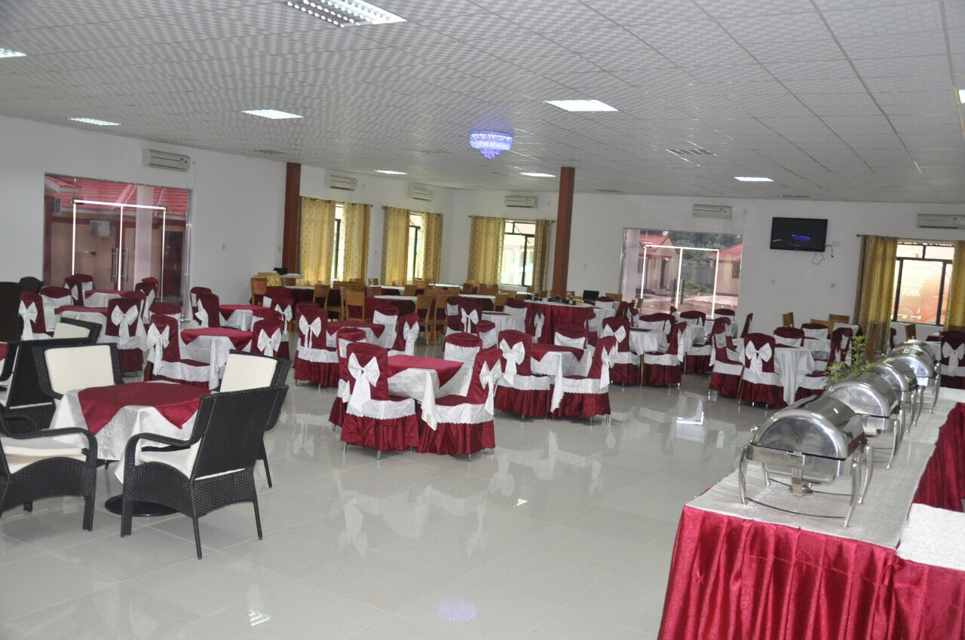
8.Two open gate view From out side
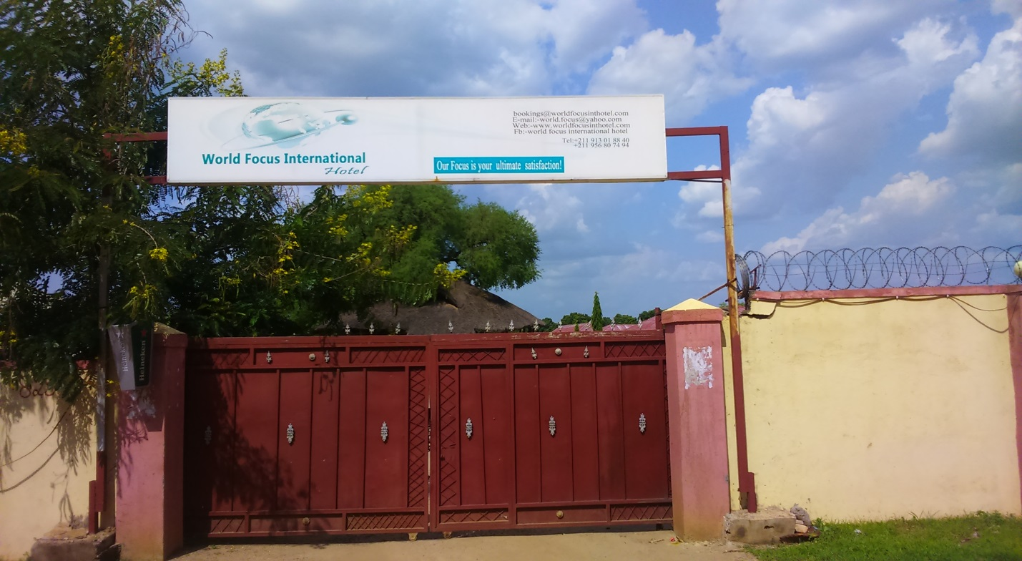
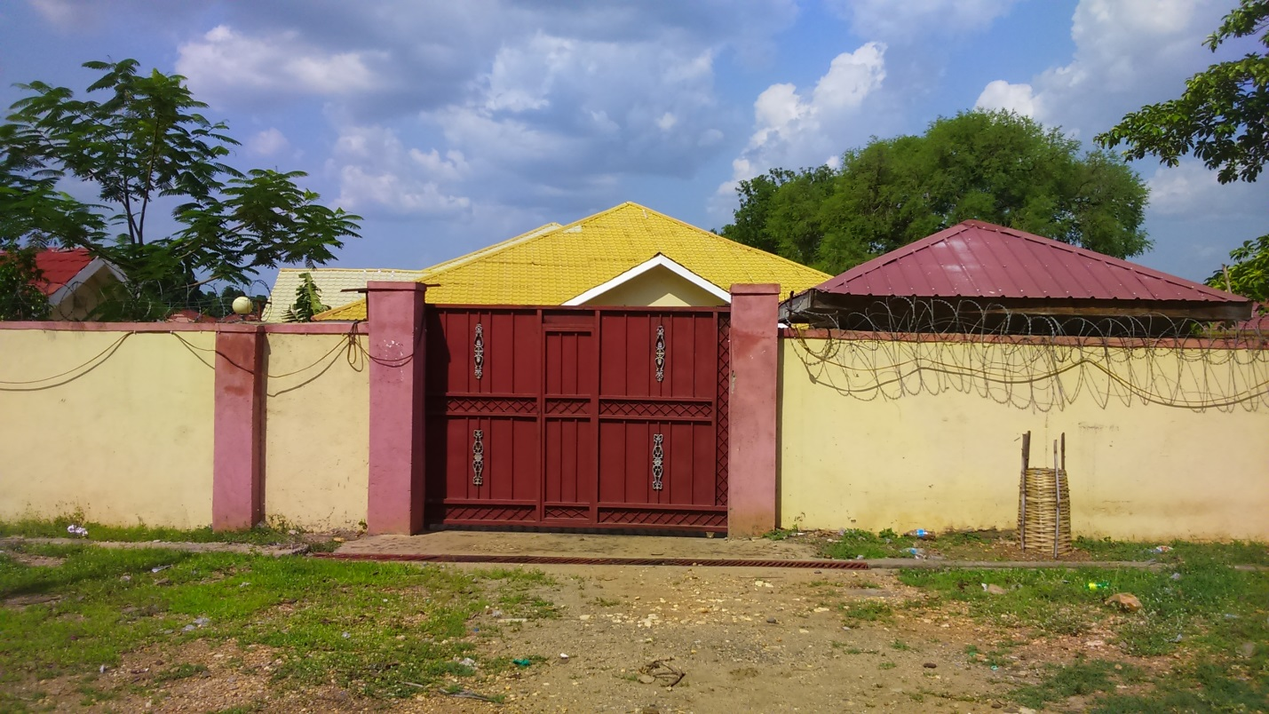
Parking Services:-
WFIH has accommodating capacity of 150 vehicles at one. Hence, we are so proud to serve our guests in our premise.
Registrations:
WFIH is registered under company act of South Sudan and has been operational in South Sudan since 23rd of July 2010.
Names of our major clients to whom similar services were provided
For further information, we have listed some of our major clients from international organizations who have been served by our hotel, and can be best references.
ORGANIZATIONS
- UNHCR GIZ
- AECOM
- SAFERWORLD
- Danish church Aid
- THE SUDD INSTITIUTE
- EQUITY BANK
- CCR
- ICRC
- Norwegians People Aid
- CORDAID
- And more ………………..

- WFIH well coming any interested party to negotiated and rent the compound!!

