TO: Prospective Offerors

DATE: 14 February 2017

SUBJECT: RFP NO. RFP#0003/17

Request for proposal for End-line Data Collection in Awerial, Bor and Juba, South Sudan
March-June 2017.

Global Communities is an international non-profit organization that works closely with communities worldwide to bring about sustainable changes that improve the lives and livelihoods of the vulnerable. The mission of Global Communities is to create long-lasting, positive and community-led change that improves the lives and livelihoods of vulnerable people across the globe.

In September 2015, USAID-South Sudan awarded the Promoting Resiliency through Ongoing Participatory Engagement and Learning (PROPEL) program to Global Communities and partner Catholic Relief Services. This program brings together communities and strengthens their capacity to drive their own development through harnessing their own resources, leveraging other donor-funded programs, and advocating for additional support to implement projects that address priority needs. This program promotes social cohesion and resilience within South Sudanese communities while providing tangible improvements in the lives of community residents. PROPEL is a pilot Collaboration, Learning and Adapting (CLA) project that aims to provide a rigorous evidence base for a unified approach to Community Driven Development (CDD) in South Sudan.

Our PROPEL approach combines four modalities: 1) an inclusive mobilization and engagement process that integrates participation from community members, traditional leaders, and local government officials as the political situation allows; 2) grants that serve as incentives and opportunities for engagement – including engagement of women, youth, IDPs, returnees, minorities, and other marginalized populations as identified and defined through the community engagement, stakeholder analysis and community mapping process; 3) capacity building of community leaders and local non-governmental organizations (NGOs) and CSOs to strengthen the knowledge and skills necessary for sustainable CDD; and 4) a Learning Network to share community profiles, case studies and program findings to further CDD in South Sudan and beyond. Our methodology integrates discussion, analysis, and incorporation of conflict dynamics and issues affecting men, women, youth, and other groups into the design, implementation, and monitoring of CDD projects. PROPEL also exercises special care to identify and include transient groups such as pastoralists, IDPs and other migrants in community discussions.

Interested research firm/NGO/institution in South Sudan should submit their applications in electronic format in accordance with the requirements of this solicitation to the address specified. The applications must be received no later than Thursday, 23 February 2017, at 12:00 NOON, Juba time.

Responding organizations are advised that this solicitation does not in any way obligate Global Communities to make an award or compensate responding organizations for any costs associated with the preparation and submission of their proposals.

Any questions or requests for information should be addressed to jmargaret@globalcommunties.org with the subject: “PROPEL End-line Data Collection”. Any information given to one prospective offeror concerning this solicitation will be furnished to all such offerors as an amendment of the solicitation.

Organizations intending to submit proposals are requested to please e-mail Global Communities at jmargaret@globalcommunties.org with the subject: “Intention to Submit” at the earliest practicable date, so that we may anticipate the number of proposals to be evaluated.

REQUEST FOR PROPOSAL (RFP)
RFA NUMBER:  RFA-PROPEL- 002-17 |  | ISSUE DATE:  14 February 2017
ISSUER:  Cooperative Housing Foundation, doing business as GLOBAL COMMUNITIES |  | PROGRAM:  Promoting Resiliency through Ongoing Participatory Engagement and Learning (PROPEL)
End-line Data Collection in Awerial, Bor and Juba, South Sudan
March-June 2017
ISSUED BY:  Cooperative Housing Foundation,  doing business as Global Communities  8601 Georgia Avenue, Suite 800  Silver Spring, MD20910-3440 |  |  | PROPOSAL DUE DATE:  Thursday, 23 February 2017, at 12:00 NOON, Juba time.
This Request for Applications contains the following sections:
Part 1 | Instructions to Offerors
Part 2 | Evaluation Factors for Award
Part 3 | Statement of Work
Part 4 Annexes | Annex A – Evidence of Responsibility  Annex B – Budget  Annex C – Biographical Data Sheet

Part 1: Instructions to Offerors

I. GENERAL INSTRUCTIONS TO OFFERORS

- The Offeror is requested to submit an application directly responsive to the terms, conditions, and clauses of this RFP. Applications not conforming to this solicitation may be categorized as unacceptable, thereby eliminating them from further consideration.

Applications must be received no later than Thursday, 23 February 2017, at 12:00 NOON, Juba time. Applications must remain valid for a minimum of sixty (60) days. The Offeror must submit its application electronically by Internet email compatible with MS WORD, Excel, and Adobe Acrobat in a MS Windows environment to: jmargaret@globalcommunties.org

The overall application shall consist of two (2) separate documents (files), as follows: Volume I – Technical Proposal; and Volume II – Cost Proposal. Technical Proposals must not make reference to pricing.

- Global Communities will award contracts to applicants whose proposals receive the highest evaluation scores based on the evaluation criteria in this RFP.

- Any application received in response to this solicitation will be reviewed strictly as submitted and in accordance with the evaluation criteria specified in Part 2, Evaluation Factors for Award.

- The person signing the Offeror’s application must have the authority to commit the Offeror to all the provisions of the Offeror’s application.

- Global Communities is not obligated to make an award or to pay for any costs incurred by the Offeror in preparation of a proposal in response hereto.

- The Offeror should submit its best application initially as Global Communities intends to evaluate applications and make an award without discussions. However, Global Communities reserves the right to conduct discussions should Global Communities deem it necessary.

G. Applications must be clearly and concisely written and must describe and define the Offeror’s understanding and compliance with the requirements contained in Statement of Work, which can be found in Part 3 of this RFP. The application should clearly address each of the evaluation factors set forth in Part 2. All pages of each volume (cost and technical) must be sequentially numbered and identified with the name of the Offeror and the RFP number.

II. WHO IS ELIGIBLE TO APPLY

Applications will only be accepted from Offerors meeting the following conditions:

- Must be an organization legally registered in South Sudan;
- Significant experience of collecting and analysing quantitative data for development programs in South Sudan
- Demonstration of ability to provide adequate oversight and management in difficult and tense operating environments
- Able to provide evidence on number of studies and surveys in three target areas
- Able to provide evidence of producing high quality data and working within tight timeframes
- Proficiency in electronic data collection and data cleaning methods
- Roster of qualified enumerators based in the target areas with command of local language, and adequately number of female enumerators for 50% female respondents
- Be non-governmental (not part of the recognized government authorities);
- Be non-partisan (not be affiliated with any specific political party;
- Must have a bank account
- Must provide the following documentation:
- Certificate of Registration and/or NGO Operation Certificate;

III. INSTRUCTIONS FOR THE PREPARATION OF THE TECHNICAL PROPOSAL

A. The Technical Proposal should provide a straightforward, concise delineation of how the Offeror intends to carry out and satisfy the requirements of the STATEMENT OF WORK.
B. Technical Proposals shall be written in English.
C. Technical proposal should demonstrate how the applicant complies with the selection criteria under part 2 number III below.

To be fully considered, the proposal must include the following:
- Detailed description of methodology, including approach to sampling in each boma
- Detailed description of training plan on the questionnaire
- Staffing plan for enumerators with requisite cultural/linguistic abilities to collect required sample size within proposed time frame
- Work plan for data collection
- Demonstrated qualifications and experience (supported with CVs of key research team)
- Demonstrated understanding of operating environment in target areas
- Descriptions of comparable research and projects (please submit list of comparable research and projects in the relevant field and seven target oblasts)
- Client testimonials and references
- Detailed budget

IV. INSTRUCTIONS FOR THE PREPARATION OF THE COST PROPOSAL

A. The Offeror must propose costs that it believes are realistic and reasonable for the work in accordance with the Offeror’s technical approach. The Offeror shall provide a complete budget by the cost elements described below using Appendix 1 Budget.

B. All cost and financial data should be fully supported, complete in every detail, and organized in a manner that facilitates review and permits cost analysis. The cost and financial data shall include the following information/data:

- Direct Employee Salaries – List employee name (when identified), functional position and duration of assignment (in terms of person days). The annual salary of an employee is that individual’s basic compensation exclusive of fringe benefits, travel incentives, housing allowances, differentials, and/or other bonuses.

- Fringe Benefits - Describe the allocation method and base used. If the organization has one, provide a copy of the latest Negotiated Indirect Cost Rate Agreement (NICRA) with any Government agency. Fringe Benefits, if not set forth in the Offeror’s NICRA, shall be expressed as a percentage(s) of salaries, and the proposal shall present the total fringe benefit costs.

- Indirect Costs - Describe the allocation method and base used. If the organization has one, provide a copy of the latest Negotiated Indirect Cost Rate Agreement (NICRA) with any Government agency. The detailed budget breakdown shall be structured and formatted to clearly and easily identify the rate(s) applied, and the resulting dollar amount. If the Offeror has both home office and off-site/field rates, and/or if the Offeror has more than one type of rate (e.g., overhead, G&A) the detailed budget breakdown shall be structured so as to permit easy identification of the bases to which the rates apply.

- Travel and Transportation – Provide the number of trips, destination, purpose and cost by traveler.

- Per Diem – Offerors shall budget per diem associated with travel and transportation in accordance with their established internal policies

- Other Direct Costs – Itemize and provide complete details of other direct costs, including unit prices that may be incurred.

- The offeror shall submit fully completed and signed Contractor Employee Biodata Sheets (Appendix 2) to support daily rates of consultants and employees who are identified in the budget by name

C. If the Offeror intends to work under a joint venture or partnership, the Offeror must include a copy of the agreement between the parties to the joint venture/partnership. The agreement will include a full discussion of the relationship between the firms including identification of the firm which will have responsibility for negotiation of the contract; which firm will have accounting responsibility; how work will be allocated, overhead calculated, and profit shared; and the express agreement of the principals thereto to be held jointly and severally liable for the acts or omissions of the other.

D. The Offeror shall submit as part of its Cost Proposal the following Financial Data:

1. Evidence of Responsibility, completed and signed. See Part 4 of this RFP – Annex A.

2. Indirect costs included in the Cost Proposal should be supported by financial statements for the past three years, preferably audited. Indirect cost rates used for this application should be consistent with those applied by the applicant in all its other activities over the past three years

Part 2: Evaluation Factors for Award

I. GENERAL – APPLICATION EVALUATION

A. Part 1 provides guidance to offerors concerning the documentation necessary to conduct an informed evaluation of each application. The Offeror must furnish adequate and specific information in its application. An application may be eliminated from further consideration before a detailed evaluation is performed if the application is considered obviously so deficient as to be totally unacceptable on its face or whose prices are inordinately high or unrealistically low.

B. In conducting its evaluation of applications, Global Communities may seek information from any source it deems appropriate to obtain or validate information regarding an Offeror’s application.

C. Competitive Range: If Global Communities determines that discussions are necessary, Global Communities may establish a Competitive Range composed of only the most highly rated applications. Global Communities may exclude an offer from the competitive range if it is so deficient as to essentially require a new technical application. Global Communities may exclude an offer from the competitive range so unreasonably priced, in relation to more competitive offers, as to appear that there will be little or no chance of becoming competitive. Global Communities may exclude an offer from the competitive range requiring extensive discussions, a complete re-write, or major revisions such as to allow an Offeror unfair advantage over those more competitive offers.

D. Global Communities reserves the right to award one or more contracts under this RFP on the basis of initial offers without discussions or without establishing a competitive range.

II. BASIS FOR AWARD

Technical and cost factors will be evaluated as described below.

A. The evaluation factors presented below will serve as the basis upon which proposals will be evaluated. The relative weight accorded to each factor is expressed in points with a maximum of 100 points possible.

B. Offerors are reminded that Global Communities is not obliged to award a grant/contract on the basis of lowest proposed cost or highest technical evaluation score. Although for this grant technical proposal merits are considered more important than cost relative to deciding who might best perform the work, cost factors will also be considered. Therefore, after the final evaluation of applications, Global Communities will make the award to the Offeror whose proposal offers the best value to Global Communities and USAID, considering both technical and cost factors.

III. EVALUATION CRITERIA

Proposals will be evaluated by selection committee on the basis of the following criteria:
- Price (20 scores)
- Work plan in alignment with time frame (10 scores)
- Technical Approach (35 points) – Quality of methodology, feasibility of work plan, the extent that the Offeror’s proposal demonstrates a clear and effective overall technical approach to performing the requirements described in the STATEMENT OF WORK, (Part 3, below).
- Key Staff (35 points) – Qualifications, experience, Capacity of Research Firm/NGO/institution and Key Research Staff and availability of staff proposed to carry out the activities described in the STATEMENT OF WORK, (Part 3, below).

Part 3: Statement of Work

PROPEL seeks a research firm/NGO/institution in South Sudan to carry out end-line quantitative data collection in PROPEL’s target bomas. The end-line data will provide a critical input for PROPEL’s second component, a learning agenda to identify and measure the outcomes of CDD best practices in South Sudan. The end-line will measure progress on PROPEL’s outcome indicators to measure perceptions of economic well-being, capacity for collective action, and perceptions of mechanisms for conflict-resolution, as well as gender sensitization. Further, the end-line will complete the pilot of a Social Capital Index tool, and collect data on many factors relevant for community resilience such as types of conflict, shocks and stressors, coping mechanisms, forms of social and formal support, access to markets, etc.

PROPEL’s development hypothesis which will be analyzed through the learning activities as part of the CLA approach under Result 2 is as follows: IF community members are engaged in identifying, prioritizing, and responding to their development challenges through an inclusive participatory methodology that puts them at the forefront of decision-making, THEN community resilience capacities to natural and conflict-related shocks and stressors will improve, and peace will be promoted through improved inter- and intra-communal relationships. The development hypothesis is linked to Transitional Objective 1: Promote recovery with resilience and Transitional Objective 2: Enable a lasting peace, and will be measured through the activities in Result 1.
PROPEL has adapted the USAID definition of Resilience: the ability of people, households, communities, countries, and systems to mitigate, adapt to, and recover from shocks and stresses in a manner that reduces chronic vulnerability, facilitates inclusive growth and advances peacebuilding efforts. While PROPEL primarily aims to influence social cohesion and capacity for collective action, PROPEL results contribute to larger resilience outcomes of:
- Increased adaptive capacity;
- Improved ability to address and reduce risks;
- Enhanced social capacities to address conflict;
- Improved economic conditions of vulnerable populations.

Key assumptions implicit in the PROPEL development hypothesis that will be tested through the learning agenda are as follows:
- Development projects incentivize sustained engagement of community members from all groups in inclusive community-driven development processes.
- Social cohesion arising from collaboration and shared benefits from development projects offset tensions arising from ongoing drivers of conflict.
- Traditional community engagement and conflict-management mechanisms are amenable to greater inclusivity and can be strengthened to address the priorities of marginalized groups, avoiding the creation of parallel mechanisms.

PROPEL Results Framework

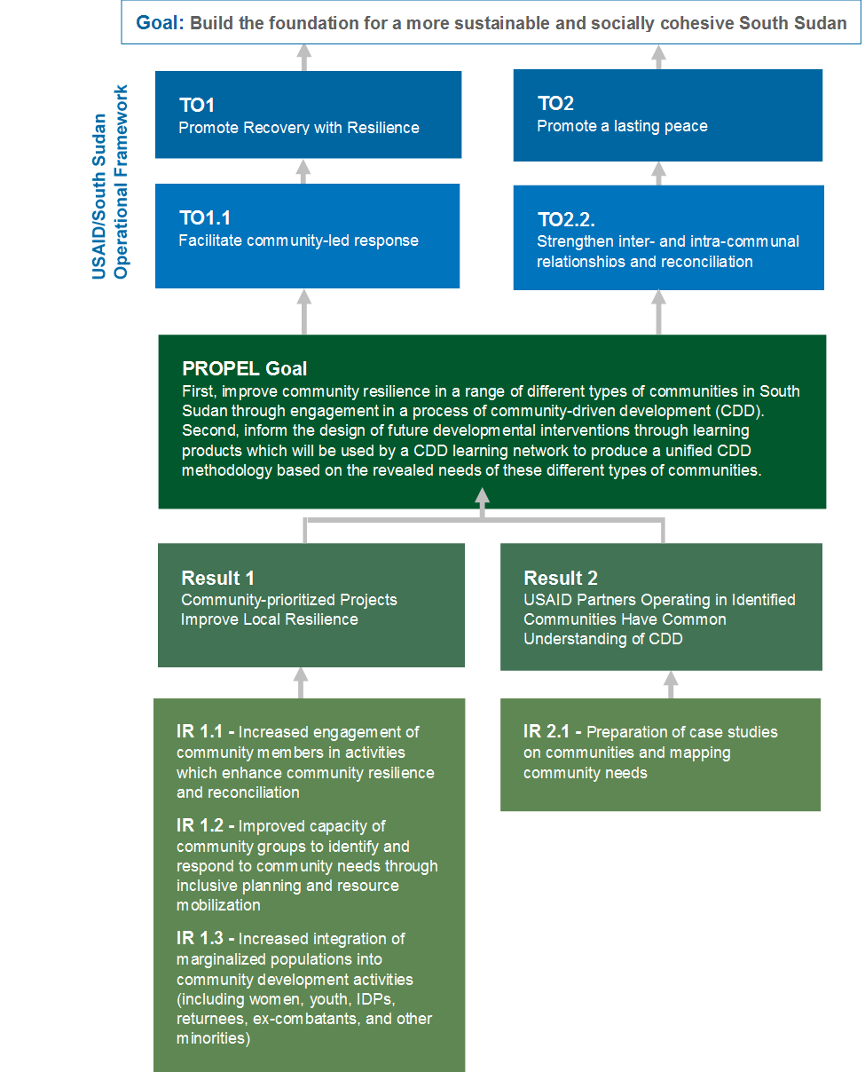

Statement of Anticipated Work

Global Communities seeks a research firm/ NGO/institution to support its program as described above, and collect data on perceptions, attitudes and behaviors in eight communities as described in the methodology section,

County | Boma(s) | Total # of Bomas
Juba | Jebel (Nyakuron South East) & Lologo (Lologo Center) | 2
Awerial | Hor, Aguarkuoth, Mingkaman, Kalthok | 4
Bor | Kolnyang, Pariak | 2
 | TOTAL | 8

- Methodology

- Face-to-face interviews in each target community with local residents. In Bor, PROPEL works in Kolnyang and Pariak, with host and IDP communities in Mingkaman and Kalthok in Awerial, in Hor and Aguarkuoth in Awerial, and in the neighborhoods of Nyakuron South East in Jebel and Lologo Center in Lologo.
- Random sample of 150-200 households in each community (50% female, 50% male), including quota sampling for IDP households, female-headed households, and vulnerable households (extremely poor, persons with disabilities, etc.) (Total sample size between 1200-1600 households.) PROPEL will not sample on the basis of tribe or ethnicity.
- Enumerators from locales neighboring to the target bomas, speaking the local dialect and knowing the local culture, able to carry out interviews in dialects while working off of an English-language questionnaire.
- Data collected using a digital solution with offline capabilities. Data should be uploaded to a centralized database and access shared with PROPEL’s MERL team on an ongoing basis.
- Data verification and cleaning on a daily basis or as often as possible, on-site supervision and random spot-checks.
- Cleaning and export of final dataset, and final sampling frame as executed

- Deliverables

- Global Communities will expect the research firm/NGO to deliver:
- Clean complete dataset in Excel, prepped for import to SPSS (specifications to be provided)
- Clean county-level datasets exported to Excel and shared on a rolling basis (as completed)
- Executed sampling design per community, specifying locations and quotas

PROPEL will utilize the baseline questionnaire adapted for end-line measurement, and will consult with the selected firm/NGO on methodology, conflict and cultural sensitivity. PROPEL will provide guidelines and training materials for the PROPEL questionnaire, and will assign a MERL team member to assist in the firm/NGO’s training of enumerators to ensure consistency of methodology with baseline data collection.

The firm/NGO will have the full support of PROPEL’s field offices in each location, including for transportation, community entry, sampling, electricity and bandwidth. Equipment and supplies for the enumerators and data collection activities should be provided by the firm/NGO. The firm/NGO will also have a members of the PROPEL MERL team in each field location as point person to facilitate coordination with the field teams and community entry.

- Anticipated Timing

The anticipated timing of each round of research is outlined below. This is not a set of firm deadlines, and the timing of each project or task order may be altered through the contract or mutual agreement.

- February 2017 - Choose Firm, sign contract
- February 2017 - Finalize survey instrument with Global Communities
- February-March 2017 - Hand-over training and guidelines for survey instrument from MERL team
- Early March 2017 - Recruitment and training enumerators
- Mid-March 2017-Early June 2017 - Data collection in target areas
- April 2017-June 2017 - Clean datasets exported to Excel on a county-by-county basis as data collection is finalized
- End June 2017 - Full clean dataset exported to Excel and provided along with final sampling frame as executed

